CMSC 204
Huffman Lab

- Create a Huffman Tree and generate the codes for each character of the following input:
create a huffman tree
For consistency:
- If same frequency – put in priority queue alphabetically; put space before other characters of the same frequency
- Add subtrees to end of group with same priority
- Lower number has higher priority (goes to front)

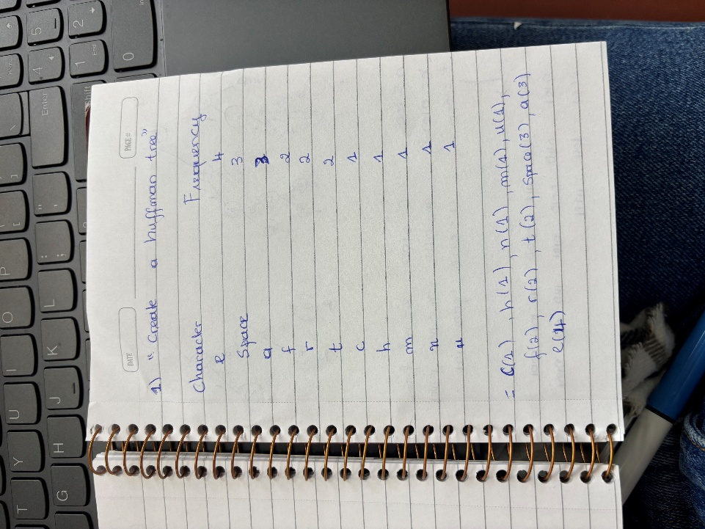

Now encode “create a huffman tree”
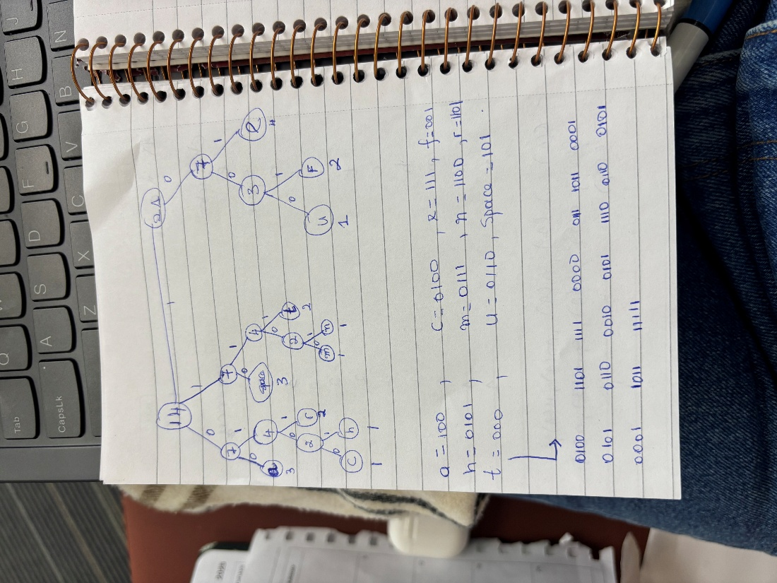
- Based on the following Huffman tree and binary sequence, what is the text

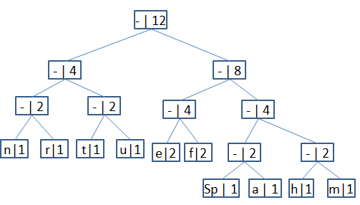

1110011101101111111010001100010001100100

