Title: Parasitic nematode infection dampens division of labour in ant colonies (TBD)

Authors

# Results

## Infection status and colony composition affects worker behaviour

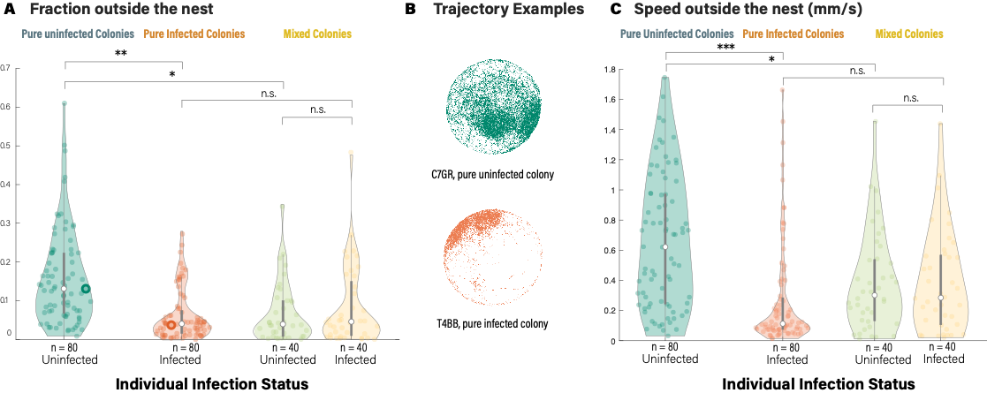

Figure 1. Infection status and colony composition affects worker behaviour. (A) The average fraction of frames when ants were outside nests. (B) Examples of trajectories of two workers (bolded edge points in A) from a pure uninfected and a pure infected colony. (C) The average walking speed of ants when outside nests. Bolded vertical bars indicate the interquartile range around the median (unfilled points), thin vertical bars represent fractions of frames or speed outside the nest that lie within 1.5 times the interquartile range, and coloured areas represent the distribution (kernel density estimate) of the data. n: sample size, ***p <= 0.001, **p <= 0.01, *p <= 0.05, n.s.:not significant.

Infection status and colony composition affect mean worker behaviour (Figure 1 and S1,Table S1). Workers in pure uninfected colonies were significantly more likely to be outside the nest than workers in pure infected colonies (Figure 3AB, Tukey’s post-hoc test for Generalised linear model (GLMM), Infectedpure versus Uninfectedpure, odds ratio (OR) = 0.377, 95% confidence interval (CI) = (0.210, 0.677), z -3.262, p = 0.006). Infected workers in pure and mixed colonies spent similar time being outside the nest (Infectedmixed versus Infectedpure, OR = 1.109, 95% CI = (0.599, 2.05), z = 0.328, p = 0.987). Interestingly, although no transmission were detected in the mixed colonies by the end of the experiment, uninfected workers in mixed colonies are less likely to be outside the nest than those in pure uninfected colonies, behaving similarly as their infected nestmates (Uninfectedmixed versus Uninfectedpure, OR = 0.388, 95% CI = (0.211, 0.713), z = -3.052, p = 0.011, Uninfectedmixed versus Infectedmixed, OR = 0.929, 95% CI = (0.669, 1.289), z = -0.442, p = 0.970).

We observed similar pattern in the differences of walking speed outside the nests (Figure 3C). Uninfected workers walk faster than those in other treatment groups, and no significant differences were detected between uninfected and infected workers in mixed colonies (Summary of pair-wise comparisons in Table S1).

Table S1. Pairwise comparisons of the outside nest speed of Uninfectedpure, Infectedpure, Uninfectedmixed and Infectedmixed ants.

|  |  |  |  |  |
| --- | --- | --- | --- | --- |
| **Pairwise comparison** | **Estimate** | **Standard Error** | **z-value** | **p-value** |
| Infectedpure versus Uninfectedpure | -0.374 | 0.103 | -3.827 | <0.001 |
| Uninfectedmixed versus Uninfectedpure | -0.265 | 0.109 | -2.541 | 0.041 |
| Infectedmixed versus Infectedpure | 0.110 | 0.109 | 1.052 | 0.674 |
| Uninfectedmixed versus Infectedmixed | 0.000 | 0.072 | -0.003 | 1.000 |

Among all infected workers, there is no correlation between the infection load and fraction of outside-nest frames or mean outside-nest walking speed (Summary for statistical test: Table S2).

Spearman's rank correlation test, infection load - fraction of outside-nest frames, S = 181938, p = 0.767, rho = 0.029; infection load - fraction of outside-nest frames, ).

# Materials and Methods

## Analysis of behaviour

All behaviour parameters were calculated using MATLAB (MathWorks, Natick, MA, USA) and were defined and analysed as follows:

(1) Fraction of frames being outside the nest: (TODO: Confirm with Daniel)

(2) Mean walking speed outside the nest: It is calculated as the average of speed over all frames in which ants were outside the nest. The speed is calculated as the euclidian distance between ants’ positions in consecutive frames. An impossible speed at 15 mm/s was set to remove tracking errors.

## Statistical analysis

All statistical tests were conducted with R 4.1.2 and associated packages (REF). Data are reported as means ± SD unless stated otherwise. The threshold for signiﬁcance was set to 5%. Violin plots were generated on the basis of the violinplot function for MATLAB provided here: https://github.com/ bastibe/Violinplot-Matlab.

### Effect of nematode infection and colony treatment on worker behaviour

We tested the effect of nematode infection and colony treatment on worker behaviour using GLMMs (function *glmmTMB* of package *glmmTMB*). In the models, a four-level independent variable combining colony treatment and individual infection status (Uninfectedpure, Infectedpure, Uninfectedmixed and Infectedmixed) was set as the fixed effect variable and the colony was set as a random effect variable. We tested the effects of these variables on the fraction of frames when the ant was outside the nest (beta family with logit link function) and the walking speed of the ant when outside the nest (gaussian family). The mixed effect models were followed by a Tukey post hoc test with Bonferroni–Holm correction (function *glht* of package *multcomp*) for the following planned pairwise comparisons: Infectedpure versus Uninfectedpure , Uninfectedmixed versus Uninfectedpure, Infectedmixed versus Infectedpure, and Uninfectedmixed versus Infectedmixed). The odds ratios were calculated as the exponetial of the estimates, indicating the change in probability of being outside the nest in each comparison.

The correlation between infection load and behaviour parameters were tested