.





**Incredible Rome Exploration**



Number of Days : 5

Budget Per Person : Rs. 100000.0

Cities : Rome

* Number of Days : 5
* Budget Per Person : Rs. 100000.0
* Cities : Rome
* Number of Days : 5
* Budget Per Person : Rs. 100000.0
* Cities : Rome









Travel Time: N/A  
Travel Distance: N/A  
  
Welcome to Rome! Upon arrival, check into your accommodation and take some time to rest after your journey. Depending on the arrival time, you can explore the neighborhood or enjoy a leisurely stroll to get a feel for the city.



Day 1: Discovering Rome





Travel Time: 1 hour  
Travel Distance: 10 km  
  
Today, immerse yourself in the rich history of Rome with a visit to the iconic Colosseum and Roman Forum. Explore these ancient landmarks and marvel at the architectural wonders that have stood the test of time. Don't forget to capture some stunning photos to cherish these memories forever.

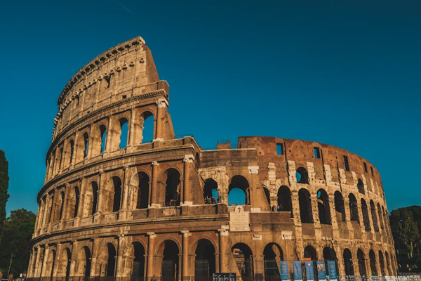

Day 2: Ancient Wonders of Rome





Travel Time: 30 minutes  
Travel Distance: 3 km  
  
Head to Vatican City, the smallest independent state in the world, and visit the breathtaking Sistine Chapel. Admire Michelangelo's masterpiece on the ceiling and walls of the chapel, and explore the Vatican Museums to delve into the art and history of this sacred place.

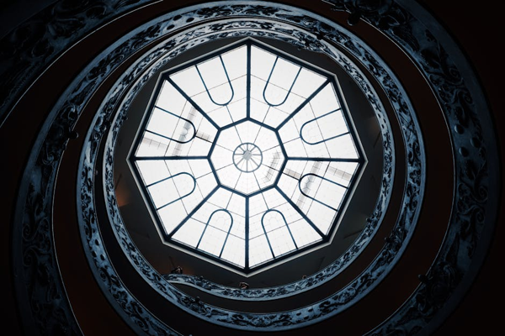

Day 3: Vatican City and Sistine Chapel





Travel Time: N/A  
Travel Distance: N/A  
  
Take a leisurely day to explore Rome at your own pace. You can wander through the charming streets, indulge in some shopping, or relax at a local cafe. Make sure to savor delicious vegetarian Italian cuisine at one of the authentic restaurants in the city.



Day 4: Leisure and Local Cuisine





Travel Time: N/A  
Travel Distance: N/A  
  
As your memorable trip to Rome comes to an end, take one last stroll through the city to soak in the atmosphere and bid farewell to this enchanting destination. Cherish the memories created with your friends and hope to return for more adventures in the future. Safe travels back home!

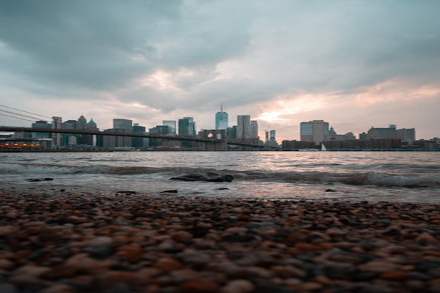

Day 5: Farewell to Rome