



Travel time: Zurich to Pune flight (approx. 11 hours)  
Bid farewell to Switzerland as you board your flight back to Pune. Cherish the memories of your Swiss adventure as you head back home.

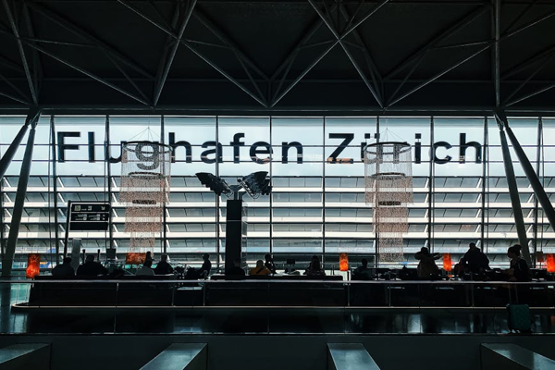

Day 10: Departure from Zurich