



- Distance: N/A  
- Time: N/A  
Spend your last day in Mumbai exploring the vibrant markets for souvenirs, handicrafts, and trendy fashion items. Shop till you drop at popular shopping districts like Colaba Causeway, Linking Road, and Crawford Market.

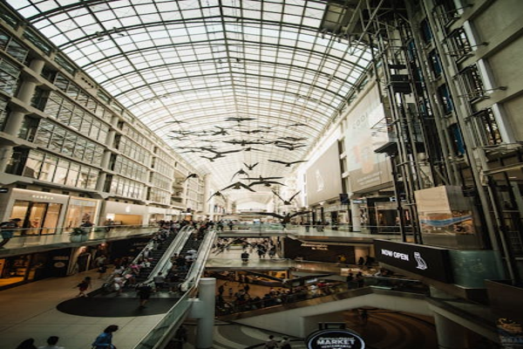

Day 11: Shopping Extravaganza in Mumbai