



- Distance: N/A  
- Time: N/A  
Immerse yourself in the cultural heritage of Mumbai with visits to museums, art galleries, and historic sites. Discover the city's rich history and artistic legacy through interactive exhibits and insightful tours.

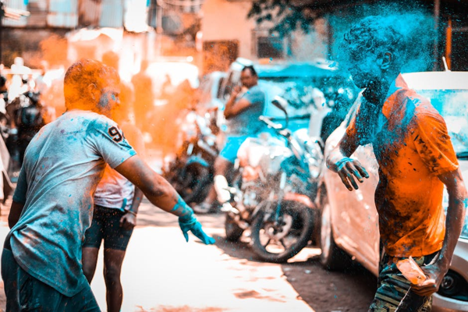

Day 13: Cultural Experiences in Mumbai