



- Distance: N/A  
- Time: N/A  
Enjoy a leisurely day in Mumbai, relaxing at a spa or on the beach, reflecting on the memories you've created during your epic journey from Punjab to Maharashtra. Bid farewell to the city with a final dinner with your friends, savoring the moments shared together.

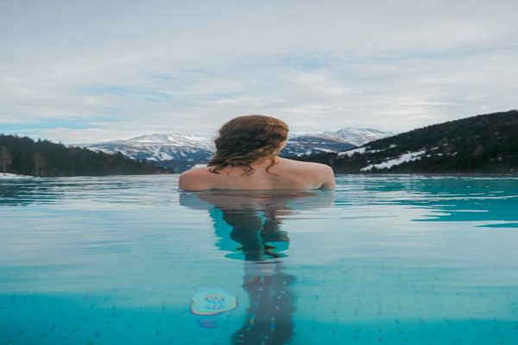

Day 14: Relaxation and Farewell