



- Distance: N/A (departure)  
- Time: N/A (departure)  
After an unforgettable adventure across Punjab and Maharashtra, it's time to say goodbye to Mumbai. Depart for your journey back home, carrying with you memories of thrilling experiences, scenic landscapes, and cultural discoveries. Until next time, happy travels!

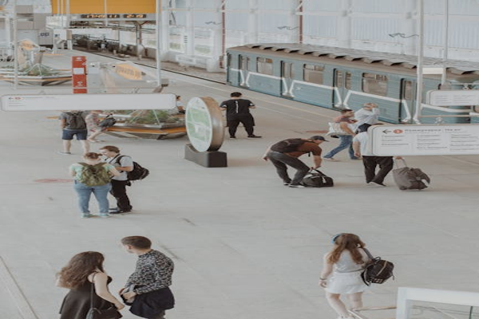

Day 15: Departure from Mumbai