



Travel time: Pune to Zurich flight (approx. 11 hours)  
Upon arrival in Zurich, you will be mesmerized by the breathtaking views of this vibrant city. Check into your hotel and take some time to relax after your long journey.

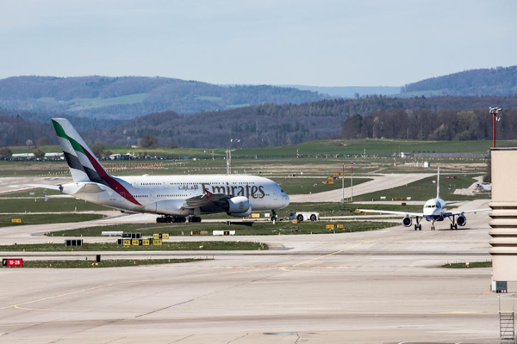

Day 1: Arrival in Zurich