



Today, embark on a thrilling desert safari adventure in the Dubai desert. Experience dune bashing, camel riding, and sandboarding before enjoying a traditional Arabian dinner under the stars at a desert camp. This exhilarating day will be filled with adrenaline-pumping activities and stunning desert landscapes.

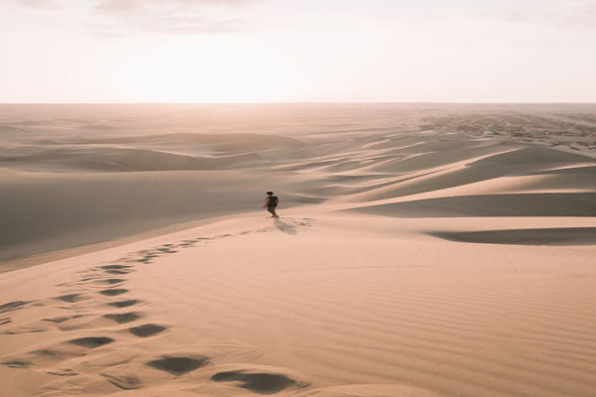

Day 2: Thrilling Desert Safari Adventure