



- Distance: N/A  
- Time: N/A  
Explore the spiritual side of Nashik with visits to ancient temples like Trimbakeshwar and Muktidham. Take a dip in the holy waters of the Godavari River and immerse yourself in the peaceful ambiance of the sacred sites.

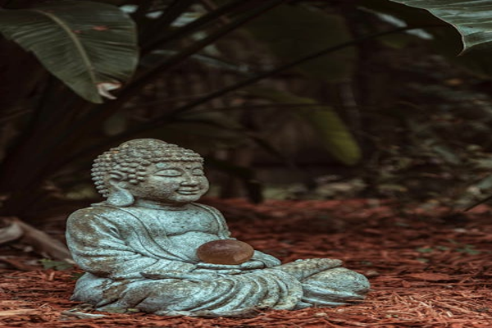

Day 6: Spiritual Retreat in Nashik