



- Distance: 330 km  
- Time: 6 hours  
Embark on a scenic drive to Kolhapur, a city famed for its historical significance and culinary delights. Enjoy the picturesque landscapes along the way and check into a cozy hotel upon arrival.

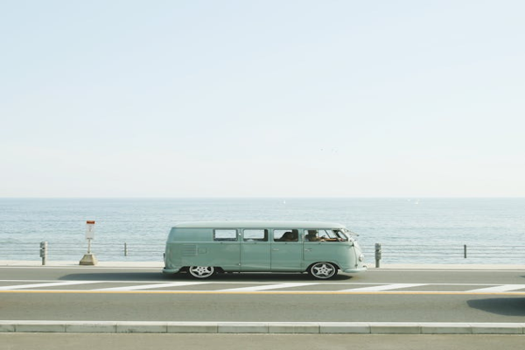

Day 7: Leisurely Drive to Kolhapur