



Travel time: Zermatt to Zurich by train (approx. 3.5 hours)  
Travel distance: 240 km  
Say goodbye to the beautiful town of Zermatt and take a scenic train journey back to Zurich. Check into your hotel and spend the evening exploring any sights you may have missed on your first day.

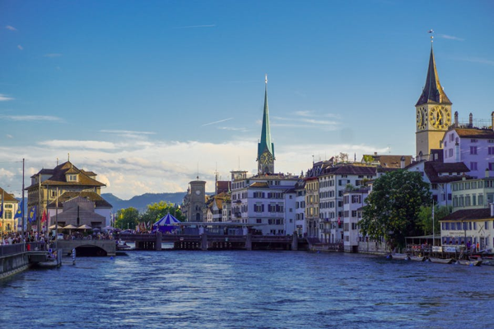

Day 8: Travel back to Zurich