



Travel distance: N/A  
Spend your last day in Switzerland exploring any remaining attractions in Zurich. Visit the Swiss National Museum, stroll through the botanical gardens, or take a relaxing boat ride on Lake Zurich.

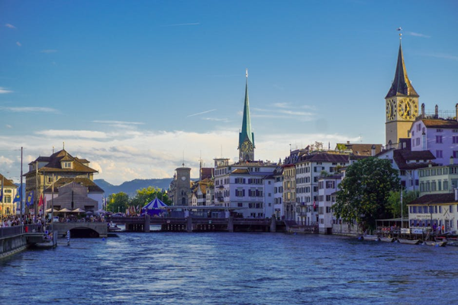

Day 9: Last day in Zurich