

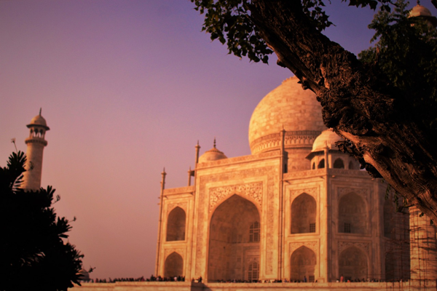

**Day 10: Cultural Insights in Srinagar**

Travel: Local sightseeing in Srinagar | Proceed to Jammu   
Explore Mughal Gardens and Shankaracharya Temple in Srinagar. Experience local market culture and buy handicrafts. Post-lunch, travel to Jammu, recounting the trip’s highlights, arriving by evening. Settle into our hotel and enjoy a group dinner reflecting on the journey so far.  
  
---