



Travel Distance: Explore the city on foot  
Spend the day shopping for souvenirs and local handicrafts at popular markets like Sitabuldi Market and Dharampeth Market. Treat yourself to some street food for lunch.

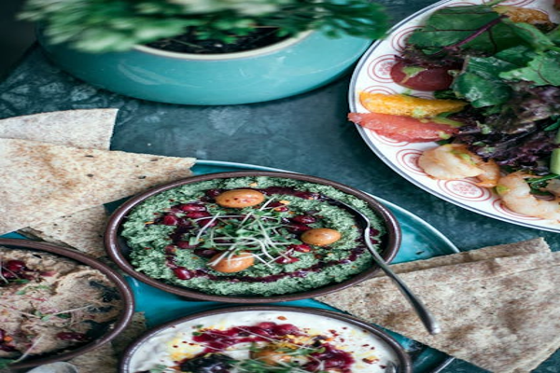

Day 11: Shopping Extravaganza in Nagpur