



Travel Distance: 15 km (45 minutes by car)  
Embark on a nature walk around Ambazari Lake, enjoying the serene surroundings and birdwatching opportunities. Have a picnic lunch by the lake and relax in nature.

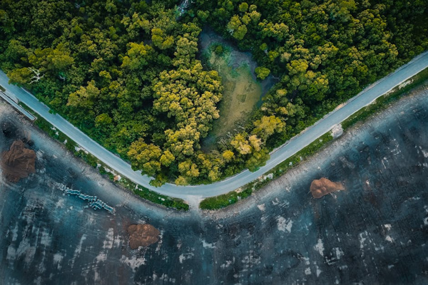

Day 12: Nature Walk at Ambazari Lake