

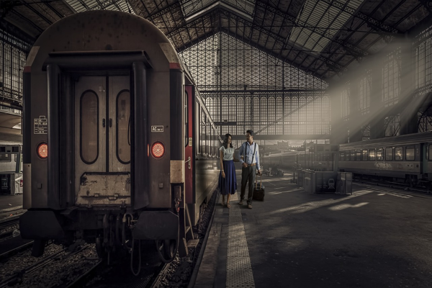

**Day 13: Scenic Train Ride Back to Pune**

Travel: Delhi to Pune | Distance: 1,200 km | Time: 23 hours   
Morning train to Pune! Enjoy onboard activities as a group: music, quizzes, and sleep. Share your favorite memories and future plans. Arrival in Pune next day, concluding our educational and adventurous journey across Northern India.  
  
---