



Bid farewell to Nagpur as you catch your flight back to Delhi, carrying with you cherished memories of your fun-filled adventure in the city.

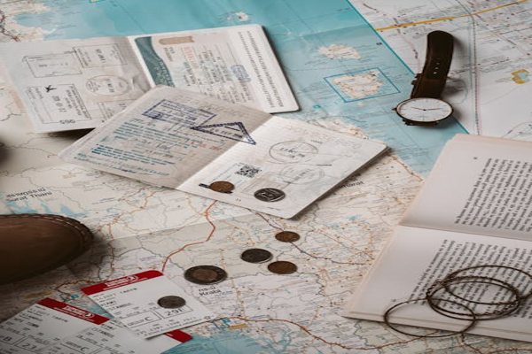

Day 15: Departure from Nagpur