

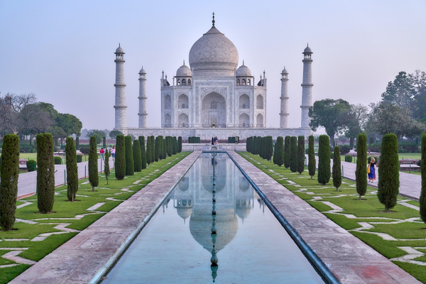

**Day 2: Majestic Arrival in Agra**

Travel: Local sightseeing in Agra   
Wake up to a grand breakfast and head to the iconic Taj Mahal! Marvel at its beauty and learn about Mughal architecture. Afternoon visit to Agra Fort, enriching our knowledge of Indian history, followed by a relaxing evening. Group dinner to discuss today’s experiences.  
  
---