



Travel Distance: 80 km (3 hours by road)  
Embark on an early morning safari at Pench National Park for a chance to spot tigers, leopards, and other wildlife in their natural habitat. Return to Nagpur in the evening for a relaxing dinner.

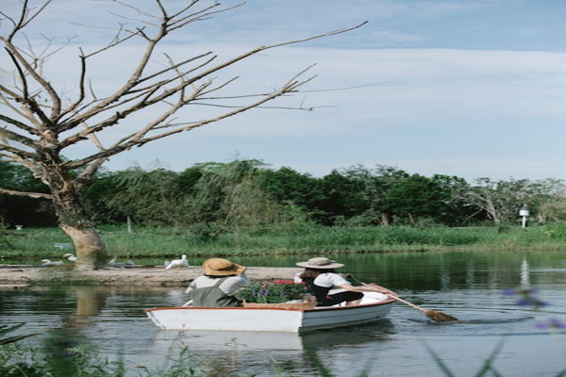

Day 3: Wildlife Safari at Pench National Park