



Travel Distance: Explore the city on foot  
Immerse yourself in Nagpur's rich culture by visiting museums, art galleries, and cultural centers. Indulge in some more delicious vegetarian cuisine for lunch.

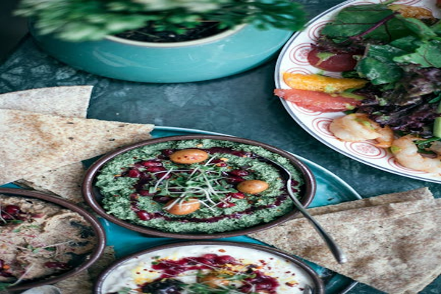

Day 4: Cultural Immersion in Nagpur