

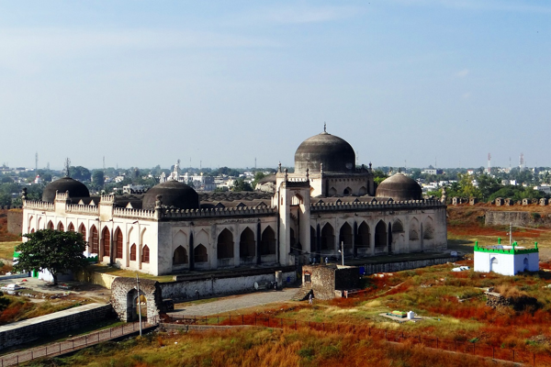

**Day 5: Delving Deeper into Delhi's Heritage**

Travel: Local sightseeing in Delhi | Night journey for Amritsar   
Explore the streets of Old Delhi in the morning: visit Jama Masjid and enjoy street food. Afternoon tour of Qutub Minar and Lotus Temple for architectural marvels. Dinner at a local restaurant before boarding the overnight bus to Amritsar.  
  
---