

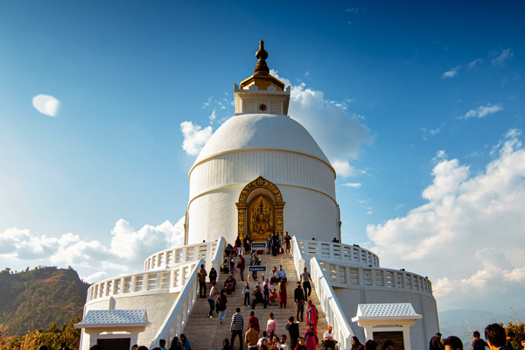

**Day 7: Temples and Mountains**

Travel Time Distance: Local transit, minimal travel.   
After breakfast, we will embark on a day trip to Katra. A trek to Vaishno Devi Temple awaits, surrounded by spiritual ambiance. Relax and absorb the tranquility post-visit. Enjoy lunch at a local eatery. Return to Jammu in the evening, with options to explore local sweet shops for some delightful treats.  
  
---