



Travel Distance: 20 km (1 hour by car)  
Join a cooking class to learn how to prepare traditional Maharashtrian dishes using fresh ingredients. Enjoy the fruits of your labor for lunch and dinner.

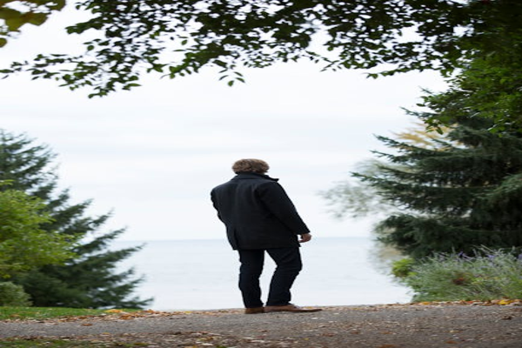

Day 9: Culinary Experience in Nagpur