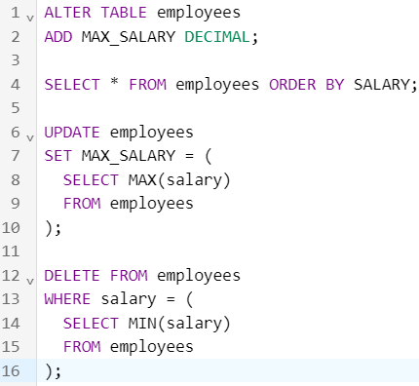EX-01

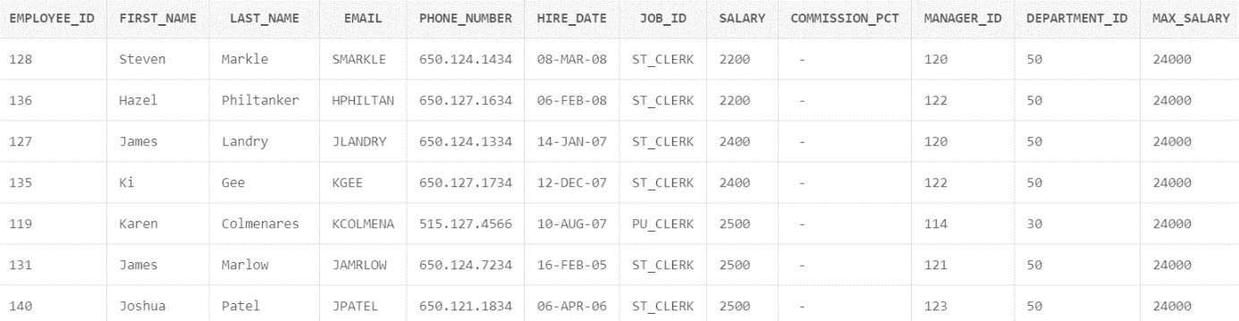

EX-02

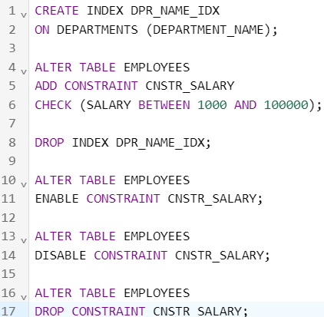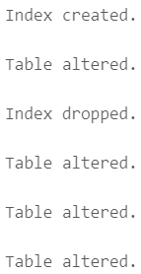

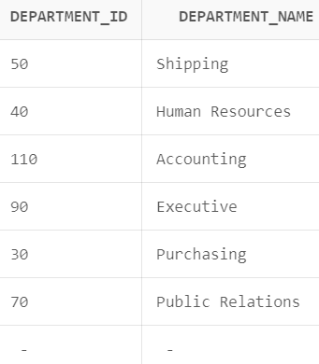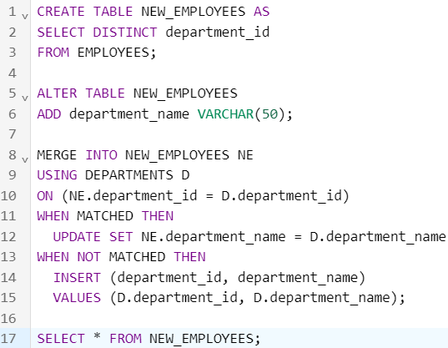EX-03

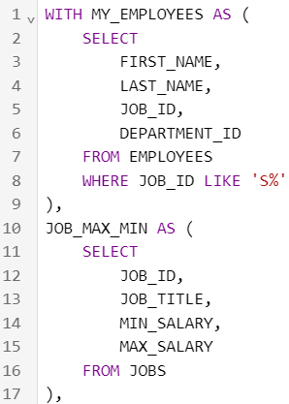EX-04

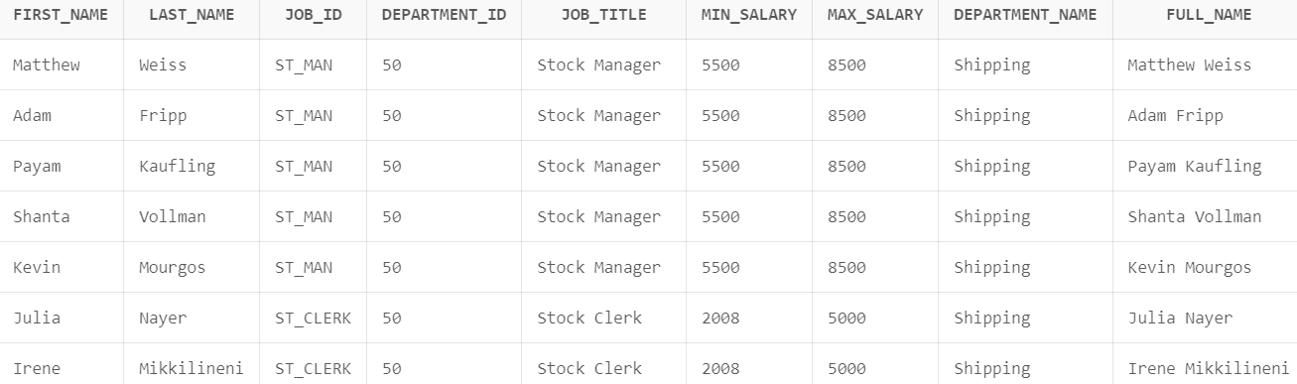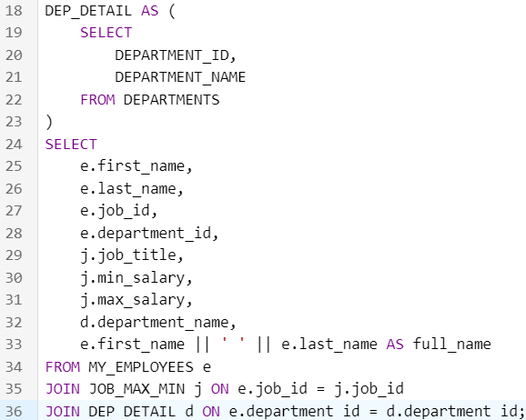

EX-05

The COMMIT statement is used to permanently save the changes made during a transaction to the database. After executing a COMMIT, all the changes made during the transaction become permanent and are written to the database.

The ROLLBACK statement is used to undo the changes made during a transaction and restore the database to its state before the transaction started. If there is an error or if the transaction needs to be canceled, a ROLLBACK can be issued to revert the changes back to the original state.