SuperAge — Data Asset & Growth Story
Slide-ready content. Numbers verified against production data as of June 12, 2026.

1. The Profile Base
Metric | Count
Total Profiles (including unsubscribes; ever consented, all states) | 1,822,753
Consented Profiles | 1,106,146
Active Consented Profiles | 772,526
Openers (last 90 days) | 640,668
Recently Engaged Clickers (last 90 days) | 194,924

2. Fields per Profile — 25+ Attributes Across 8 Categories
Demographics
Age · Date of Birth · Gender · Marital Status · Education Level · Financial Situation
Health & Lifestyle
Exercise Frequency · Sleep Hours · Diet Description · Alcohol Frequency · Smoking Status · Social Frequency · Stress Impact
Biometric & Clinical
Diastolic Blood Pressure · Obesity / BMI Indicator · Health Conditions · Longevity Score (composite, 0–100)
Family Health History
Mother's Independent Age · Grandparents' Age at Death · Family Cancer Count
Safety & Risk
Traffic Incidents (last 5 years)
Acquisition
Source / Channel · Acquisition Date
Engagement & Behavioral
Engagement Segment · Open History · Click History · Days Active
Lifecycle
Subscribe Date · Unsubscribe Date · Current State

3. Health Data Coverage
10 validated health attributes per profile.
49.1% (896,299 out of 1,822,753 total profiles) carry validated health data — a clinically meaningful health dataset at near-million scale, including biometric (blood pressure, BMI) and behavioral risk factors (smoking, alcohol, exercise) used in actuarial and longevity research models.
Health attributes captured:
- Exercise Frequency
- Sleep Hours
- Diet Description
- Alcohol Frequency
- Smoking Status
- Stress Impact
- Diastolic Blood Pressure
- Obesity / BMI Indicator
- Health Conditions
- Longevity Score (composite, 0–100)

4. Subscriber Growth — 5-Month History
Month Start | Total Active | MoM Change | MoM %
Jan 1, 2026 | 1,076,055 | — | —
Feb 1, 2026 | 1,077,202 | +1,147 | +0.11%
Mar 1, 2026 | 1,088,742 | +11,540 | +1.07%
Apr 1, 2026 | 1,093,187 | +4,445 | +0.41%
May 1, 2026 | 1,108,740 | +15,553 | +1.42%
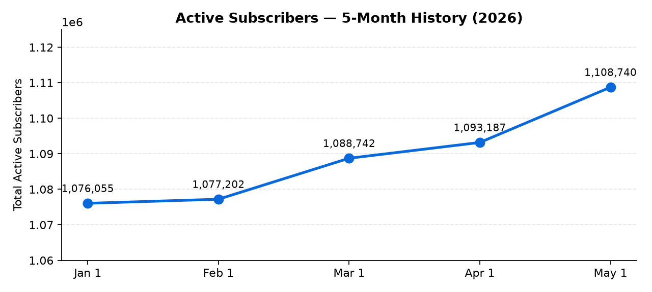
Key observations:
- 5-month average MoM: +0.75% (~+8,171 subs / month).
- Peak months: Mar (+1.07%) and May (+1.42%) — driven by campaign pushes.
- Variance is the story: growth is real but campaign-dependent; needs a consistent driver. Games is that lever.

5. Games — Validated Funnel
Metric | Value
Paid ticket buyers | 142
Waitlist signups (closed) | 3,190
Landing events (52 days, Apr 22 – Jun 12) | 45,585
Current run-rate | ~17,000 events / month
Site conversion (events → paid) | 0.316% (1 buyer per 317 events)
The funnel is real and measurable — not hypothetical.

6. Games — Two-Fold Value to SuperAge
Acquisition (net-new subscribers driven by Games):
- 8,975 partner-brand clickers (HealthBrief + AllHealthy, time-stamped).
- 102 subscribed to SuperAge AFTER clicking Games and are still consented.
- 1.14% gross acquisition rate / 2.21% on net-new-eligible audience.
Retention / Engagement (existing subscribers re-engaging with brand):
- 4,363 existing SuperAge subscribers clicked Games URLs from partner-brand campaigns.
- That's 48.6% of all Games clickers — Games is a powerful re-engagement signal for the existing list.

7. Projections — Primary Case

7a. 3-Month Subscriber Projection (Jul → Sep 2026)
Starting base: 1,108,358 active subscribers (Jun 1, 2026)
- Baseline: +0.60% / mo (return to the historical 6-month average)
- Games adds: +114 net-new / mo from scaled partner activation
- Net change: ~+6,765 / mo
Month | Total Active | MoM %
Jul 1, 2026 | 1,114,565 | +0.56%
Aug 1, 2026 | 1,122,367 | +0.70%
Sep 1, 2026 | 1,128,778 | +0.57%
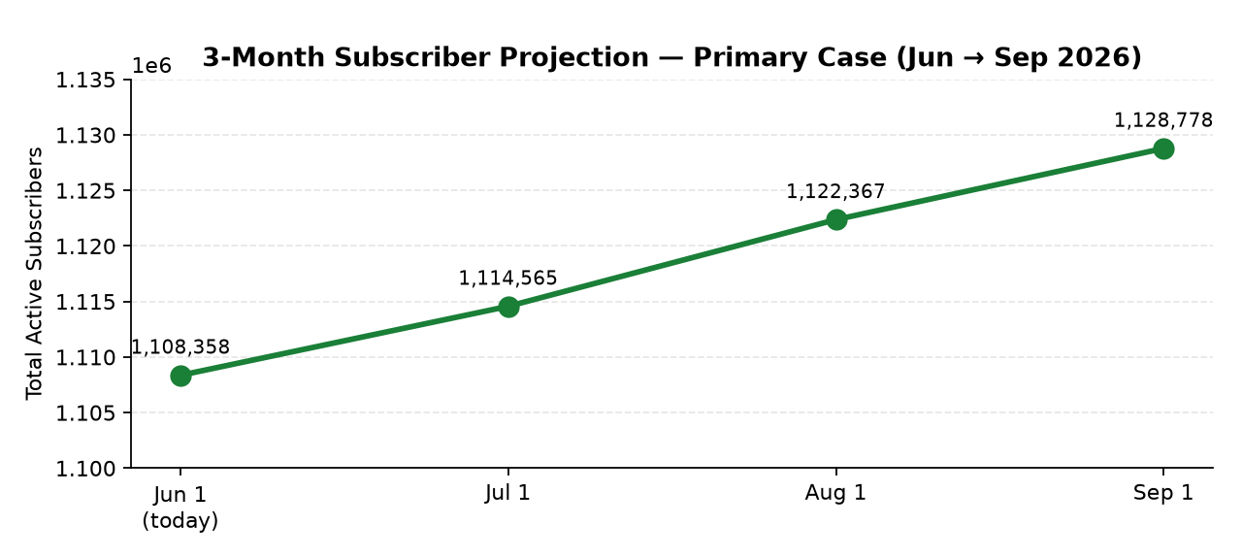
3-month outcome: +20,420 subs (+1.84%) — Growth returns to historical norm with modest Games activation. This is the case to plan against.

7b. Games Ticket Sales — 5 Months to November Event
Public launch + light paid acquisition. Conversion held at observed 0.316%.
Month | Cumulative Paid Buyers
Jun (today) | 142
Jul | ~210
Aug | ~380
Sep | ~620
Oct | ~1,100
Nov (event) | ~1,750
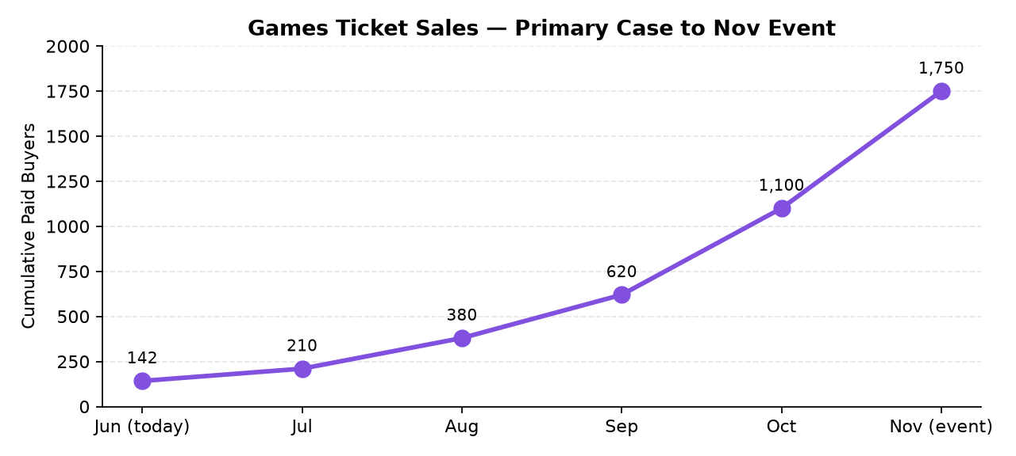
S-curve concentrates ~50% of sales in the final 8 weeks — standard event-ticketing dynamic.

7c. Net-New SuperAge Acquisition Driven by Games (5-Month View)
Using the validated 1.14% net-new acquisition rate from partner-brand Games clickers.
Month | Cumulative Net-New SuperAge Subscribers
Jun (today) | 0
Jul | ~95
Aug | ~200
Sep | ~320
Oct | ~450
Nov | ~570
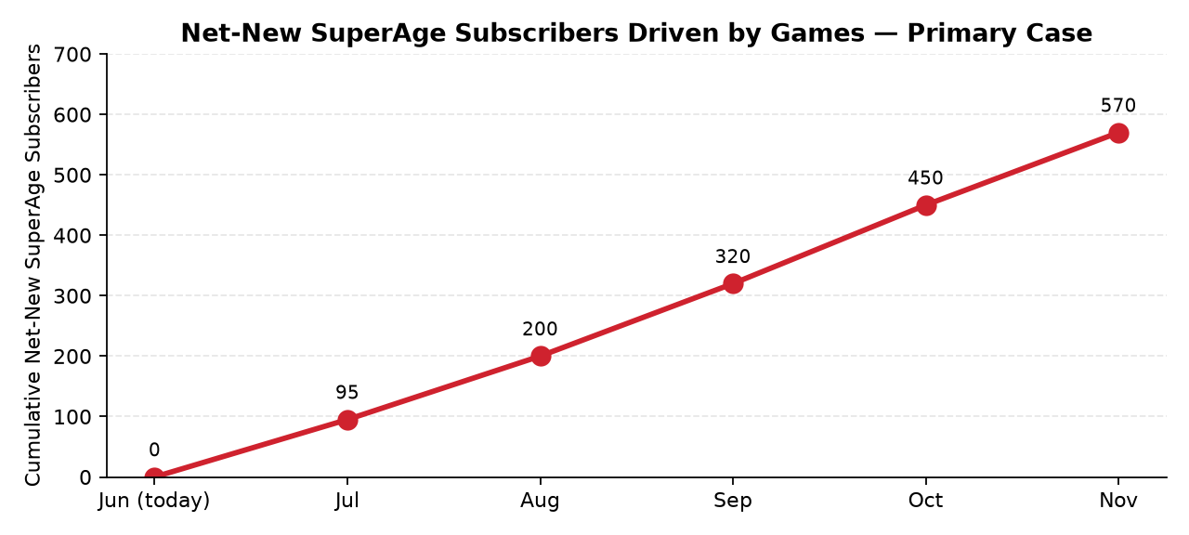
~570 net-new SuperAge subscribers acquired through Games campaigns by event date.

8. The Strategic Story
Today: 1.1M consented profiles, 49.1% health-data-validated, growth averaged +0.75% MoM over 5 months but is campaign-dependent.
Primary case with Games activation:
- Sep 1, 2026 → 1,128,778 active subscribers (+20,420, +1.84% over 3 months) — restoring growth to the 6-month historical norm.
- Nov event → ~1,750 paid Games buyers (5× current customer base).
- Games campaigns drive ~570 net-new SuperAge subscribers over the 5-month run-up.
Why the primary case is defensible:
- 0.316% Games landing-event-to-paid conversion (measured)
- 1.14% Games-click-to-SuperAge-subscriber acquisition (measured)
- 48.6% Games-click-to-existing-sub retention engagement (measured)
- +0.60% MoM baseline is the historical 6-month average — not a stretch assumption
- November event is the inflection point — 5 months of build with measurable funnel mechanics

9. Data Licensing Position
All data will be aggregated and de-identified in packaging for licensing.
- 1.1M consented profiles with 25+ attributes spanning demographics, behavior, lifestyle, and biometrics.
- Industry-standard k-anonymity safeguard (minimum bucket size = 25 profiles) ensures privacy in every export.
- Comparable to Truveta, Wirestock, and Protégé in scale and depth — distinguished by behavioral + longitudinal engagement signal (open / click history per subscriber over time).

