PROJECT: CRIME ALERT SYSTEM

INTRODUCTION / PROBLEM STATEMENT

In a country where there is increase in crime rate and little infrastructure in place to tackle crime, there is need for solution that will help to keep citizen safe from preventable dangers that may be avoided or neutralized only if there were sufficient information that can help security agent respond quickly to incident and carry out their job more effectively.

In developed countries, we have state of the art technology such as high definition CCTVs, motion sensors, state of the art recognition system and a very informative database system of its citizen.

As a developing country we struggle to use the available resources which are largely based on manual effort which provide less and inaccurate information about the nature of crimes committed in certain areas and how frequent these crimes occur. We lack the technical resources that are needed to provide more and accurate information about these crimes, hence, making it more hectic for the security agencies to carry out their jobs effectively and efficiently.

The technology needed to increase the security of the country is quite expensive, rigorous and time consuming to implement, therefore we need a disruptive solution that will be able to solve this problem as closely as those state of the art technology would.

**CRIME ALERT APP**

The crime alert app is disruptive technology that can be use to tackle some of the problems in the security sector. This application requires the involvement of citizen as part of the stakeholders by providing information that can be used by the security agent to work effectively.

One major problem we face is the lack of recorded data with which we could draw insight to find solutions to problems we are facing; this is another aspect the app will help in tackling. The main goal of this app is to ensure **DYNAMIC PLACEMENT OF SECURITY AGENT AND INCREASE RESPOND TIME** to places where crime is currently going on or are most prevalent at certain times due to the insight drawn from data that is provided by citizen about recent crimes through the crime alert system.

The crime alert app consist of 4 main windows.

* The Home window
* The registration page or sign in page
* The app function
* The description page.

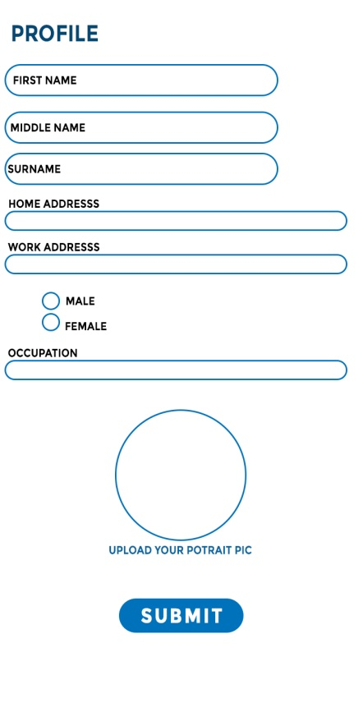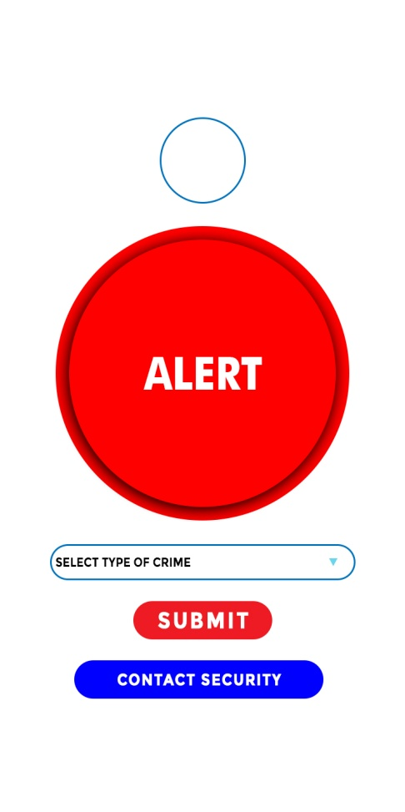**crime alert functionality**

Here are some functionality the app will be performing.

* An alert system that user can touch to trigger an alert in the system database about an ongoing crime.
* You can get access to security authority by just a click
* You can report the kind of crime on going without needing to fill in much details instantly
* You can also give an elaborate description of the crime you experienced, the accurate address and how it occurred in the description page.
* The application will also employees the use of data science to map locations where crimes are most prevalent as data is been gathered on a daily interval to be able to dynamically place security agent on areas where the alert system is been triggered by the most and the kind of crime occurred.

**Benefit of the crime alert system**

* There will be timely data about ongoing crime.
* Data gathered over time can be used to get insight in areas where there are high crime rate and areas with low crime rate, hence which will be effective in assigning security agents to certain areas in order to curb it.
* Crime patterns will be able to be analysed and get insight on why such high crimes occur in certain areas, what that areas needs, what kind of economical solution can be provided to limit the occurrence of these crimes in that location.
* There will be effective utilization of manpower as security agents will be effectively managed and resources would be managed effectively as well

**COMPONENT OF THE APPLICATION**

The application need to integrate certain technologies in order to carry out the function that it is been built for, some technologies that will be integrated include

* Machine learning for natural language processing, data anaylsis and insight generation
* Visual component to be able to view maps and visualize statistics
* A database technology to store users information and data generation such as time series information over time
* A dashboard that will display when an alert is triggered and the information about the alert like the description of the crime.

**MAJOR DELIVERABLES (FUNCTIONAL REQUIREMENT)**

* User sign in and login page
* Database of user information
* Database for crime data and information
* The alert trigger system
* The crime description page

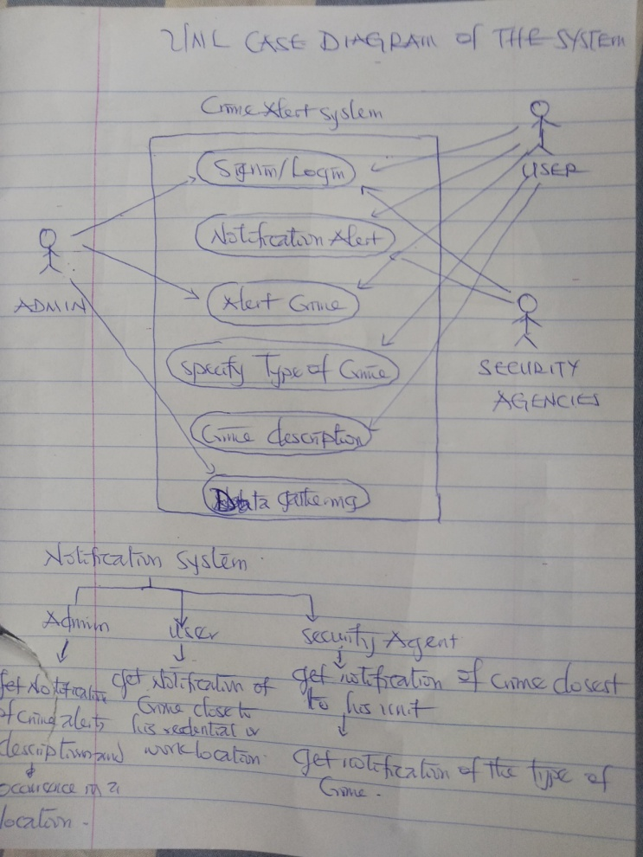**DESIGN PROCESS**

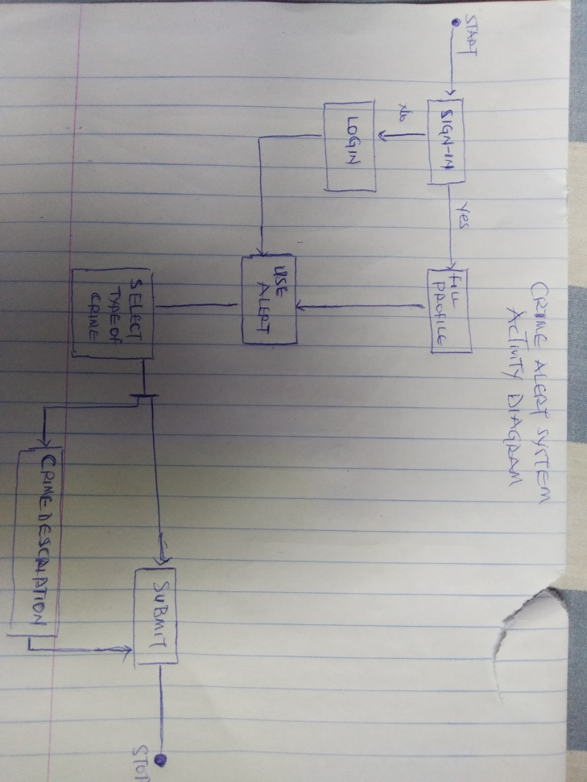

UML ACTIVITY DIAGRAM REPRESENTSTION

UML USE CASE DIAGRAM REPRESENTATION

**COMPETITIVE ANALYSIS**

Crime prevention technologies are classified under two class; Hard and Soft Technologies. The hard technologies include the use of CCTV, and sensor technologies, while the soft technology involves the strategic use of information to prevent crime which is based on historic data accumulated overtime from either Hard technologies or data recorded.

The Crime Alert System (CAS) is a soft crime prevention technology that is modeled to be disruptive in finding solution to prevent crime, our competitive advantage lies in the fact that our country has no accurate data of crime occurrence and the mappings of hot spots, that is, places where crime are most prevalent, and it will take years and huge capital to be able to provide existing technologies which places with low crime rate employ to prevent crime.

Our system combines the function of both the hard and soft technologies into a cheap and affordable means and process using existing technology in order to prevent crime and as well gather data that can be use to map out hotspots and get insight on ways to prevent crime and efficiently use available resources. More so, there is no technological solution that is similar to ours in terms of automation and job process.

Also the model of this project has numerous applications in different field including health and fire alarms which has great economical value.