CBI Migration STUDY

Introduction

* The objective of this study to demonstrate that without access to inward migration, Northern Ireland’s economy will struggle to grow. Given the small population of only 1.8 million, the future of Northern Ireland’s **future economic success** will be dependent upon the private sector’s ability to access international workers
* With only 3 percent of the UK’s population, firms in Northern Ireland have traditionally struggled to attract workers from management level right down to low-skilled workers. However, a chill factor for immigrants to the UK following the Brexit referendum, weak sterling and improving economies across Europe have both combined to reduce the number of EU nationals in the local economy.
* The population statistics in this report demonstrate that employers will need to access young EU and international workers as the pool of indigenous working-age people in diminishes.
* Given the demographic backdrop which includes an aging population structure a, the local economy will require significantly increased subvention from HM Treasury if living standards in Northern Ireland are to be maintained. Migration of working people from inside and outside the EU is one of the most realistic ways of mitigating our reliance on Westminster funding in the future. From a macroeconomic perspective, any restrictions on Northern Ireland’s private sector to access people will reduce the economy’s ability in the future to be self-sufficient.
* The CBI therefore strongly recommends that any migration system for Northern Ireland is evidence-based and takes into consideration the full range of influencing factors such as population trends as outlined above. Both the long-term and short-term consequences of any change to migration policy must be fully analysed.

### Natural change and net migration, Northern Ireland, 2001-2016

Since the turn of the century Northern Ireland's population has been dependent on positive net migration (in-migration minus out-migration) combined with a positive natural population change (births minus deaths).

However, as the graph below demonstrates, the levels of positive net migration declined rapidly after the financial crisis and then fell into negative territory between 2010-2014 when more people left the region than came into it. While some improvement has since occurred along with stronger economic growth between 2013 and 2016; net migration levels have remained subdued.

Alongside lower inward migration, Northern Ireland has also observed that the natural change in population has followed a broad downward trend since 2011 (put in numbers to help explain.moving from a positive net migration of 11,--- in 2011 to 9,--- in 2016)

Figure 1

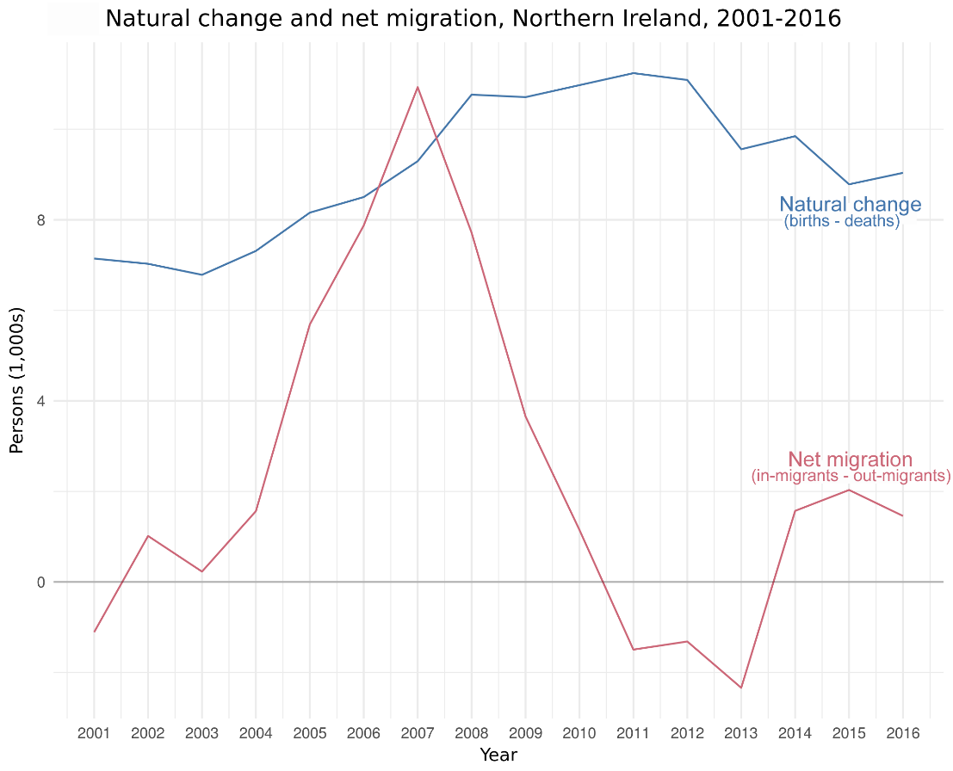

**Source:** *Mid-Year Population Estimates, Components of Population change (October, 2017), NISRA*

### Figure 2. Population by non-UK nationality, June 2017

In Oct- Dec 2016 NISRA reported that there were 117,000 EU (inc RoI) residents in Northern Ireland representing 6.3 per cent of the local population. By June 2017 that figure fell to an estimated 97,000 EU citizens living in Northern Ireland. Alongside EU born citizens, there were an estimated 26,000 other international migrants. In total, it is estimated that Northern Ireland is home to 123,000 EU and international citizens - represent 6.6% of the region’s population.

The majority of migrants in Northern Ireland come to work (40.5%) join family (25.6%) or study (14.5%).

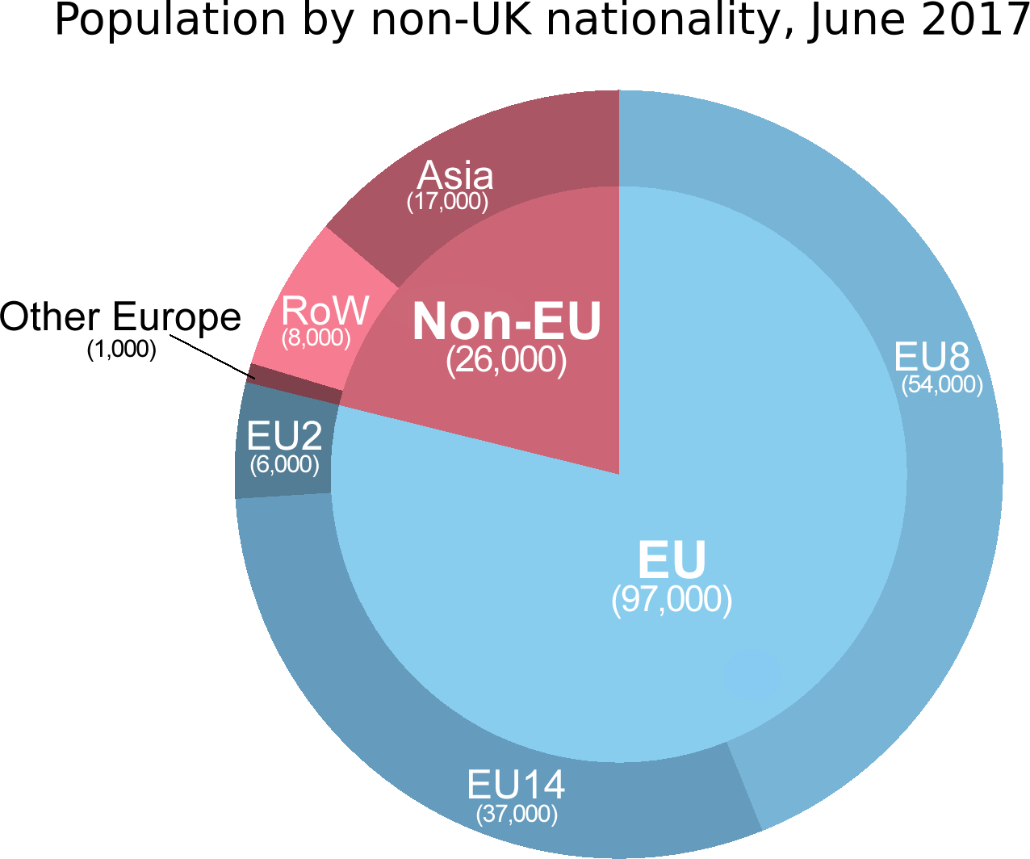

Source: **Source:** *Annual Population Survey (June, 2017), ONS*

Note:

* The EU2 (formerly known as the A2) are the two countries that joined the EU on 1 January 2007: Bulgaria and Romania. EU2 nationals currently have certain restrictions placed on them; in the first 12 months of stay, working Bulgarian and Romanian nationals are generally required to hold an accession worker card or apply for one of two lower-skilled quota schemes.
* The EU8 (formerly known as the A8) are the eight central and eastern European countries that joined the EU on 1 May 2004: Czech Republic, Estonia, Hungary, Latvia, Lithuania, Poland, Slovakia and Slovenia. The EU8 does not include the two other countries that joined on that date: Cyprus and Malta. EU8 nationals previously had restrictions on their rights to work and were required to register under the Worker Registration Scheme, but since 1 May 2011 EU8 nationals now have the same rights as other workers from the EU and EEA.
* The EU 14 would be the other old member countries of the EU (before 2004): Austria, Belgium, Denmark, Finland, France, Germany, Greece, Ireland, Italy, Luxembourg, Netherlands, Portugal, Spain, Sweden

### Northern Ireland residents born in Ireland and EU26, 2007-2016

In terms of the working age population, the NI Statistics Research Agency (NISRA) has estimated that there were 1,455,000 people residing in NI aged 16 or over. Of these 841,000 (58%) were employed and working in NI.

Between October and December 2016 NISRA found that 79,000 persons resident in NI were born in the EU26; with 71,000 aged 16 or over. Of these, 57,000 (80%) were employed and working in NI. Moreover, it was also found that 38,000 residents in NI were born in Ireland; with 37,000 aged 16 or over. Of these, 21,000 (57%) were employed and working in NI.

Figure 3.

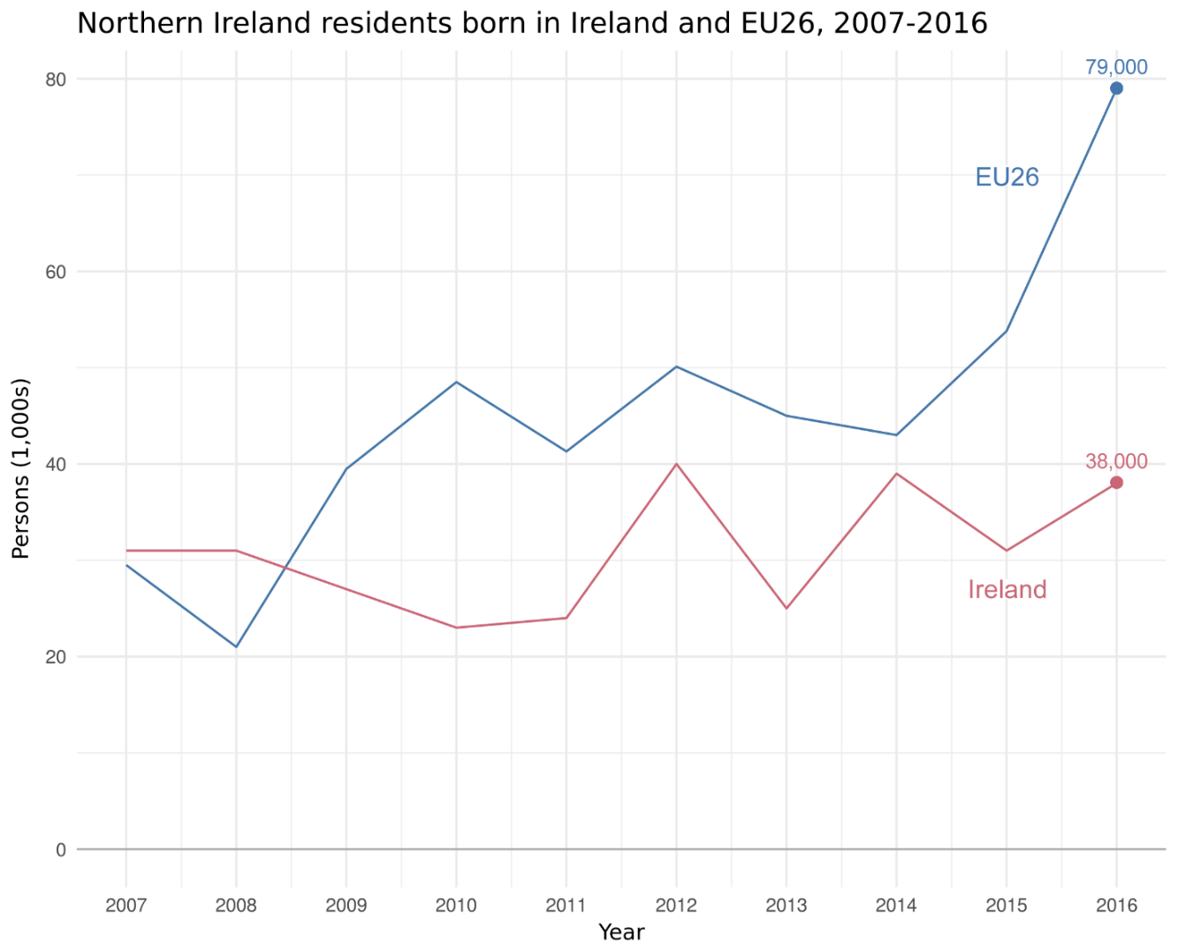**Source:** *Labour Force Survey (March 2018), NISRA*

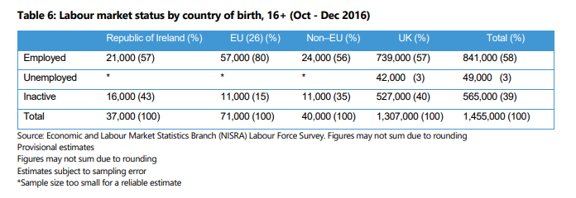

### Figure 4. Births in Northern Ireland to mothers born in GB, EU26 and Ireland, 1997-2016

**Source:** *Registrar General Annual Report: Births (2016), NISRA*

A number of phenomena are worth noting over the past 20 years. First, there has been a long-term decline in births in Northern Ireland to mothers born in Great Britain. This is a decline in both absolute and relative terms. Specifically, there were 1,052 (4%) births in Northern Ireland to mothers from GB in 2016, which is a fall from 1,756 (7%) births in 1997.

Second, there has been a small fall in births in Northern Ireland to mothers born in Ireland: 618 births to mothers from Ireland in 2016; down

from 723 births in 1997.

Finally, there has been a substantial rise in births in Northern Ireland to mothers born in EU26 countries. This is a significant increase in both absolute and relative terms. In 2016 there were 1,590 (7%) births to mothers from EU26 countries; up from 176 (1%) births in 1997. The biggest rise in EU26 mothers came soon after the 2004 EU expansion.

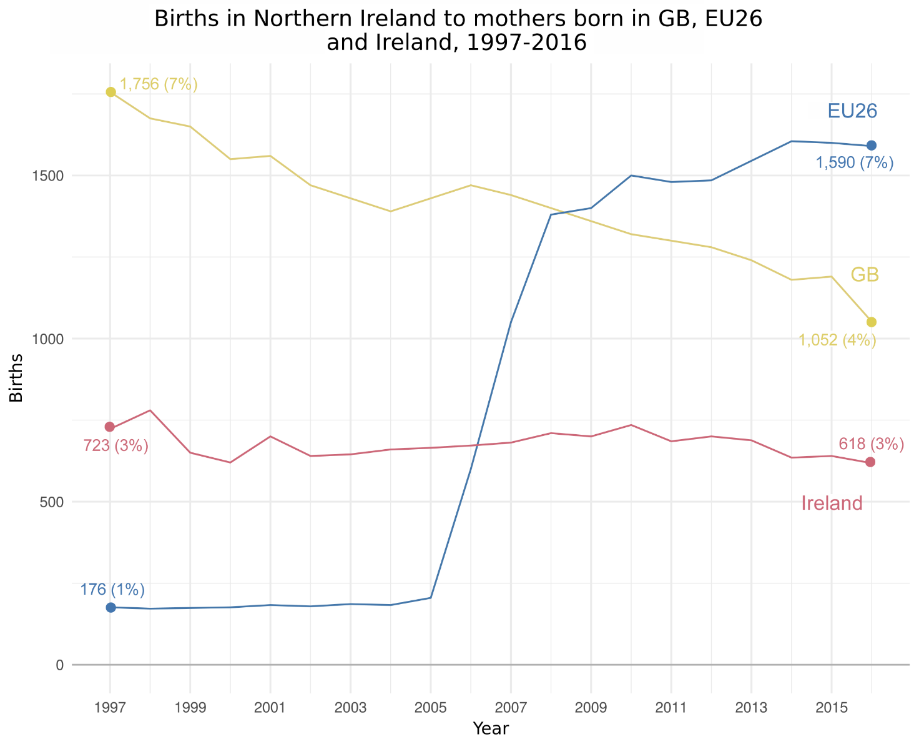

### Change in employment by country of birth, Northern Ireland, 2008-2017

**Source:** *Labour Force Survey (March, 2018), NISRA*

Due to the global financial crisis, employment fell by 40,000 between Q1 2008 and Q2 2009. By 2014 employment levels were at pre-crisis levels. By 2016 employment had risen by nearly 40,000. Since 2014 employment recovery driven by people born in EU26 now living in Northern Ireland.

**Figure 5**.

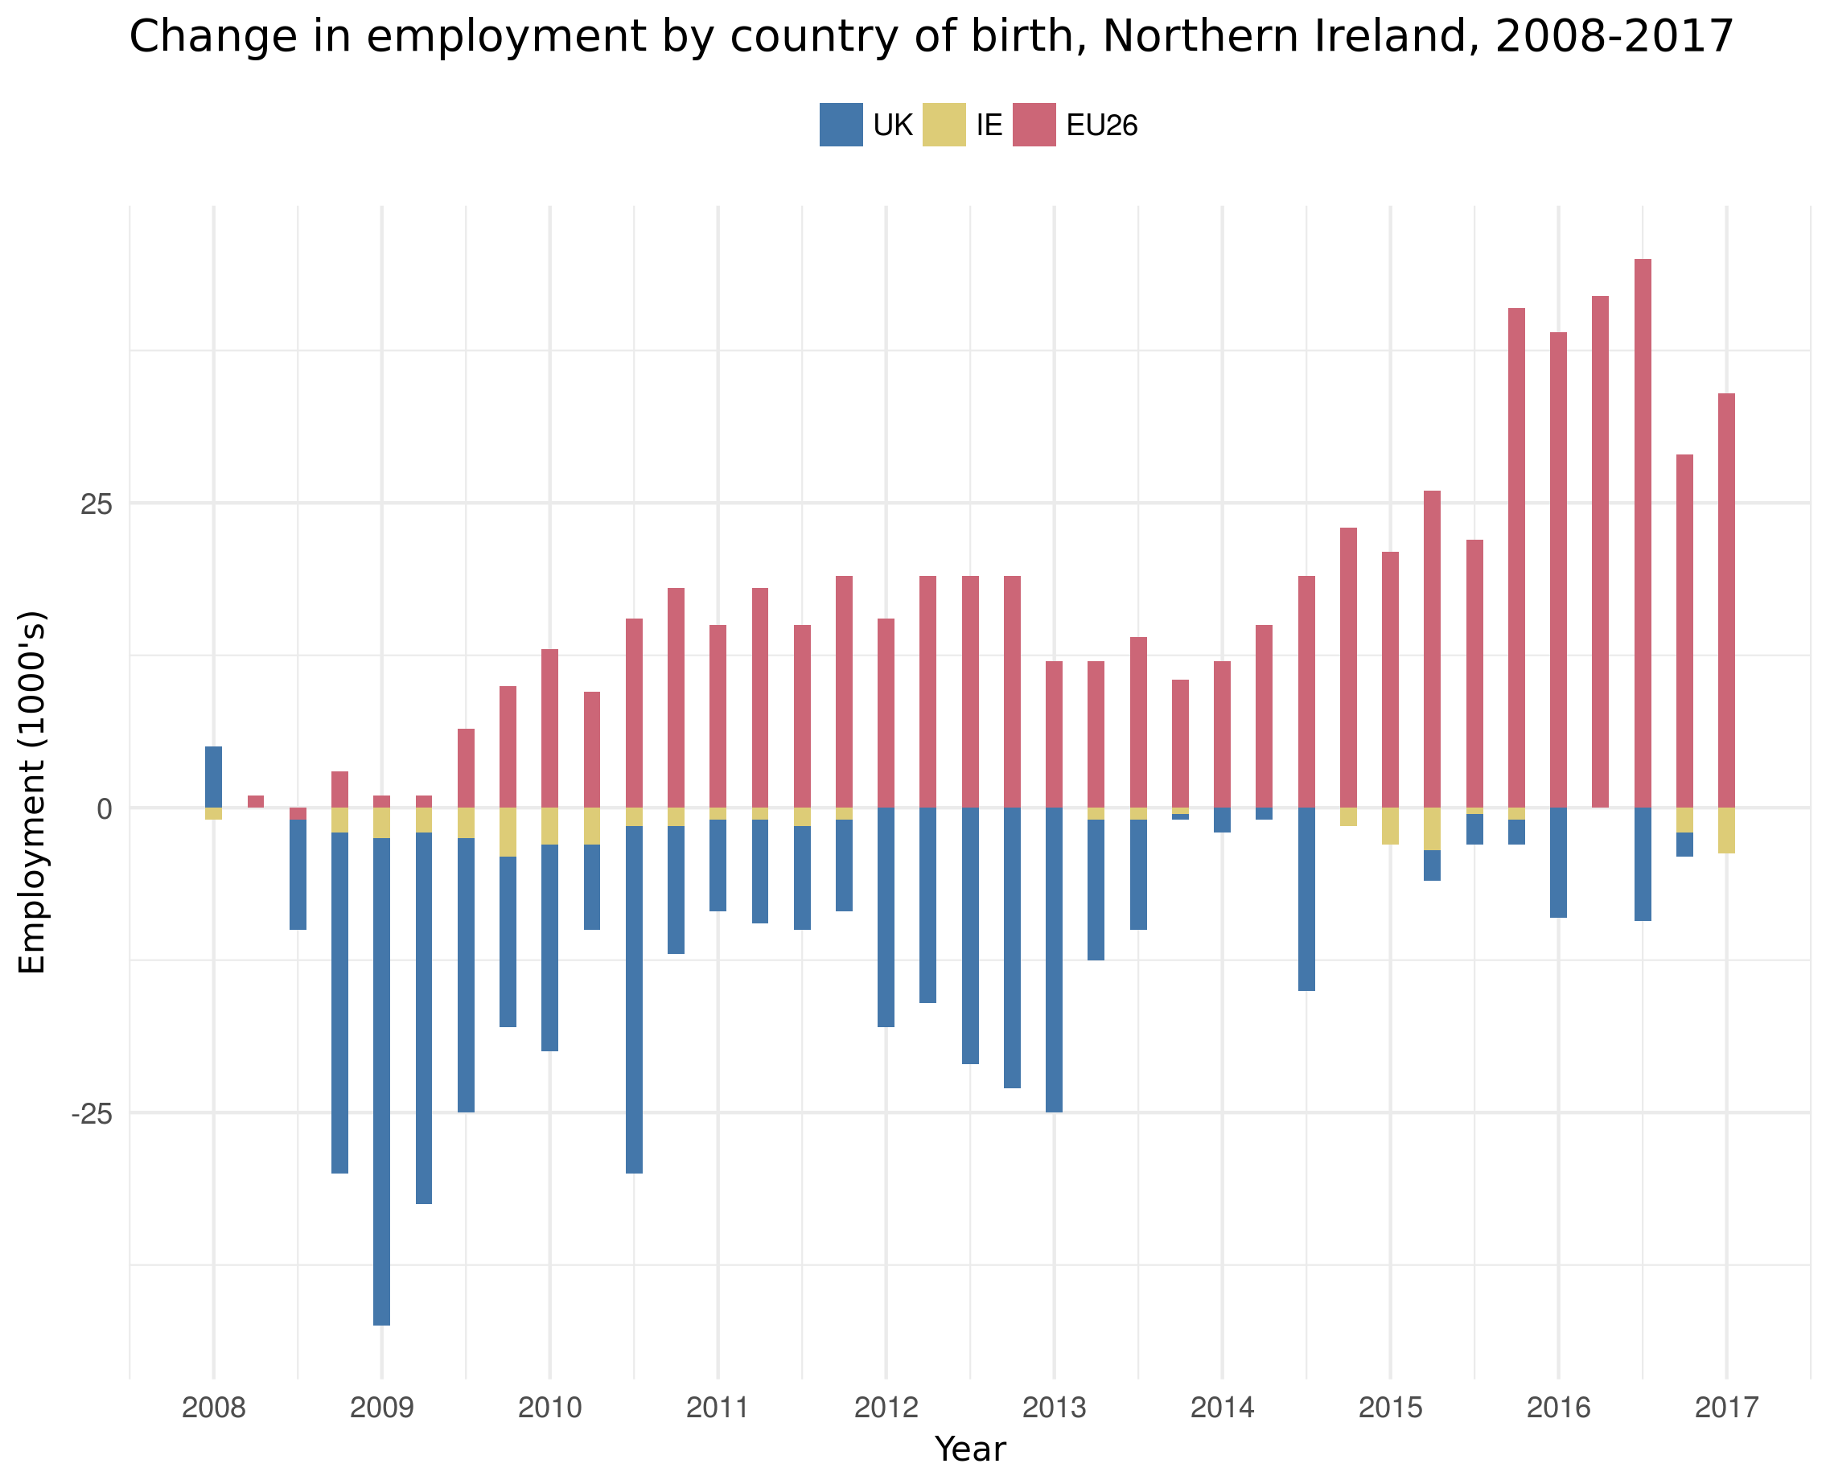

GENERAL DISCUSSION TO BE FIXED UP BY AMCG

* With only 3 percent of the UK’s population, firms in Northern Ireland have traditionally struggled to attract workers from management level right down to low-skilled workers.

* During the last two decades, the business community in Northern Ireland has benefited hugely from the free movement of skilled workers. Indeed, productivity data for the region shows that in the last number of decades, the biggest productivity gains were attained during 2003-2007 when Eastern European migrant workers came to live in Northern Ireland.
* Immigration has played a vital role by supplementing skills and plugging skills gaps, which is critical for success of the industrial strategy.
* In the last decade, NI employment growth has been largely reliant on migrant labour. DfE statistics suggest that between 2008-2016 the number of people in employment in NI rose by 36,000. At the same time the number of EU-born people in employment rose by 40,000.
* However, businesses are reporting that a growing number of long-established migrant employees are leaving Northern Ireland. Crucially, and for the first time, those leaving are not being replaced by new arrivals. DfE statistics suggest that the number of EU nationals (excluding Irish citizens) employed in Northern Ireland has fallen from 54,000 at the end of June 2016 to 40,000 by the end of March 2018 – a drop of 26%.
* Regional unemployment is 3.3% with average unemployment levels in several rural Council areas below 2%. In CBI NI’s 2017 migration survey, 96% of firms believed that Northern Ireland is facing a growing skills shortage.
* Northern Ireland’s employers are facing a growing skills shortage. Firms need continued access to low & high skilled migrant labour to support economic prosperity in the region
* The latest labour market statistics from NISRA (2017) show that private sector employee jobs have grown to a series high in June 2017 (547,170 jobs), to now stand at 6.2% above a series peak which occurred in June 2008. However, NISRA report that there is some evidence that the annual growth in private sector jobs is slowing (from 17,130 over the year to June 2016 to 10,700 over the year to June 2017).

*:*

* But immigration must not only be viewed through the narrow prism of being about filling domestic skills shortages. Overseas workers bring fresh ideas, added diversity, and unique skills sets which cannot be replicated and are critical for success of the industrial strategy. Migrants often bring unique cultural understanding or specialist knowledge which indigenous workers cannot provide, even if trained to the highest degree.
* Today’s firms are operating in a global environment and if they are not able to access the world’s top talent, from academia to engineering to life sciences, then they will be at a distinct competitive disadvantage. Language proficiency is a prime example where there are not enough local workers with the necessary skills, this forces local businesses to recruit native speakers to fill the language skill gap.

# B. Population Projections

### Actual and projected natural change and net international and rest of UK migration, Northern Ireland

Inward migration brings benefits to Northern Ireland’s demography, economy and society. The demographic benefits of migration are made clear in projections from the ONS regarding Northern Ireland's future population growth. This Figure demonstrates these projected trends.

There are projected to be more births than deaths in every year going forward, but the level of this positive natural change is to decline from its peak of x in 2011 to y by 2041.

Each year for the next 25 years all of Northern Ireland's population growth is projected to come this (declining) natural change. (Note see Page 3 NICS)

In Figure 6 below international migration is based upon NISRA projections which have not included a tightening of immigration restrictions in a post-Brexit world. However, UK Government policy ambitions to reduce immigration to “tens of thousands” combined with the impact of Brexit would suggest that international migration to Northern Ireland will decline further, which would further inhibit Northern Ireland's population growth.

**Figure 6.**

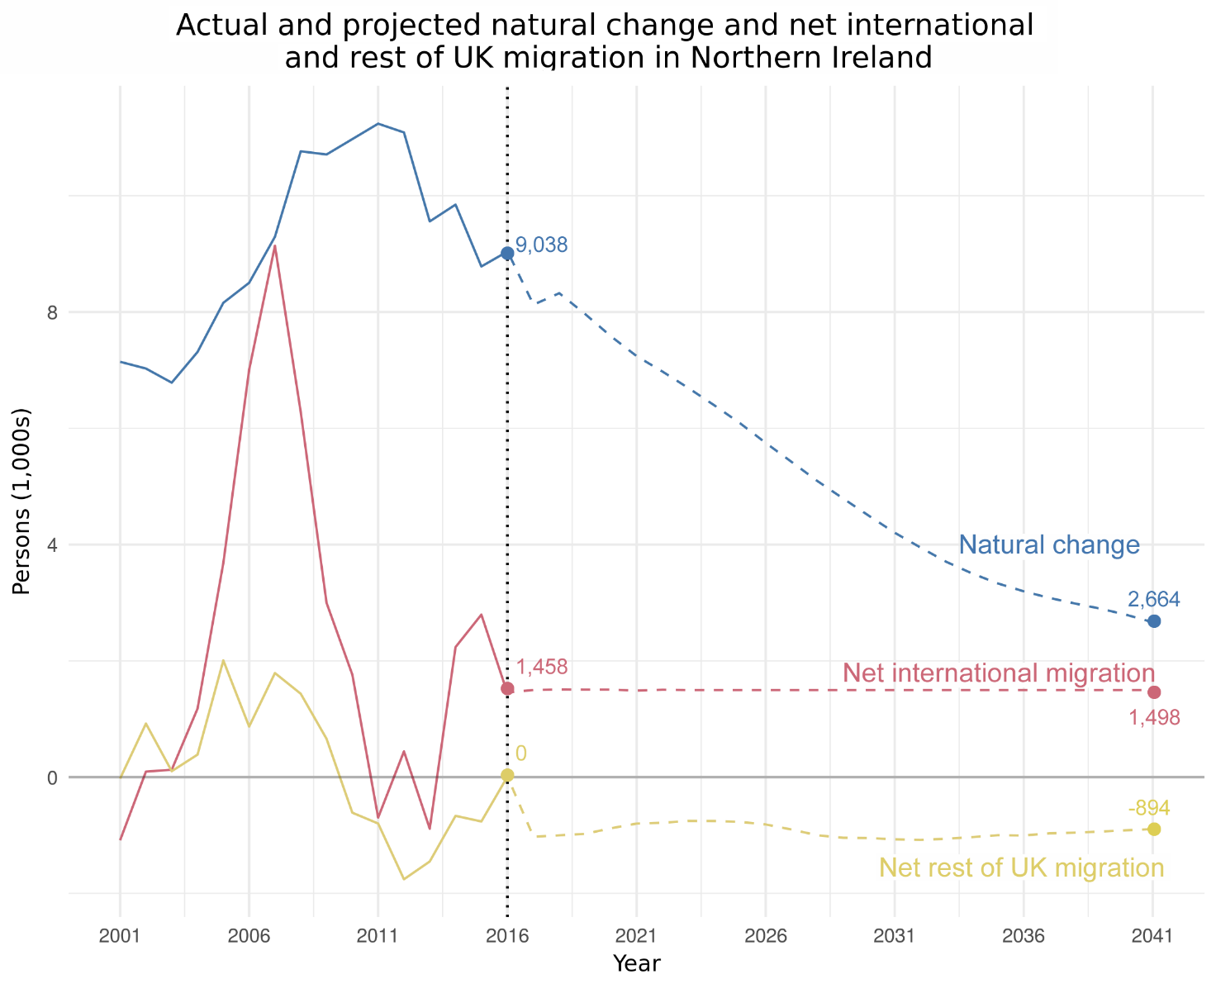

**Source:** *Northern Ireland Principal Population Projection Summary (October, 2017), ONS*

### Figure 7. Estimated and projected age structure of the Northern Irish population, mid-2016 and mid-2041

**Source:** *Projected populations at mid-years by age last birthday in five year age groups, Northern Ireland (October, 2017), ONS*

The age profile of the population will also change, as Figure 7 below shows. The proportion of the population of state pension age will increase by over 30% in the coming years as the Baby Boomer generation reaches retirement. People aged 75 and over are projected to be the fastest growing age group in Northern Ireland, increasing by 64% over the next 25 years. This trend is expected to

put significant strain on health and social care resources.

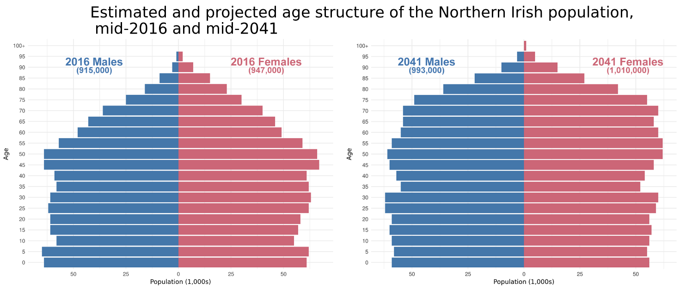

**Health:** In common with advanced economies across the world, the Department of Health in NI has been striving to transform how it delivers and manages health and social care to meet the population needs. In 2011 a review of healthcare delivery by the Department of Health set out a vision and strategy for responding to the many challenges that the health sector faced.

Transforming your Care set out a shared view of how that transformation would take place and a huge component was the reallocation of resources from secondary care to the primary and community care sectors. Private sector companies charged with delivering that community care for the NHS however are encountering severe problems accessing staff to fulfil those contracts.

Private sector health and social care suppliers have reported in 2018 that they must now turn down a significant proportion of tendering for new contracts because they have no staff to carry out the work. Should this continue to be the case there will be a problem for NI’s NHS to transform its delivery model, make the necessary savings and improve patient outcomes.

Figure 8. Projected population by age group, Northern Ireland, 2016-2041

**Source:** *Projected populations at mid-years by age last birthday in five year age groups, Northern Ireland (October, 2017), ONS*

Demographic and economic benefits of migration to Northern Ireland are directly linked through growth in the working age population and the impact on tax revenue. The size of the population aged 16 to 64, which makes up most of the working age population, is very important for the economy and public finances. These individuals are more likely to be working and will be generating the highest tax receipts, for example, in income tax.

Taking factors including the changing relationship between the UK and EU, demographic change and possible future policy changes into account, we judged that the 50% less future EU migration and low migration variants of the population projections were appropriate for Northern Irish circumstances in preparing forecasts. Figures 8 and 9 demonstrate how the variants affect the age structure of the population compared to the principal projections in Northern Ireland and the UK.

**B. Population Projections**

*From CBI NI MAC response:*

* A further concern from a macroeconomic perspective, relates to Northern Ireland’s aging population. Official statistics from NISRA (2017) show that the region’s overall projected population growth over the 25 year period to mid-2041 is significantly lower than in the rest of the UK (7.6 per cent compared with 11.2 per cent). At the same time, our population is projected to age at a much faster rate.
* Out of all the UK countries, at 43.1 per cent Northern Ireland had the largest percentage growth of people aged 85 and over between mid-2006 and mid-2016. The population aged 65 and over in NI is projected to increase by 65.1 per cent to 491,700 people from mid-2016 to mid-2041, with the result that almost one in four people (24.5 per cent) will be in this age category. The population aged 85 and over is projected to increase by 127.2 per cent to reach 82,800 people over the same period, which will see their share of the population doubling from 2.0 per cent to 4.1 per cent.
* These demographic changes will serve to put much more pressure on the dependency rate in Northern Ireland. In NI, the dependency rate for children has fallen from two thirds of the total number of dependents to just over a half (55.3%) in 2016 as the ratio of children to working age people declined.
* Simultaneously, the dependency ratio of people of pensionable age has been rising and is expected to increase from 271 per 1,000 people of working age to 377. For Northern Ireland, these population statistics are a stark reminder that employers will need to access young international workers as the local pool of working age people diminishes.
* From a macroeconomic perspective, any restrictions on Northern Ireland’s private sector to access people will reduce the economy’s ability in the future to be self-sufficient. Given this demographic backdrop and the additional costs of the ageing population, it will require significantly increased subventions from HM Treasury if living standards in Northern Ireland are to be maintained; migration of working people from inside and outside the EU is one of the most realistic ways of mitigating our reliance on Westminster funding in the future. In summary, any ambitions to re-balance Northern Ireland’s public and private expenditure will be thwarted by limited access to immigration.
* The CBI therefore strongly recommends that any migration system for Northern Ireland is evidence-based and takes into consideration the full range of influencing factors such as population trends as outlined above. Both the long-term and short-term consequences of any change to migration policy must be fully analysed.
* Immigration is not just a skills issue though. Against a backdrop of low unemployment and an ageing workforce, more than a third (35%) of businesses view access to labour supply as a threat to the UK’s labour market competitiveness. This is a rising concern, with half (50%) believing it to be a threat to competitiveness in five years’ time.

Owen - Can we define – assumptions on Low Immigration / 50% future EU immigration and Principal Projection for Figures 8 and 9

Figure 8

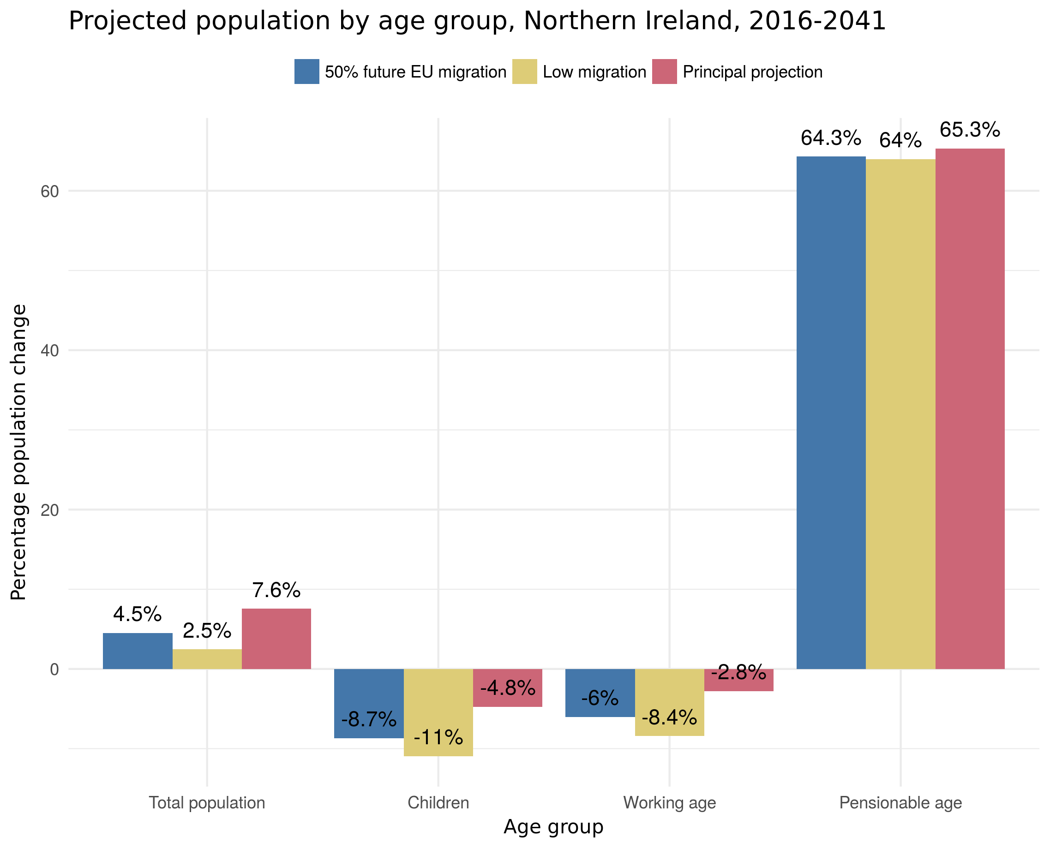

### Figure 9. Projected population by age group, UK, 2016-2041

**Source:** *Projected populations at mid-years by age last birthday in five year age groups, UK (October, 2017), ONS*

Figures 8 and 9 highlight the great significance of migration to Northern Ireland's population growth relative to the rest of the UK, and the greater exposure Northern Ireland faces to reduced inward migration as a consequence of UK policy changes. This outcome would severely impact Northern Ireland's economic prospects.

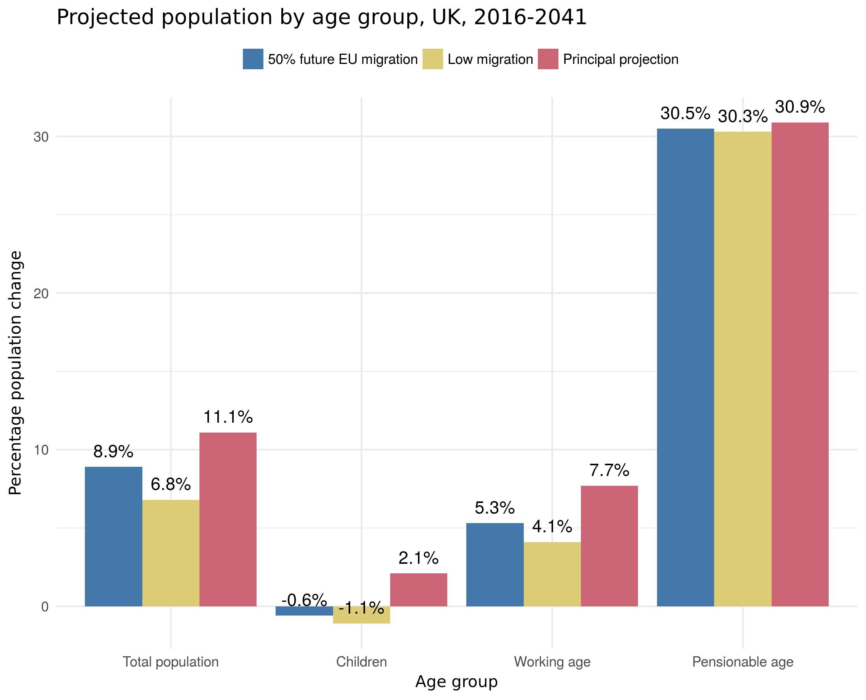

# C. People and Places

### Figure 10. Sub-regional projected percentage change in total population, 2016-2041

**Source:** *2016-based population projections for areas within NI (April, 2018), NISRA*

A projected reduction in migration due to Brexit will impact different areas of Northern Ireland in different ways.

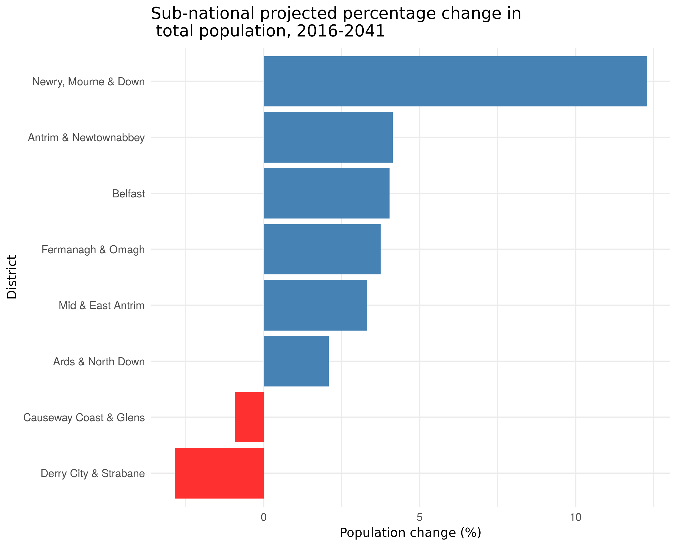

### Figure 11. Projected population change, Northern Ireland, 2016-2041

Possible to [provide a scale (colour)

**Source:** *2016-based population projections for areas within NI (April, 2018), NISRA*

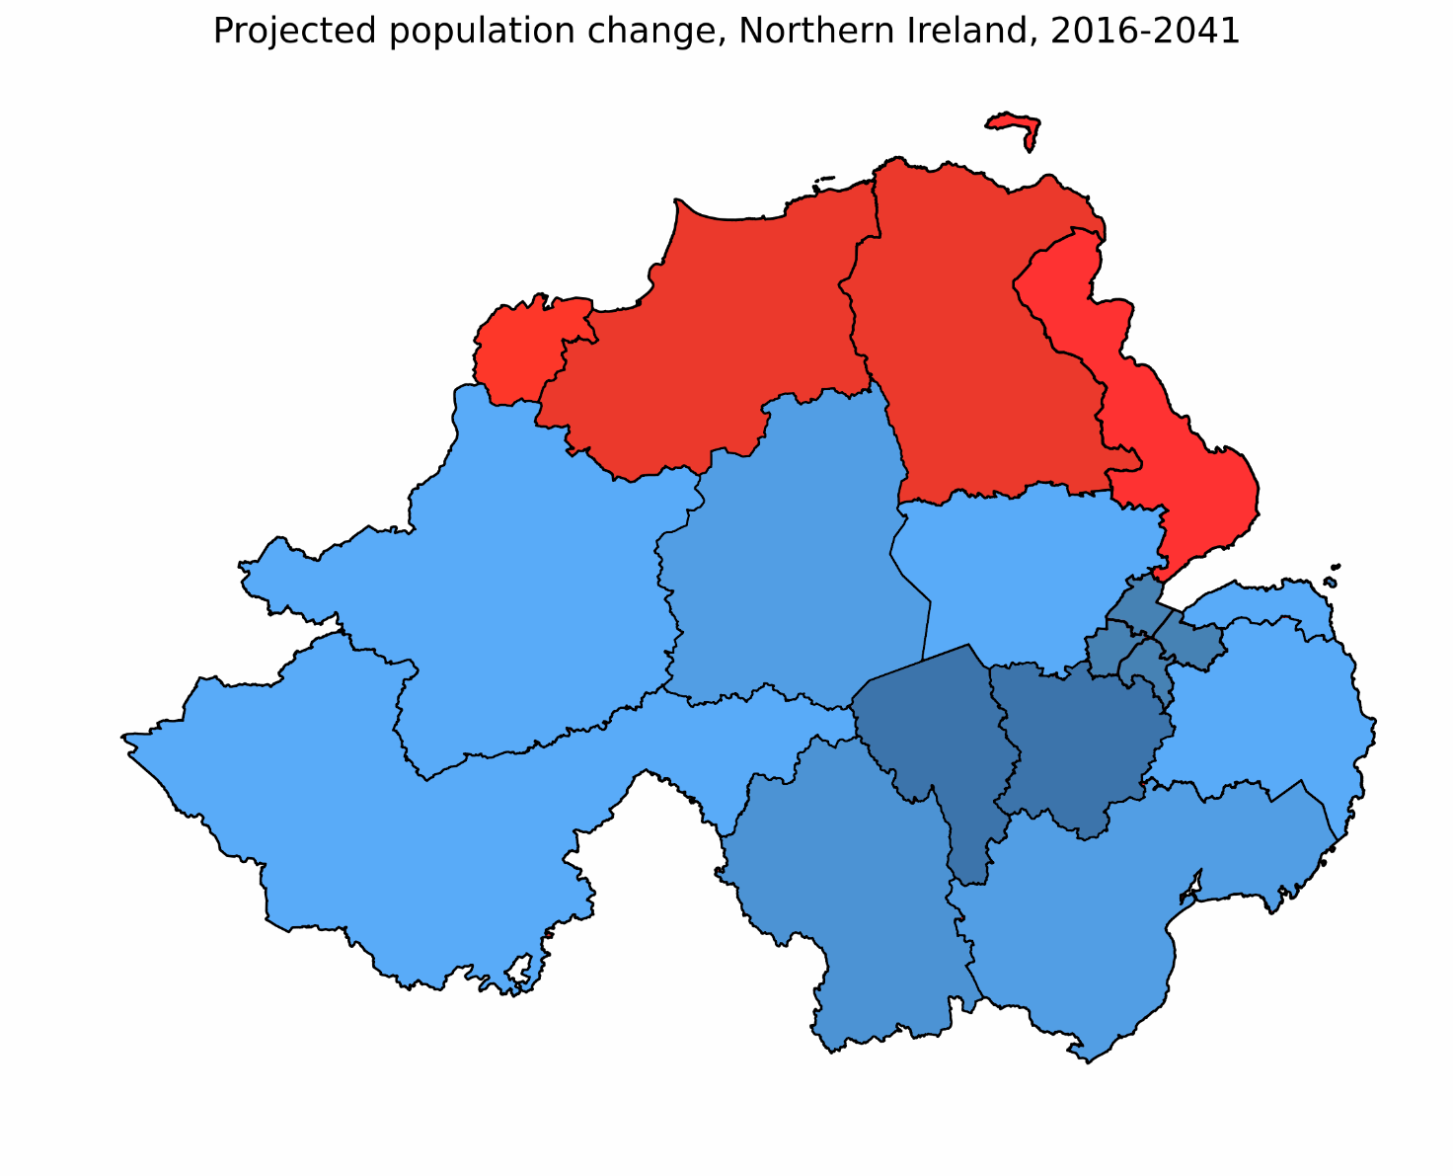

# D. Economic Growth

### Figure 12. Historical and projected population, Northern Ireland, 1901-2116

**Source:** *Components of change (mid-year to mid-year), total fertility rate and expectation of life at birth based on the mortality rates for the year (October, 2017), ONS*

The Brexit driven reduction in migration is simulated through the economic model and the size of the shocks are estimated by calculating the percentage change in working age population between the two projections. We use the low migration variant as the main driver for simulating the impact of Brexit. This data is fed into the DSGE simulation of a labour shock.

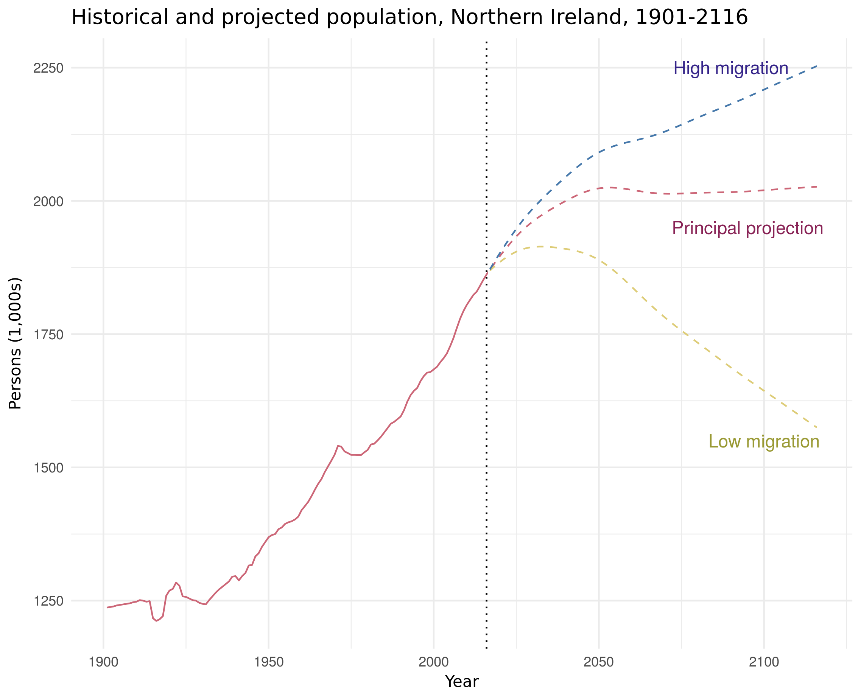

### Figure 13. Northern Irish net overseas migration, historical and projections, 2001-2041

**Source:** *Components of change (mid-year to mid-year), total fertility rate and expectation of life at birth based on the mortality rates for the year (October, 2017), ONS*

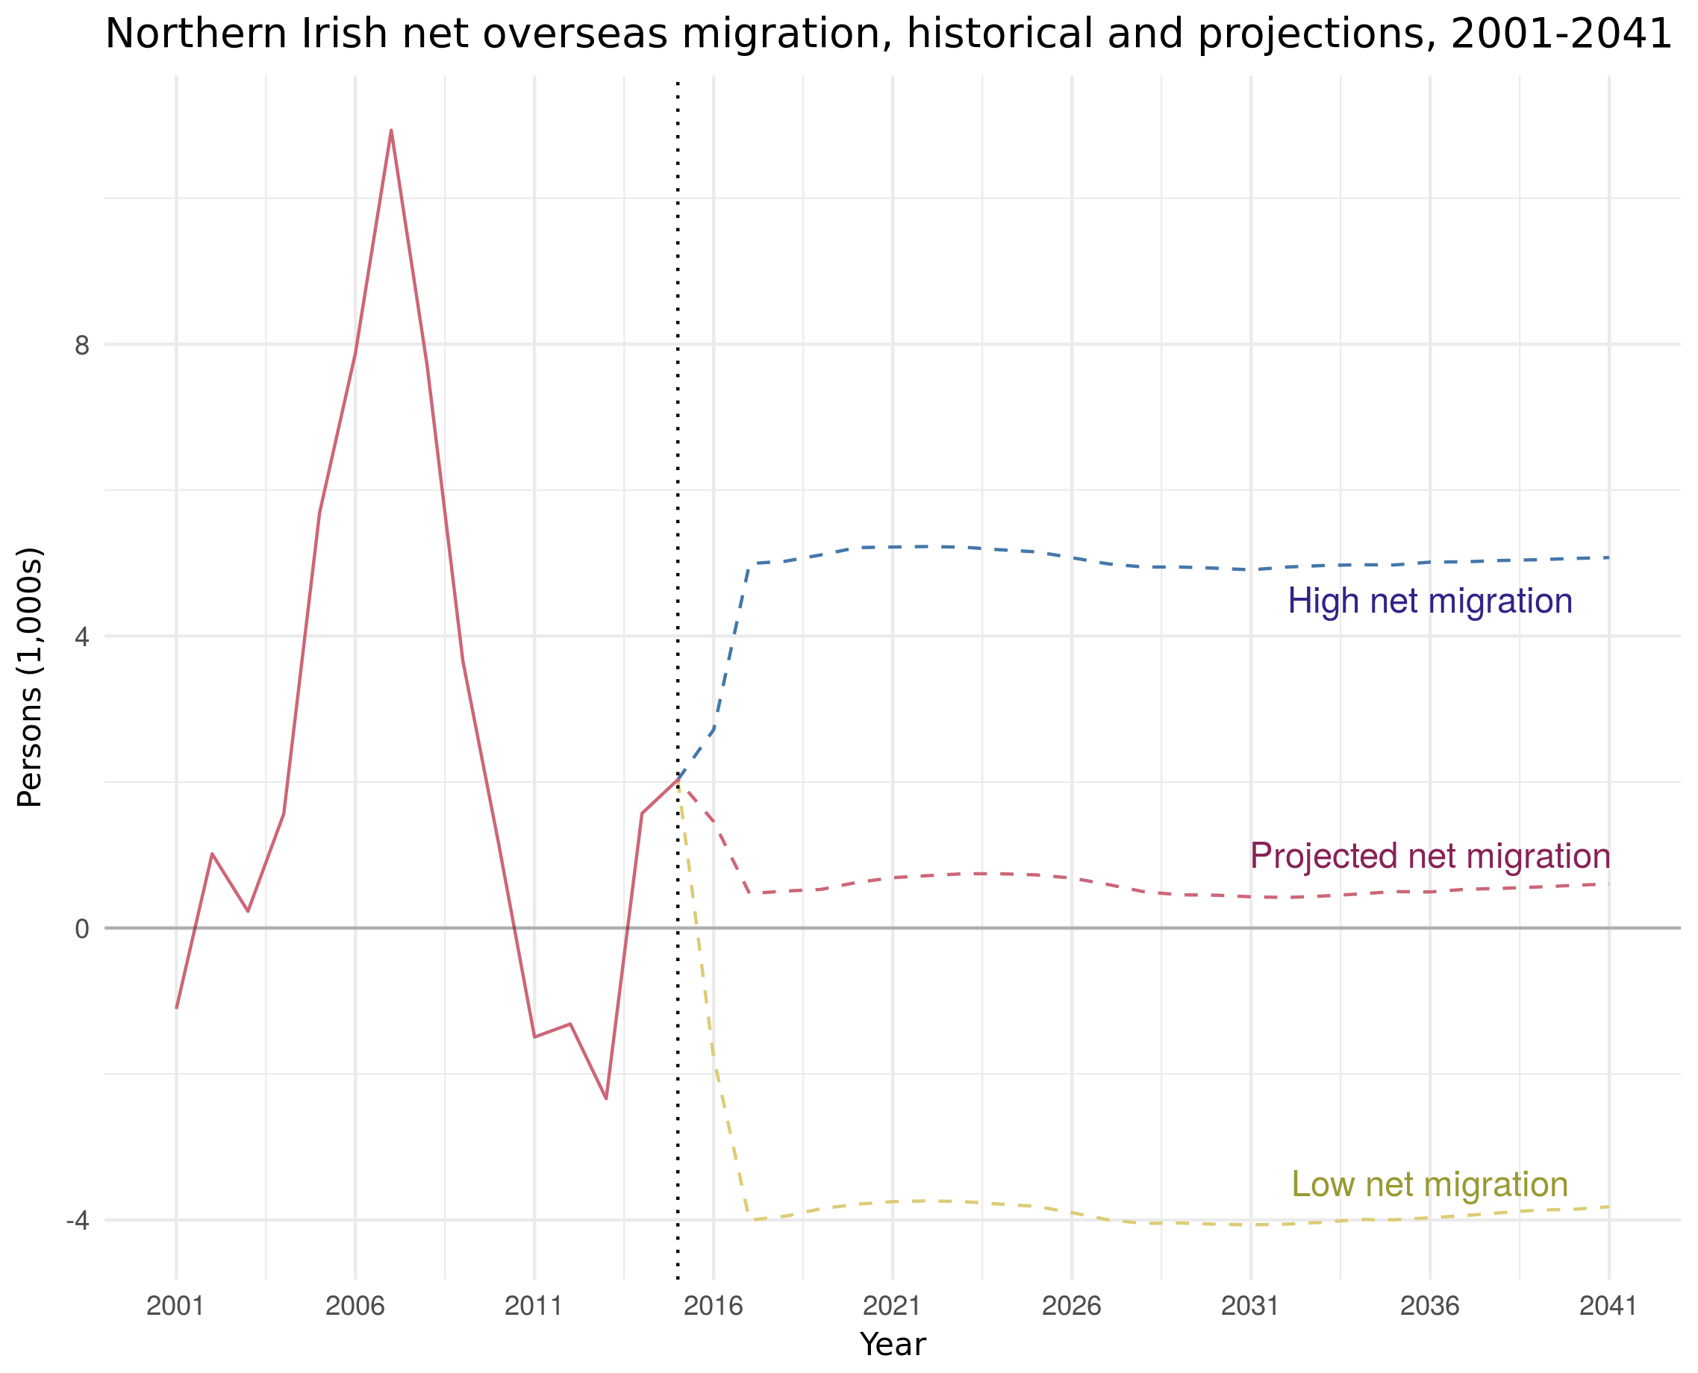

### Figure 14. DSGE model simulating the impact of a negative labour shock

Resulting plot showing the trajectories of capital (K), income (Y), consumption (C) and investment (I) due to a collapse of labour (L).

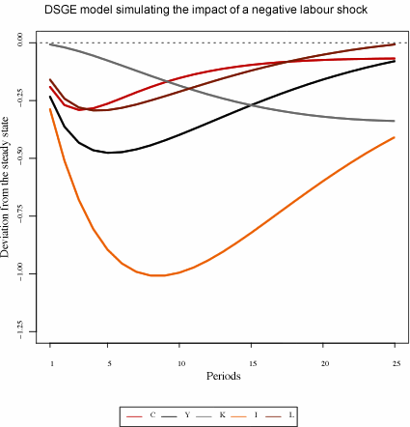

### Figure 15. Projected change in real GDP, Northern Ireland and rest of UK, 2016-2041

The projected cumulative collapse of real GDP over the simulated 25 year period.

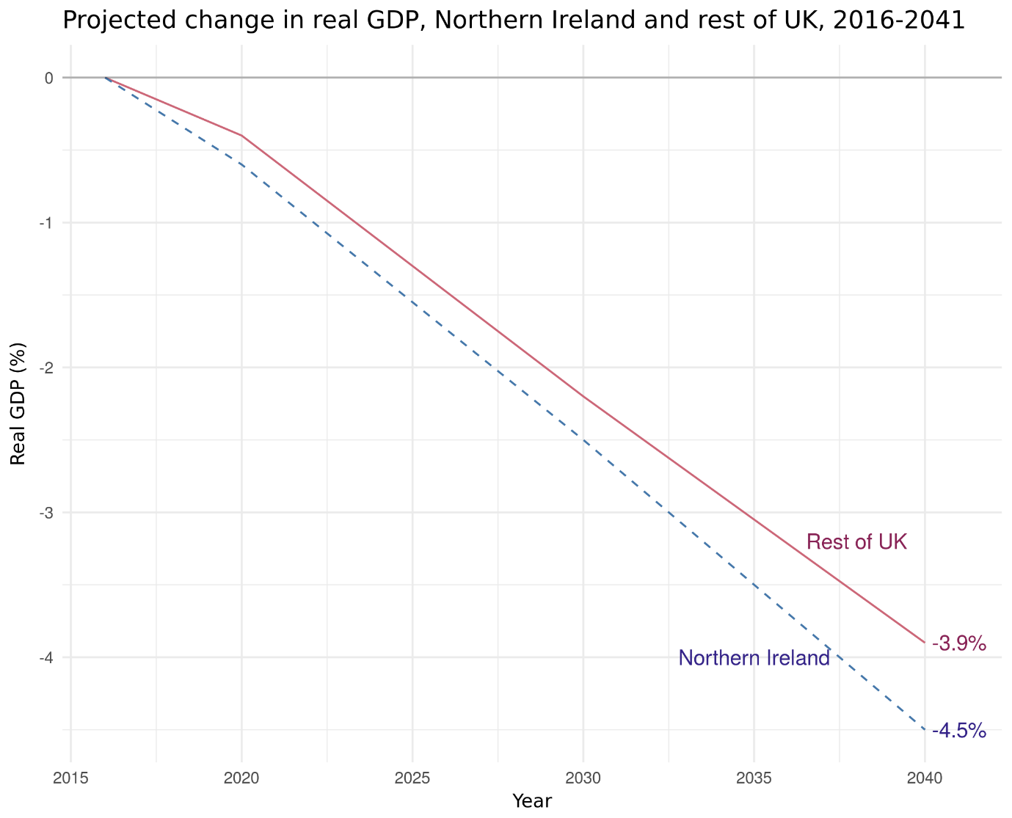

### Figure 12. Historical and projected population, Northern Ireland, 1901-2116

*From CBI NI MAC response:*

* **Competitiveness:** If firms in Northern Ireland cannot access the labour they need, many will decide to focus their future investments in the Republic of Ireland. Here the option of relocating to the Republic of Ireland is far easier than it is for firms operating elsewhere in the UK to relocate overseas. Already, uncertainty over future access to EU labour and skills is causing firms to consider relocating more seriously. Several businesses, particularly larger firms, have already signalled that they have already started exploring re-location opportunities. A number have already purchased facilities in the Republic of Ireland and others are considering expanding facilities they already possess.
* **Agri-food:** The NI Food & Drink Association has estimated that 48% of their member’s full-time employees, and 91% of seasonal contract agricultural workers, are EU nationals.[1] While local firms do not wish to be so reliant on European labour, they recognise that these workers are not replacing indigenous labour but instead are addressing important shortages in the regional labour market. Without access to European labour the agri-food sector cannot grow and contribute to the Executive’s efforts to rebalance the regional economy.
* **Health:** *Transforming your Care* set out a shared view of how that transformation would take place and a huge component was the reallocation of resources from secondary care to the primary and community care sectors. Private sector companies charged with delivering that community care for the NHS however are encountering severe problems accessing staff to fulfil those contracts. They have reported that they must now turn down a significant proportion of tendering for new contracts because they have no staff to carry out the work.
* **Tourism:** By 2020, the tourism sector in NI aims to double the contribution to GDP and generate £1bn in tourism spend, creating 10,000 new jobs in the process. These ambitions cannot be achieved without access to migrant workers. This sector currently relies heavily on a strong supply of migrant labour and ambitions to grow requires that an international pool of workers remains accessible.
* **Construction:** Having experienced the worst housing crash in Europe back in 2008, Northern Ireland’s construction sector is only just recovering in terms of economic activity. In March 2016, the Construction Industry Training Board (CITB) commissioned a skills and training survey. The survey found that right across the UK this sector had common themes around recruitment difficulties and skill shortages, skills deficiencies and gaps in established workforces as well as training and development activity. Construction firms in Northern Ireland report the same issues and additionally note that the industry has really struggled to attract young people as the sector’s turbulent past during 2007-2014 – which resulted in parents encouraging young people to bypass this sector for job security reasons. NI construction companies have expressed concerns about bidding for further work as they currently face skills shortages. Attracting international workers into this sector will also be crucial if NI is to realise its ambitions for infrastructure delivery in terms of roads and housing.
* **Manufacturing:** CBI members report skills shortages in a range of manufacturing sub-sectors. While there is a significant need for lower and mid-tier skills in the manufacturing sector there is also a significant need for high-level skills too. For example, the regional manufacturing sector extends to knowledge intensive areas such as medical diagnostics, pharmaceuticals, food nutrition, aerospace and plastic composites and engineering. Companies report the need to attract qualified engineers (chemical, design as well as project management engineers), chemists and graduates with PhDs from across Europe to meet their business needs. Any restrictions on that access to professional talent will severely restrict Northern Ireland’s ambition to grow its knowledge economy.
* **Universities:** Securing a sustainable Higher Education system is vitally important as today’s young people will drive tomorrow’s economic growth. We must, therefore, nurture their talent so that our students can maximise their potential as global citizens. Local universities have expressed deep concerns that restrictions on the freedom of movement between European countries will have implications for thousands of NI students who go to Europe to study or engage on work exchange programmes.
* Investment in research and development by local businesses has never been higher, although there is still more to do if we are to reach our knowledge economy growth ambitions. It is essential therefore that both businesses and universities in NI will continue to have access to research funding opportunities as well as have access to the best international research staff to work on collaborative projects. The most successful universities globally are those that can attract world-leading talent.
* For example, Queen’s University in Belfast currently employs 764 EU staff members (479 EU academics and researchers as well as 285 EU Professional Support staff). Future limitations on the freedom of movement of talent into Northern Ireland could potentially jeopardise both of our local universities ability to produce world-class research - which is determined by their ability to collaborate on global projects and attract the best of international talent. Beyond damaging our universities’ future research capabilities, this dent to their global competitiveness will be further amplified if local universities have restricted access to research funding and income from international students. Currently, QUB has 1,010 EU students enrolled for the 2016-17 academic year.

Summary (to be done by AMCG):

* Prior to its dissolution the local Executive was taking steps to address Northern Ireland’s economic fragility through its own regionally focused Industrial Strategy which envisioned “*a globally competitive economy that works for everyone.”* This vision required Northern Ireland to transform its economic competitiveness, grow the private sector and increase wealth. Such objectives however are highly correlated with rising productivity and access to talent. Local companies argue that the private sector simply cannot grow and deliver industrial strategy goals if access to European migrant labour is unduly curtailed.

1. *Brexit: Challenges & Opportunities for Northern Ireland Food & Drink, NIFDA, November 2016*