COUNTY LEVEL PERFORMANCE ANALYSIS
2022 Kitui Governor: Total votes by candidates

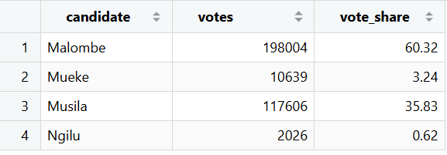
The table summarizes total votes and vote share for each gubernatorial candidate in Kitui County.
- Malombe had the highest votes (198,004) and the highest vote share (60.32%), meaning he performed best.
- Musila followed with 117,606 votes (35.83%), showing moderate support.
- Mueke came in third with 10639 votes (3.24%)
- Ngilu had a lower vote total of 2026 (0.62%), indicating less voter support.
- The table makes it easy to compare exact numerical values between candidates.

Bar Chart: Total Votes By Candidates

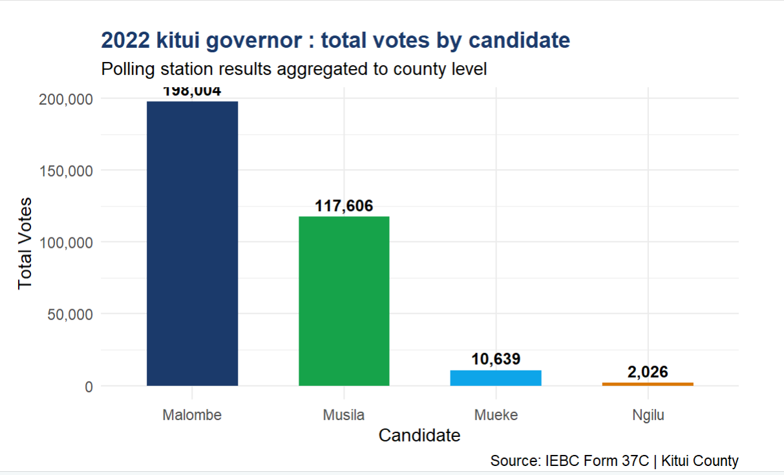
The bar graph provides a visual comparison of candidate performance in the election.

- Malombe’s bar is the tallest, showing he received the most votes.

- Musila’s bar is the second tallest, showing he was the closest competitor.

- Mueke and Ngilu have much shorter bars, indicating lower performance.

- The graph helps to identify trends and differences in votes among candidates quickly

Pie Chart of Votes Share
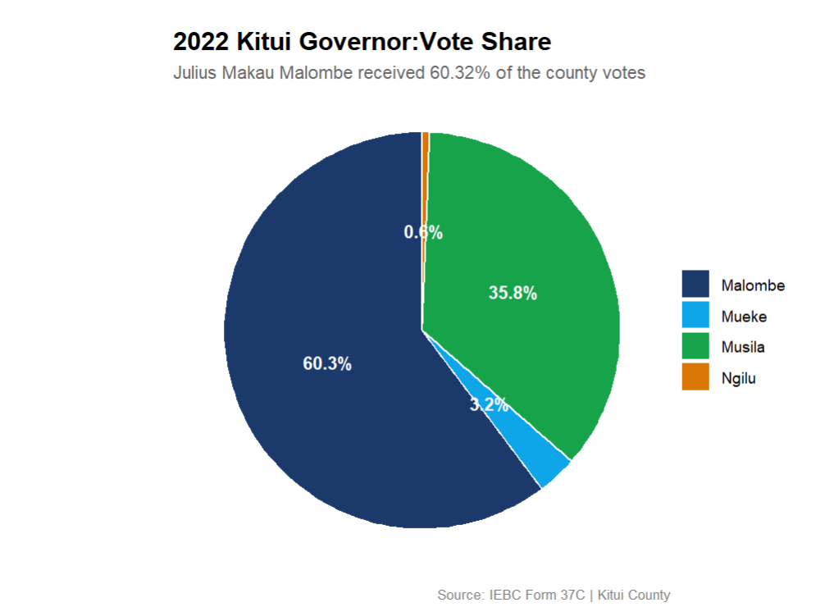
The pie chart illustrates the proportional distribution of votes among the four candidates.
- Malombe's slice is the largest, occupying 60.3% of the chart, confirming his overwhelming dominance in the election.
- Musila's slice is the second largest at 35.8%, establishing him as the only candidate who posed a meaningful challenge.
- Mueke’s slice comes in third, although it occupies a considerably smaller slice at 3.2%
- Ngilu is last with 0.6%, showing she had the least support
- Together, Malombe and Musila accounted for 96.1% of all valid votes cast, making the election effectively a two-candidate contest.
Constituency Level Votes Share Summary

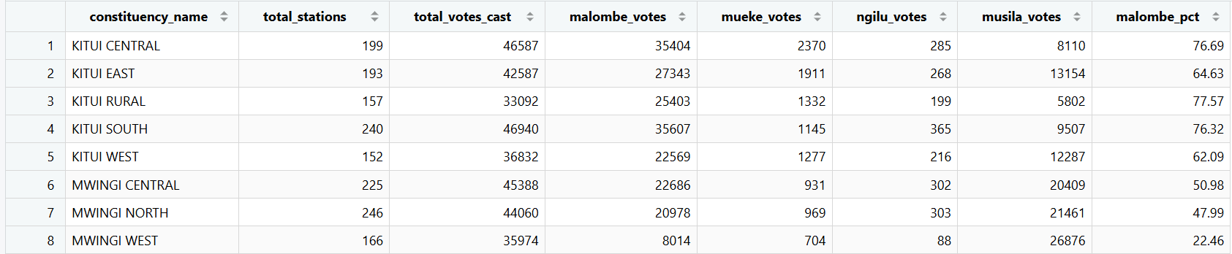

Stacked Bar Graph
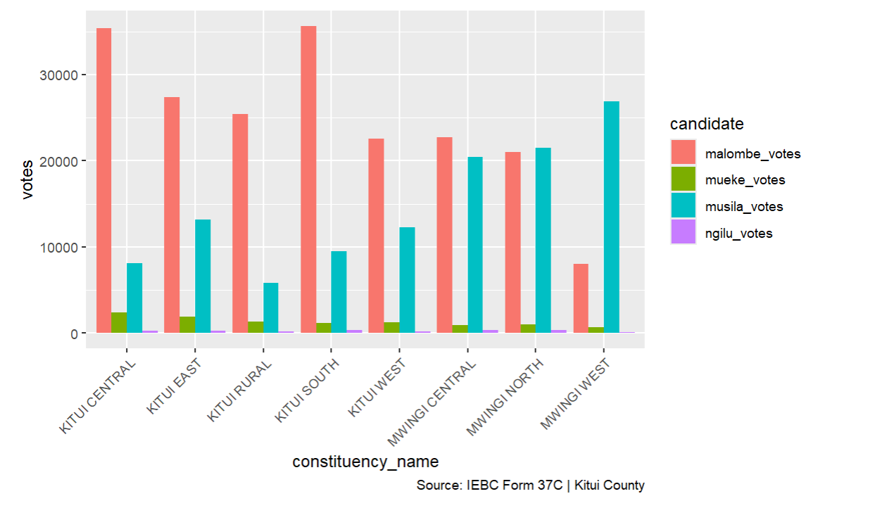
The stacked bar graph presents a constituency-level breakdown of votes received by each of the four candidates across Kitui County's eight constituencies.
- Malombe's dark blue segment is the most dominant across all eight constituencies with a total of 198,004 votes (60.32%).
- Musila's green segment is most prominent in the Mwingi constituencies, with a total of 117606 votes (35.8%).
- Mueke's light blue segment remains consistently small across all constituencies, with a total of 10,639 votes (3.2%).
- Ngilu's orange segment is barely visible across all constituencies, with her county-wide total of just 2,026 votes (0.6%).

