Character and Digits | 2280 | 855 | 35 | 28X28 | 70 | 94.15

25/25 - 1s - loss: 0.1861 - accuracy: 0.9415 - 1s/epoch - 44ms/step
Test accuracy: 0.9415204524993896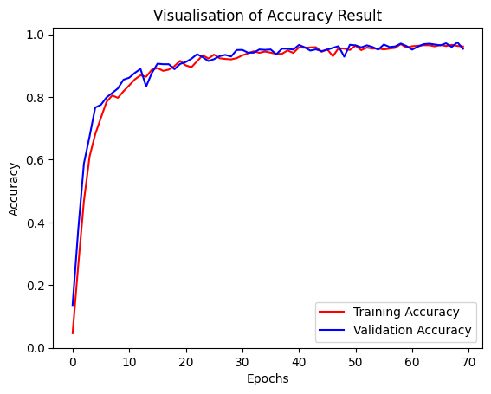
Character and Digits | 2280 | 855 | 32 | 28X28 | 70 | 96.61
27/27 - 1s - loss: 0.1065 - accuracy: 0.9661 - 1s/epoch - 43ms/step
Test accuracy: 0.9660818576812744 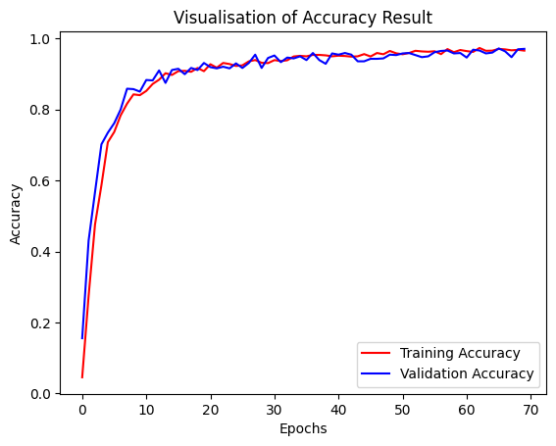

Character and Digits | 2280 | 855 | 36 | 28X28 | 70 | 97.42

24/24 - 1s - loss: 0.0813 - accuracy: 0.9743 - 1s/epoch - 45ms/step
Test accuracy: 0.9742690324783325
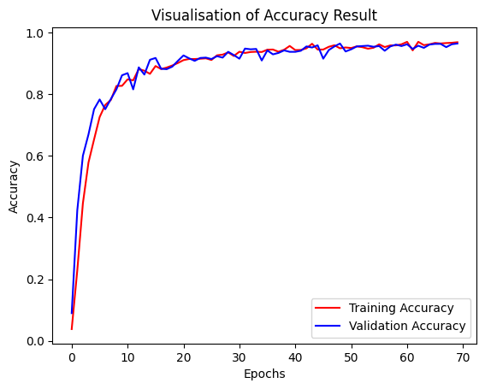
Character and Digits | 2280 | 855 | 34 | 28X28 | 70 | 95.32

26/26 - 1s - loss: 0.1354 - accuracy: 0.9532 - 1s/epoch - 42ms/step
Test accuracy: 0.9532163739204407

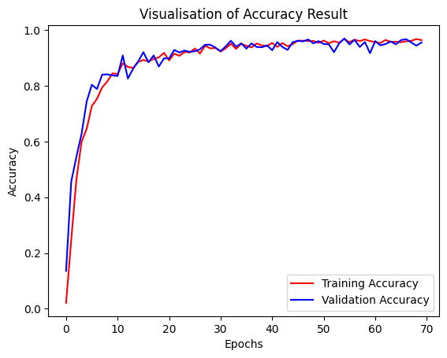
26/26 - 2s - loss: 0.0478 - accuracy: 0.9871 - 2s/epoch - 63ms/step
Test accuracy: 0.9871345162391663
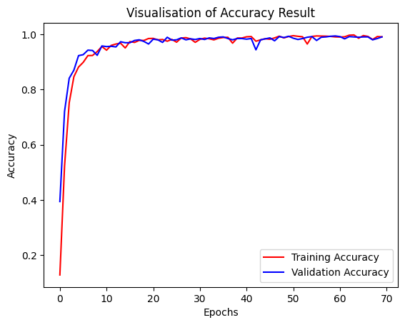
Character and Digits | 2280 | 855 | 36 | 28X28 | 50 | 93.68

24/24 - 1s - loss: 0.1868 - accuracy: 0.9368 - 1s/epoch - 52ms/step
Test accuracy: 0.9368420839309692
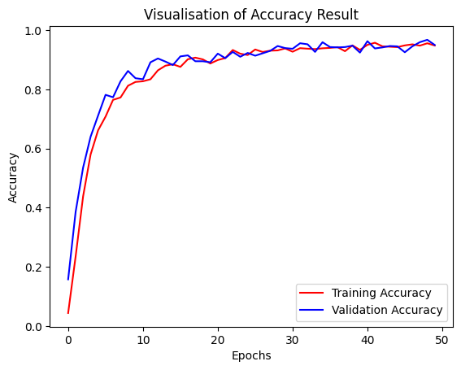
Character and Digits | 2280 | 855 | 35 | 28X28 | 50 | 95.2
25/25 - 1s - loss: 0.1421 - accuracy: 0.9520 - 1s/epoch - 47ms/step
Test accuracy: 0.952046811580658
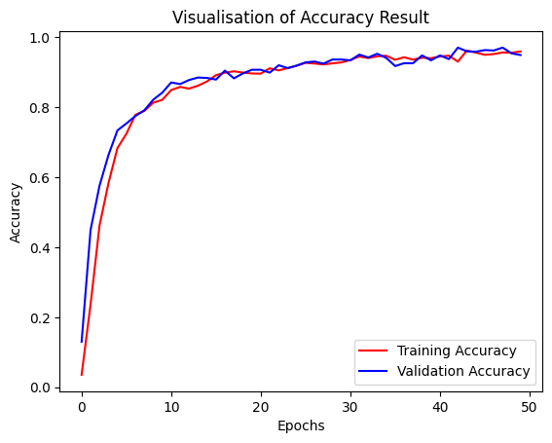
Characters and Digits | 2280 | 855 | 34 | 28X28 | 50 | 92.63
26/26 - 3s - loss: 0.2025 - accuracy: 0.9263 - 3s/epoch - 110ms/step
Test accuracy: 0.9263157844543457 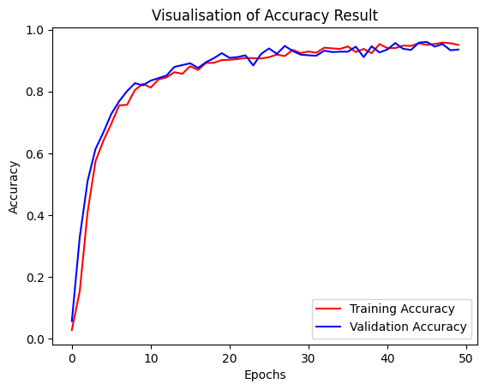
Characters and Digits | 2280 | 855 | 32 | 28X28 | 50 | 95.55

27/27 - 1s - loss: 0.1354 - accuracy: 0.9556 - 1s/epoch - 46ms/step
Test accuracy: 0.9555555582046509
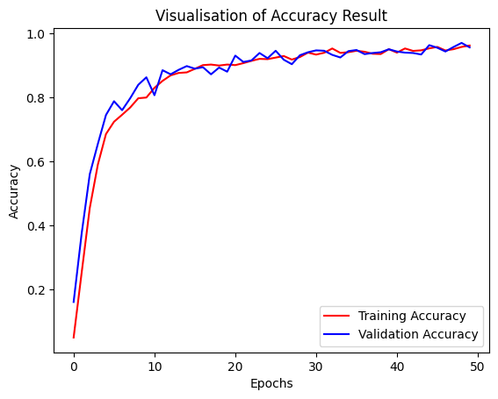
Model: "sequential"
_________________________________________________________________
Layer (type) Output Shape Param #
=================================================================
conv2d (Conv2D) (None, 26, 26, 32) 896

max_pooling2d (MaxPooling2 (None, 13, 13, 32) 0
D)

conv2d_1 (Conv2D) (None, 11, 11, 64) 18496

max_pooling2d_1 (MaxPoolin (None, 5, 5, 64) 0
g2D)

conv2d_2 (Conv2D) (None, 3, 3, 128) 73856

max_pooling2d_2 (MaxPoolin (None, 1, 1, 128) 0
g2D)

flatten (Flatten) (None, 128) 0

dense (Dense) (None, 512) 66048

dense_1 (Dense) (None, 57) 29241

...
Total params: 188537 (736.47 KB)
Trainable params: 188537 (736.47 KB)
Non-trainable params: 0 (0.00 Byte)

