RECRUITMENT AND EMPLOYEE ATTRITION ANALYTICS: A DATA-DRIVEN ANALYSIS OF WORKFORCE RETENTION AND PERFORMANCE,
Prepared By,
Ayoola Enoch Ayo-oni,
Wetin Dey Code Academy,
September, 2026.

- Outline
- Introduction
- Data Source and Overview
- Objectives
- Data Cleaning Process
- Data Transformation, Analysis and Insights
- Visualization
- Conclusion
- Recommendations

- Introduction
Merson is a North American metals processing and manufacturing company that provides a broad range of metal products, processing, fabrication, and manufacturing solutions to customers across various industrial sectors. The company operates through an extensive network of facilities, enabling it to support customers with different metal requirements and manufacturing applications.
Merson’s services include metal cutting, machining, forming, welding, fabrication, and assembly, allowing the company to provide both standard and value-added solutions to its customers. Its operations support manufacturers and other industrial organizations that require dependable metal products and processing services for their production activities.
The company’s operations involve a diverse workforce working across different functions, including production, engineering, sales, administration, information technology, and management. These different functions contribute to the coordination of manufacturing activities, customer service, supply operations, and overall business performance.
The analysis provides insights into workforce patterns that can support data-driven human resource decision-making within the organization.

- Data Source and Overview
The dataset used for this analysis was gotten from the Kaggle.com website. It contains 312 rows and 19 columns. The Dataset includes the following fields:
Employee_Name DateofTermination
EmpID TermReason
Salary EmploymentStatus
Position Department
State ManagerName
DOB RecruitmentSource
Sex PerformanceScore
MaritalDesc Empsatisfaction
RaceDesc Absences
DateofHire

- Data Limitations
- The dataset represents employee information from a specific period and may not reflect the organization's current workforce structure, recruitment practices, or employee outcomes.
- The dataset identifies the recruitment source used for employees but does not contain detailed information about recruitment costs, time-to-hire, candidate qualifications, or the recruitment process.
- Although termination reasons are recorded, the dataset does not provide detailed qualitative information explaining the circumstances behind each departure.
- Employee performance is recorded using categorical performance classifications rather than continuous performance measurements.

- Objectives
- To analyze the employee performance across different recruitment sources.
- To examine employee attrition patterns across recruitment sources.
- To analyze the reasons for employee termination and identify the major drivers of attrition.
- To examine the relationship between department and attrition.
- To evaluate recruitment sources based on employee retention, performance, and satisfaction outcomes.

- Data Cleaning Process

Fixing column Headers: Some of the column headers were fixed to ensure easy interpretation and understanding. Such as :‘EmpID’,’DOB’,’MaritalDesc’,’RaceDesc’,’TermReason’,’EmpSatisfaction’. They were changed to the following respectively:‘EmployeeId’,‘DateofBirth’,’MaritalSatus’,’Race’,’TerminationReason,’’EmployeeSatisfaction’

Blank Space Detection and Replacement: I checked for blank cells using the find and replace function and none were found.

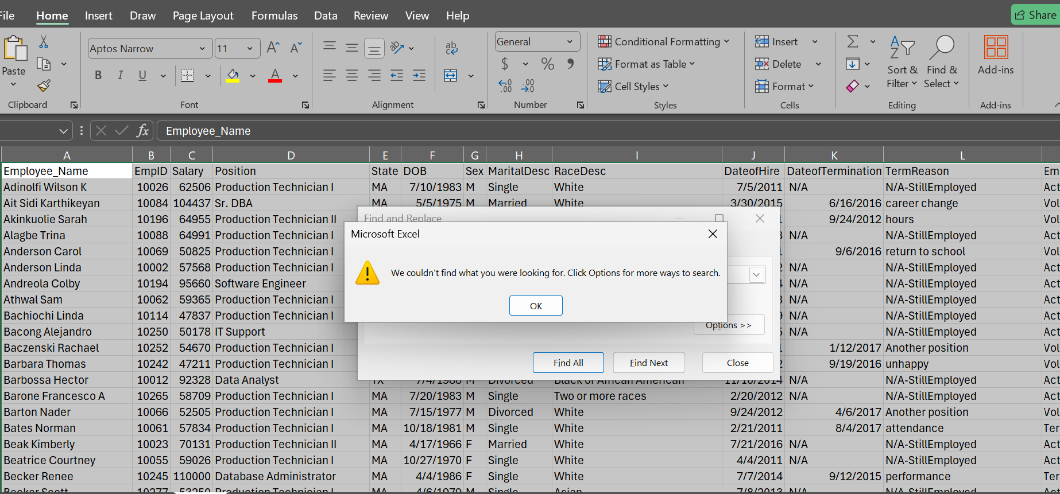

Duplicate Check and Removal: I checked the dataset for duplicate records using the Remove Duplicates feature in the Data tab. No duplicate records were found nor removed from the dataset.
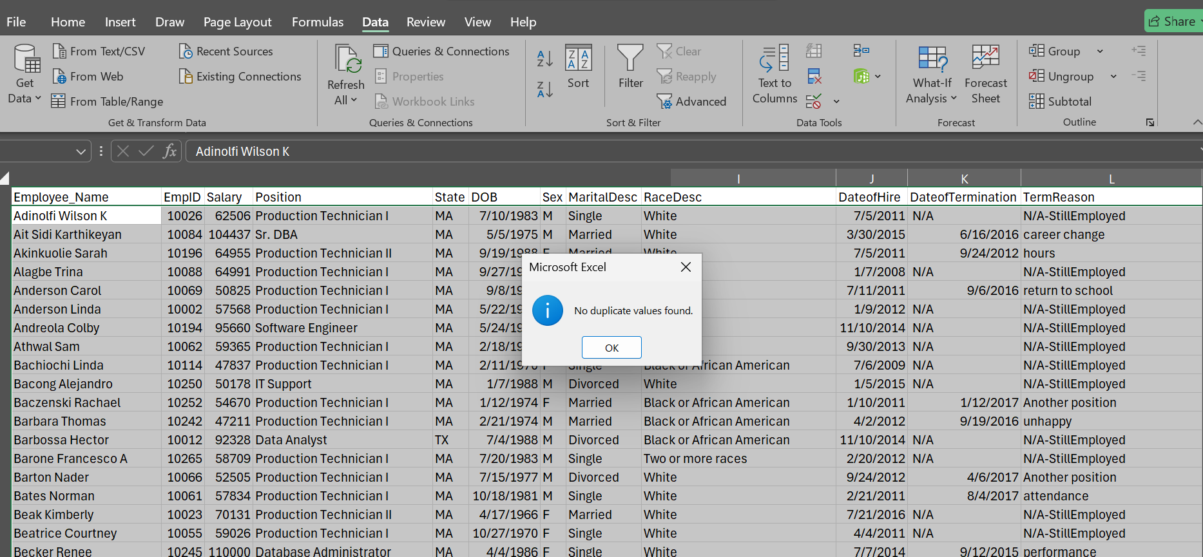
Column labeling: Recoded shorthand gender identifiers (M/F) to full text (Male/Female) to ensure clear labeling.
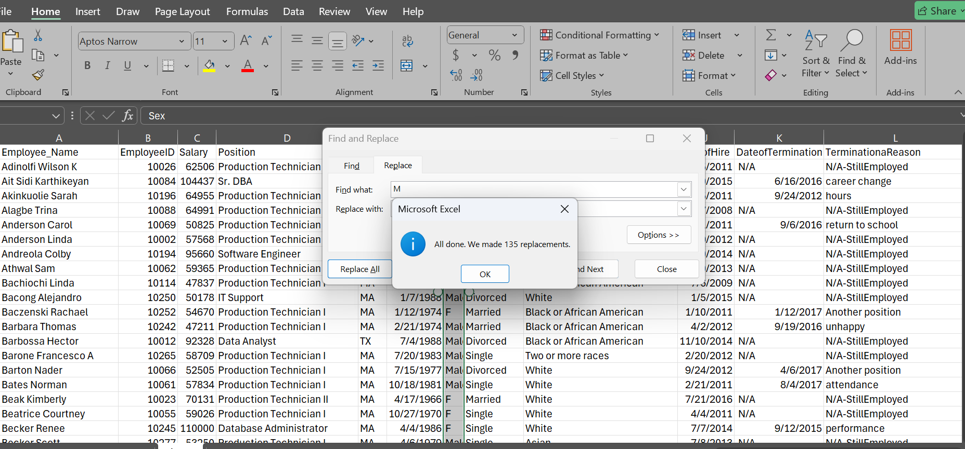
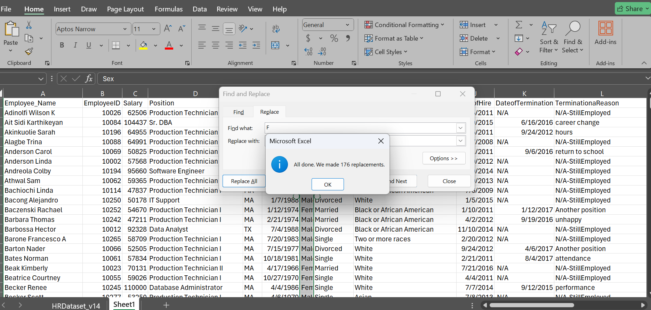

- DATA TRANSFORMATION, ANALYSIS AND INSIGHT
TRANSFORMATION
I imported the cleaned dataset into my Power BI environment for analysis. As part of the data preparation process, I transformed the dataset by creating the following column and measures using DAX functions.

MEASURES | DAX FUNCTION
Active Employees | COUNT
Attrition Rate | DIVIDE
Average Satisfaction | AVERAGE
Exceeds Expectations | CALCULATE
Exceeds Percentage | CALCULATE
Retention Rate | CALCULATE
Terminated Employees | CALCULATE
Total Employees | COUNT

ANALYSIS
1st Objective: To analyze the employee performance across different recruitment sources.

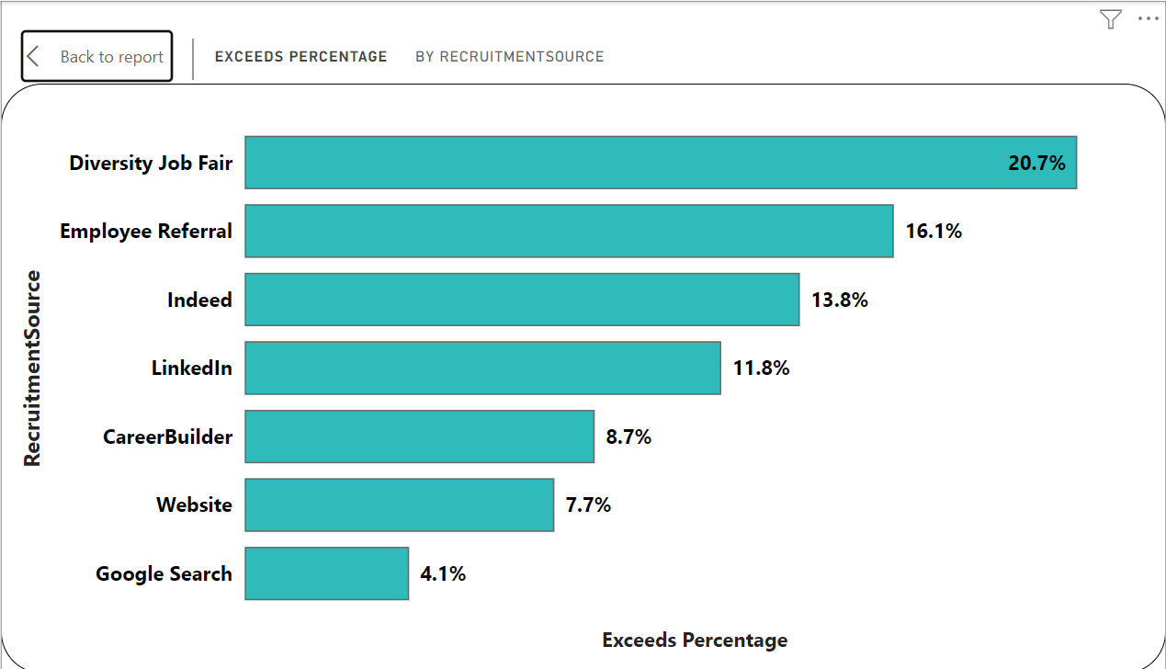
2nd Objective: To examine employee attrition patterns across recruitment sources.
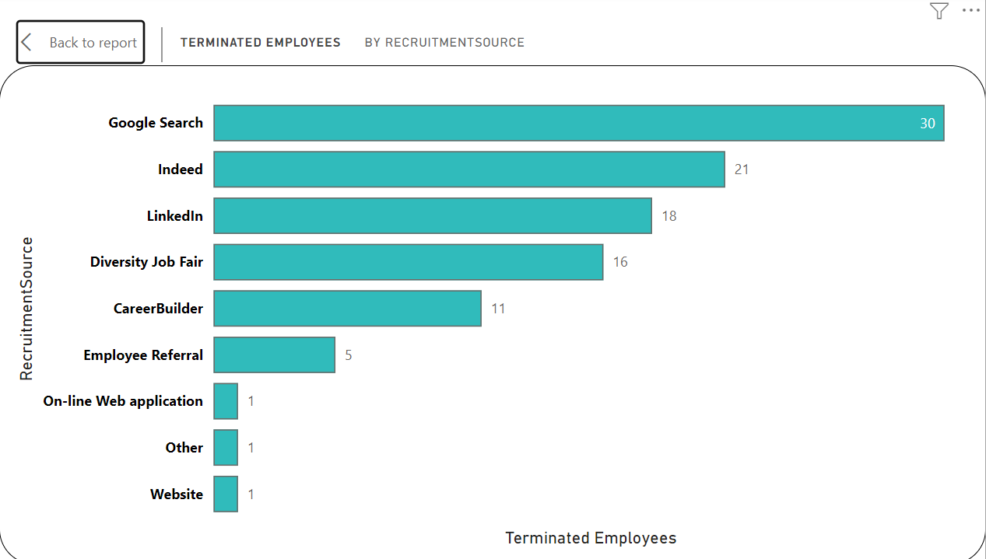
3rd Objective: To analyze the reasons for employee termination and identify the major drivers of attrition.
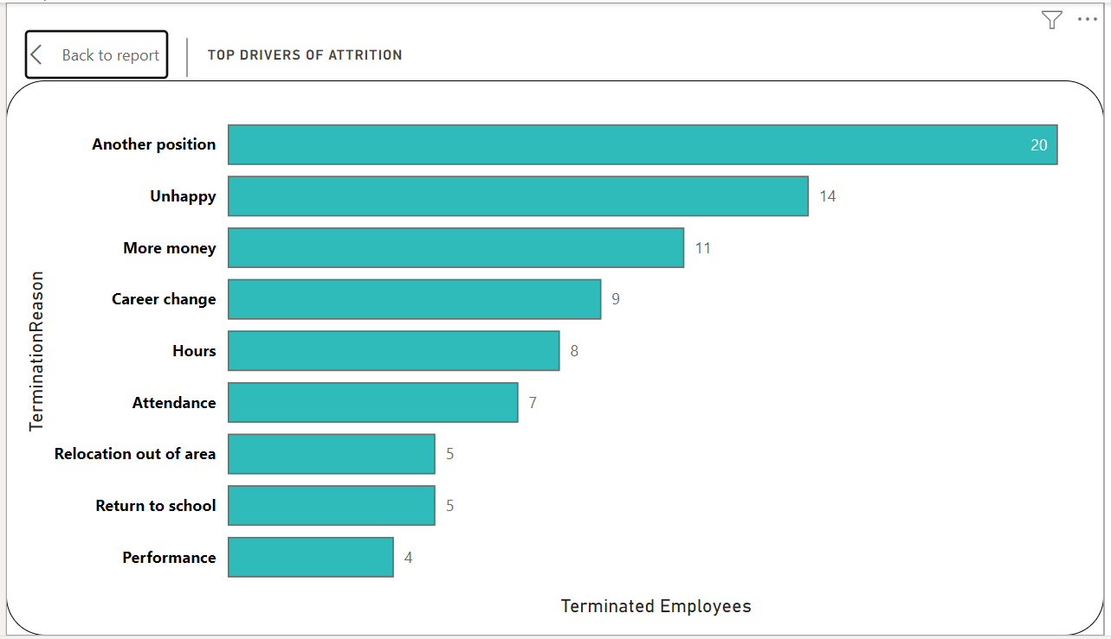

4th Objective: To examine the relationship between department and attrition.

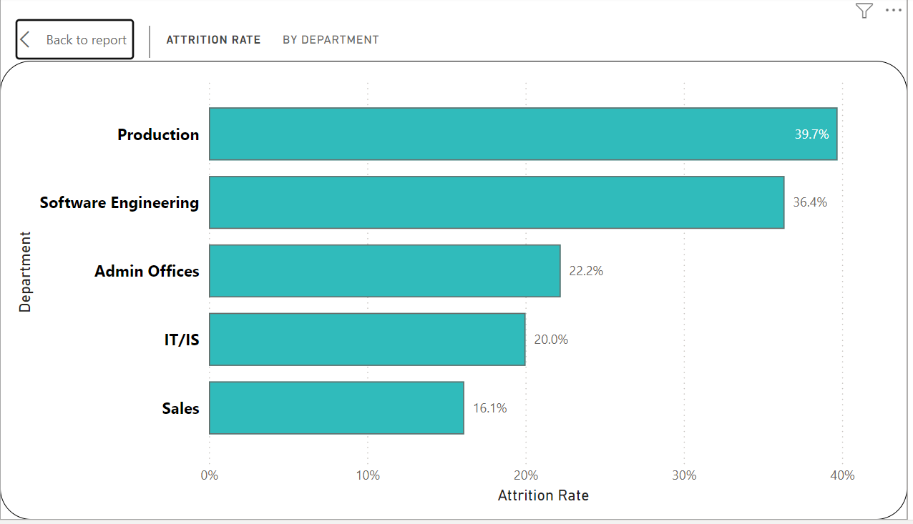

5th Objective: To evaluate recruitment sources based on employee retention, performance, and satisfaction outcomes.

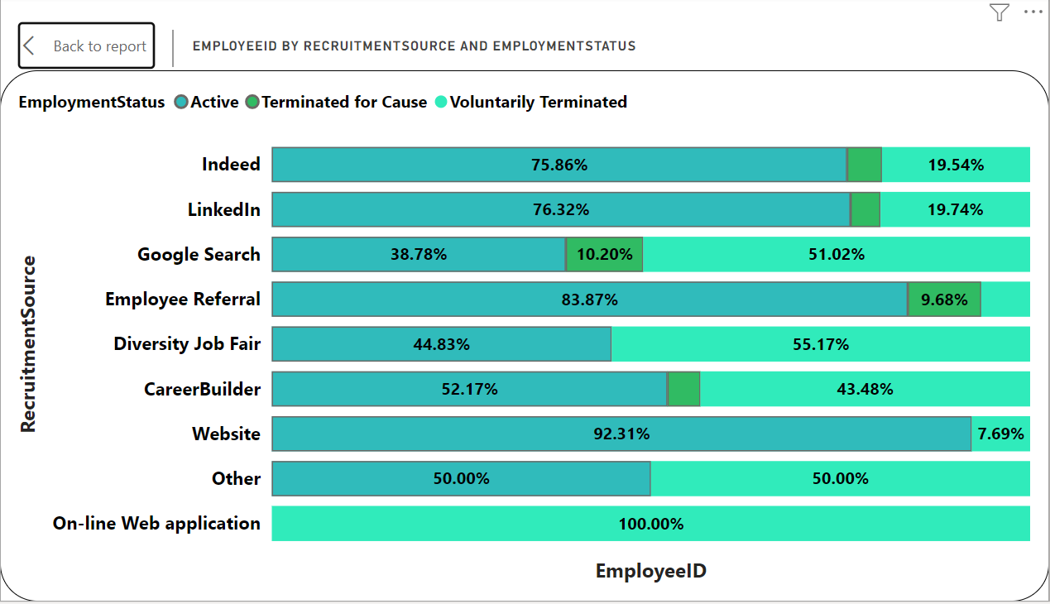

INSIGHTS
1st Objective: To analyze the employee performance across different recruitment sources.
Employee performance quality varies meaningfully by recruitment source. Diversity Job Fair hires recorded the highest proportion of employees rated "Exceeds Expectations" at 20.7%, followed by Employee Referral at 16.1%. Indeed (13.8%) and LinkedIn (11.8%) - despite being the two largest sourcing channels by volume - produced a below-average share of top performers, while CareerBuilder (8.7%), Website (7.7%) and Google Search (4.1%) recorded the lowest proportions of high performers. This indicates that the volume of hires a channel produces is not a reliable indicator of the quality of hires it produces.

2nd Objective: To examine employee attrition patterns across recruitment sources.
Terminated employee counts varied considerably by recruitment source. Google Search recorded the highest number of terminations (30), followed by Indeed (21), LinkedIn (18), Diversity Job Fair (16) and CareerBuilder (11), while Employee Referral (5), Website (1), Online Web Application (1) and Other (1) recorded far fewer. When these counts are viewed as a proportion of each source's total hires, the gap widens further: Google Search's 30 terminations come from only 49 hires, an attrition rate of 61.2%, compared with Indeed's 21 terminations out of 87 hires, an attrition rate of 24.1%. This shows that Indeed's termination count looks high mainly because of its hiring volume, whereas Google Search is a genuinely high-risk channel on a like-for-like basis.

3rd Objective: To analyze the reasons for employee termination and identify the major drivers of attrition.
The analysis shows that employee departures were concentrated around a small number of recorded reasons. "Another position" (20 cases), "Unhappy" (14), "More money" (11), "Career change" (9), and "Hours" (8) collectively accounted for 59.6% of all 104 recorded terminations. Attendance-related exits (7) and "Performance" (4) followed. Notably, the four leading reasons - another position, unhappiness, pay, and career change - are all voluntary and largely preventable through pay, engagement, and career-pathing interventions, rather than being driven by misconduct or poor performance, which together account for a much smaller share of departures.

4th Objective: To examine the relationship between department and attrition.
Attrition is heavily concentrated in specific departments. Production recorded the highest attrition rate at 39.7%, followed by Software Engineering at 36.4%, Admin Offices at 22.2%, IT/IS at 20.0%, and Sales at the lowest, 16.1%. Because Production also holds the largest share of the workforce (209 of 311 employees, 67.2%), it drives the majority of the organization's total attrition in absolute terms as well as rate, making it the single most consequential department for retention efforts.

5th Objective: To evaluate recruitment sources based on employee retention, performance, and satisfaction outcomes.
Employment outcomes differ sharply by recruitment source. Website (92.3% active), Employee Referral (83.9% active) and LinkedIn (76.3% active) produced the strongest retention outcomes, while On-line Web Application (0% active, single hire), Google Search (38.8% active) and Diversity Job Fair (44.8% active) produced the weakest. Employee Referral is a notable exception worth flagging: although 83.9% of referral hires remain active, referral hires who do leave are disproportionately terminated for cause (9.7%, versus 6.5% voluntary), the highest for-cause rate of any major channel alongside Google Search (10.2%). Taken together with the performance results from Objective 1, Employee Referral and Diversity Job Fair emerge as the two most valuable but differently-flawed channels: Referral delivers strong retention and good performance but carries a for-cause risk, while Diversity Job Fair delivers the best performers but loses over half of them.

- Conclusion
This analysis examined recruitment patterns and employee attrition within the organization using 311 employee records. The findings show that Indeed was the largest recruitment source with 87 employees (28.0%), followed by LinkedIn with 76 employees (24.4%). Together, these two sources accounted for more than half of the employees in the dataset, highlighting their significant contribution to the organization's workforce.
The analysis of attrition revealed that 104 out of 311 employees were terminated, representing a termination proportion of approximately 33.4%. However, termination was not evenly distributed across recruitment sources or departments. Google Search produced the highest attrition rate among sourcing channels (61.2%), while Production carried the highest departmental attrition rate (39.7%) and, owing to its size, the largest absolute number of departures - indicating that attrition risk in this organization is concentrated rather than spread evenly.
The analysis of termination reasons further showed that employee departures were concentrated around a small number of largely voluntary and preventable causes - another position, unhappiness, pay, and career change together explained 59.6% of all exits. Termination also varied by performance classification, with employees rated "Needs Improvement" leaving at 55.6%, more than double the rate of top performers (21.6%), and by department, with Production and Software Engineering recording the highest attrition rates. This combination suggests that turnover in this organization is driven jointly by where an employee works, how they were recruited, and how they are performing, rather than by any single factor in isolation.
Overall, the findings demonstrate that recruitment should be evaluated beyond the number of employees obtained from each source. High-volume channels such as Indeed and LinkedIn are not necessarily the highest-quality or best-retaining sources, while smaller channels such as Employee Referral and Website consistently outperform on retention, and Diversity Job Fair consistently outperforms on employee quality despite weak retention. The analysis provides clear evidence that recruitment source, employee performance, department, and employment status jointly shape workforce outcomes, and that Production and Google Search represent the two highest-priority areas for intervention given their scale and severity of attrition.

- Recommendations
- Recruitment Source Distribution
Indeed and LinkedIn should remain core recruitment channels given their volume and above-average retention (75.9% and 76.3% active respectively), but Human Resources should not expand them further on volume alone, since both produced a below-average share of "Exceeds Expectations" performers (13.8% and 11.8%). A defined share of the recruitment budget should shift toward Employee Referral and Website, which combine strong retention (83.9% and 92.3% active) with above-average performance outcomes, to broaden the candidate pool while improving overall hire quality.
- Attrition Across Recruitment Sources
Human Resources should prioritize a review of Google Search (61.2% attrition rate) and Diversity Job Fair (55.2%) hires to identify differences in candidate-job fit, expectations-setting, onboarding, and early employee experience relative to lower-attrition sources such as Website (7.7%) and Employee Referral (16.1%). Given that Diversity Job Fair hires also show the strongest performance outcomes, the review for this channel should focus specifically on early-tenure retention and onboarding support rather than candidate screening, since the quality of hire is not in question.
- Reasons for Employee Termination
Human Resources should prioritize the top voluntary termination reasons - another position (20 cases), unhappiness (14), pay (11), and career change (9) - which together account for 59.6% of all departures and are largely preventable through pay, engagement, and career-pathing action. Because Production carries both the largest headcount and the highest departmental attrition rate (39.7%), HR should target this department first with compensation reviews, structured career progression paths, and systematic exit interviews to confirm whether these same reasons are driving its outsized share of departures.
- Performance and Attrition
Given that employees rated "Needs Improvement" leave at 55.6% - more than double the rate of "Exceeds" performers (21.6%) - management should introduce earlier, structured coaching and support for employees flagged as underperforming, rather than allowing attrition to resolve performance issues passively. For high-performing employees, who already leave at the lowest rate, management should protect this advantage through continued recognition, competitive compensation, and clear progression opportunities, particularly in Production and Software Engineering where overall attrition is highest.
- Recruitment Source and Employee Outcomes
Management should incorporate retention, performance, and satisfaction outcomes - not headcount alone - into recruitment source decisions. Employee Referral and Website should be treated as preferred channels given their strong combined retention and performance profiles, while Employee Referral's elevated for-cause termination rate (9.7%) should prompt a review of referral vetting practices. Diversity Job Fair should be retained and invested in for its strong performance outcomes, paired specifically with improved onboarding to close its retention gap, while Google Search should be scaled back or restructured until its underlying attrition drivers are addressed.

Contact details
Email: ayoolaoni09@gmail.com
Phone: 07036127122
Linkedin: https://www.linkedin.com/in/AyoolaAyooni
Github: https://github.com/OAAlago

