Cyclistic Bike-Share Analysis

Case Study By: OAK SOE KYAW
Date: 17/October/2025
Contents
Case Study Summary 3
Analysis Highlights 3
Strategic Takeaways 4
Business Goal 5
Preparing and Processing the Data for Analysis 5
Source of the Data and License Agreement 5
Data Preparation and Standardization 5
Data Integrity 6
Exploratory Data Analysis (EDA) 6
Overview 6
User Composition 6
Ride Duration Behavior 7
Total Ride Time Contribution 7
Weekly Usage Patterns 8
Hourly Usage Patterns 9
Seasonal and Quarterly Trends 10
Popular Stations 11
Summary of Findings 12
Key Takeaways 12
Recommendations 13
Appendix 13

Case Study Summary
This report presents an analysis of Cyclistic’s bike-share data from 2019 to early 2020. The goal was to identify behavioral differences between casual riders and annual members to support the company’s marketing strategy for increasing annual memberships.

The datasets were obtained from the official Divvy Trip Data portal, containing over 4.2 million rides across five quarters. The data was cleaned, standardized, and merged into a unified dataset for consistent analysis. Error entries, missing values, and unrealistic trip durations were removed to ensure accuracy.

Analysis Highlights
User Composition: Members accounted for roughly 76% of total rides, while casual riders made up 23%.
Ride Behavior:
- Members typically rode during weekday, commute hours (7–9 AM and 5–6 PM).
- Casual riders were more active on weekends and summer afternoons, likely for leisure and sightseeing.
Trip Duration: Average ride duration for casual riders was ~39 minutes, compared to ~13 minutes for members.
Seasonality: Ride activity peaked in Q3 (summer) due to favorable weather and major city events.
Geographic Trends:
- The most active stations for casual riders were located near tourist hotspots like Streeter Dr & Grand Ave and Millennium Park.
- Members were concentrated around transportation and business districts such as Canal St & Adams St.

Strategic Takeaways
- Target casual riders with promotions around weekend passes, seasonal memberships, and loyalty discounts.
- Highlight cost-saving benefits and convenience of annual membership to frequent riders.
- Deploy location-based campaigns at high-traffic casual stations to convert tourists and leisure riders into members.
This analysis provides the Cyclistic marketing and operations teams with actionable insights to design data-driven campaigns that can boost membership conversion rates and increase overall program profitability.

Business Goal
The business goal is to understand how annual members and casual riders use Cyclistic bikes differently in order to identify opportunities to convert casual riders into annual members and increase profitability. By analyzing historical ride data and uncovering behavioral patterns, the Cyclistic marketing analytics team aims to provide actionable insights that can inform targeted marketing strategies and improve member conversion rates.

Preparing and Processing the Data for Analysis

Source of the Data and License Agreement
The data used in this project comes from Motivate International Inc., the operator behind Chicago’s Divvy bike-share system, managed by Lyft Bikes and Scooters in partnership with the City of Chicago. It is publicly available under the Divvy Data License Agreement and used here solely for non-commercial, educational purposes. The dataset contains no personally identifiable information (PII).

Data Preparation and Standardization
The datasets include quarterly ride data from early 2019 through early 2020. Because the data format changed slightly in 2020, adjustments were made to align all files into a consistent structure. Only information directly relevant to the business objectives — such as trip duration, start and end times, and station details — was kept. Columns unrelated to the analysis were removed to simplify and standardize the data.
For the most recent quarter, some missing fields (like trip duration) were recalculated to match earlier data formats, ensuring accurate and consistent comparison across all periods. This preparation allows for smooth analysis of how Cyclistic’s casual riders and annual members use the service differently.

Data Integrity
The datasets were obtained directly from the official “Divvy-Tripdata” source, ensuring their authenticity and reliability. To maintain consistency and accuracy, only data relevant to the business objectives was retained. Columns such as bike ID, gender, and birth year were excluded as they were not essential for this analysis. Records with missing or invalid values in key fields like start time, end time, from station, or to station were removed to ensure data completeness.
In addition, a small number of trips showing unrealistic durations (for example, lasting several days or weeks) were identified and removed, as these likely resulted from system or user errors. The trip ID column was standardized as a text identifier across all datasets to ensure compatibility between quarterly files and prevent technical inconsistencies. Overall, all tables were aligned to follow a uniform data structure, enabling accurate comparison and analysis across time periods.

Exploratory Data Analysis (EDA)

Overview
The goal of this analysis is to uncover behavioral differences between annual members and casual riders of Cyclistic. By exploring ride patterns across time, location, and usage metrics, we can identify actionable insights to help Cyclistic convert casual riders into annual members and improve overall profitability.
The cleaned and standardized dataset combines all five quarters of historical data (2019 Q1–2020 Q1), resulting in a total of 4,235,068 ride records for analysis.

User Composition
User Type | Total Rides | Percentage
Member | 2,949,689 | 76.4%
Casual | 911,302 | 23.6%

Annual members make up the majority of rides; however, casual riders still represent a significant segment of users. Their lower frequency but higher engagement makes them an important target group for conversion opportunities.

Ride Duration Behavior
User Type | Average Duration (minutes)
Member | 13.97
Casual | 39.96

Casual riders take trips roughly three times longer than members. This pattern suggests that casual riders primarily use the service for leisure, sightseeing, or social activities, while members use it for short, purpose-driven commutes such as traveling to work or running errands.

Total Ride Time Contribution
User Type | Total Trip Duration (seconds)
Member | 2,472,842,562
Casual | 2,184,680,203

Despite being only 23% of total users, casual riders’ total ride duration nearly matches that of members. This reinforces the finding that casual users, though fewer in number, spend considerably more time per ride — a behavior indicative of high engagement potential.

Weekly Usage Patterns
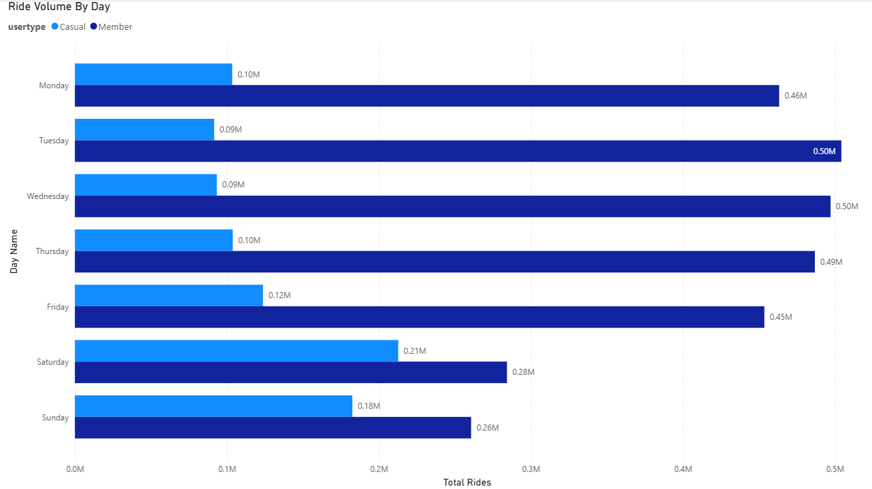
Casual riders are most active on weekends, while annual members show higher activity on weekdays.
This trend suggests that:
- Members rely on Cyclistic for commuting or weekday routines.
- Casual riders treat the service as a recreational activity, favoring weekends for exploration or leisure.

Hourly Usage Patterns
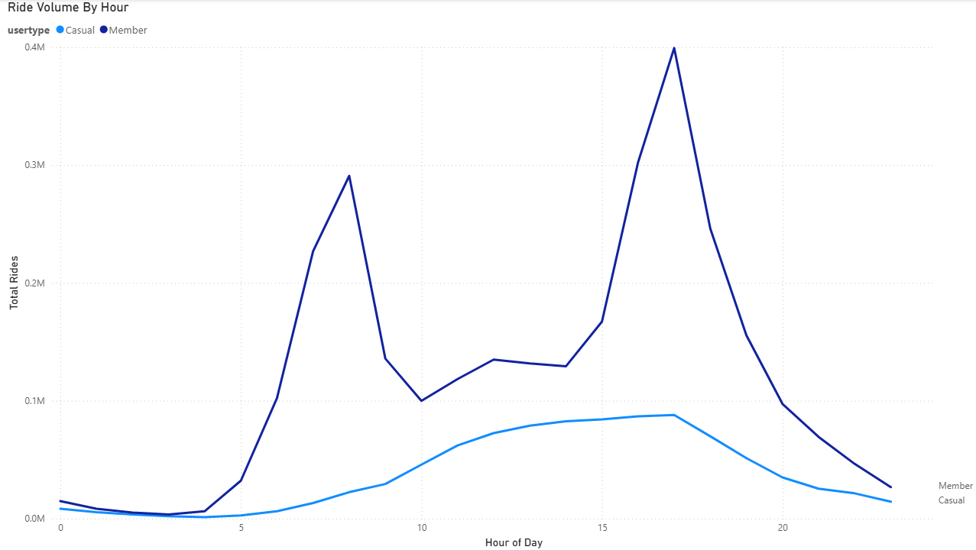
Analysis of start times reveals distinct usage trends throughout the day.
Annual Members:
- Morning peak between 7–9 AM and evening peak between 5–6 PM.
- These times align with typical commute hours, suggesting that members primarily use Cyclistic bikes for daily transportation.
Casual Riders:
- Gradual increase starting from late morning (around 10 AM) and peaking between 3–5 PM.
- This pattern reflects more recreational or sightseeing usage, especially during midday and weekends.
Marketing strategies could emphasize weekday commuting benefits for annual members, while promoting weekend leisure rides to attract casual users.

Seasonal and Quarterly Trends
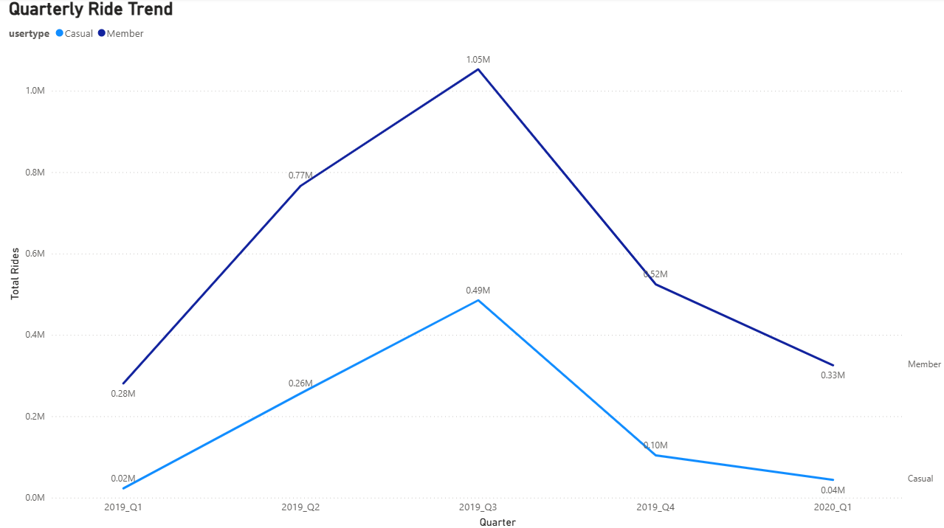
Both user types show sharp increases in Q3 (summer months).
This seasonal surge can be attributed to:
- Favorable weather encouraging outdoor travel.
- City festivals and events (e.g., Lollapalooza, Taste of Chicago) attracting tourists and local activity.
- Increased leisure mobility and lighter traffic, making bike-sharing more appealing.
Cyclistic can leverage this seasonal opportunity by promoting short-term summer memberships or event-based discounts to attract casual riders.

Popular Stations
Top Stations by User Type (Q3 2019)
Casual Riders | Total Trips | Member Riders | Total Trips
Streeter Dr & Grand Ave | 31,618 | Canal St & Adams St | 17,127
Lake Shore Dr & Monroe St | 20,602 | Clinton St & Madison St | 15,576
Michigan Ave & Oak St | 13,122 | Clinton St & Washington Blvd | 14,663
Lake Shore Dr & North Blvd | 12,553 | Daley Center Plaza | 12,366
Millennium Park | 12,549 | Franklin St & Monroe St | 11,238
Observations:
- Casual riders primarily start trips near tourist attractions (Lakefront, Riverwalk, Millennium Park).
- Members favor downtown business hubs near Union Station and central offices.
- Average ride duration is longer for casual riders (43–49 minutes) at these popular leisure stations, compared to 11–14 minutes for members.
Cyclistic could deploy targeted marketing at tourist-heavy stations, offering incentives or QR-based discounts for casual riders to join membership programs.

Summary of Findings
Theme | Insight | Business Implication
Usage volume | Members dominate overall ridership | Maintain and enhance member retention strategies
Ride duration | Casual users ride 3× longer | High engagement potential; conversion opportunity
Day of week | Members = weekdays;  Casual = weekends | Segment marketing by ride purpose
Hourly pattern | Members = commute peaks;  Casual = midday leisure | Tailor promotions to time-of-day patterns
Seasonality | Peak in Q3 (summer) | Focus seasonal marketing on festivals and tourists
Location | Members = business zones;  Casual = waterfront/tourist spots | Geo-target casual riders for membership offers

Key Takeaways
- Casual riders exhibit strong seasonal and recreational usage, suggesting opportunities for targeted membership promotions during summer and weekends.
- Annual members demonstrate steady weekday commuting patterns, showing satisfaction and consistent use of the service.
- Station-level insights reveal a clear distinction between business and leisure travel zones, guiding localized marketing strategies.
- By aligning marketing and membership campaigns with time, location, and user behavior, Cyclistic can effectively increase conversion and profitability.

Recommendations
Targeted Campaign Timing: Focus marketing campaigns during the summer months (Q3), when ridership is highest, to encourage casual users to purchase memberships.
Commuter-Focused Messaging: Emphasize convenience, cost savings, and flexibility to retain and attract more annual members.
Leisure-Focused Promotions: For casual riders, highlight fun, exploration, and family experiences, particularly near tourist and waterfront stations.
Membership Incentives: Offer short-term membership trials or discounts during high-demand periods to convert occasional users into committed members.
Operational Planning: Allocate more bikes and maintenance support in high-demand stations during summer to ensure availability and customer satisfaction.

Appendix
Detailed SQL scripts, data-cleaning rules, and DAX measures are documented in the project’s GitHub repository for transparency and reproducibility.

