1. A database is an organized collection of ________ related data.

A) logically

B) physically

C) loosely

D) badly

1. All of the following are properties of metadata EXCEPT:

A) data definitions.

B) processing logic.

C) rules or constraints.

D) data structures.

1. Relational databases establish the relationships between entities by means of common fields included in a file called a(n):

A) entity.

B) relationship.

C) relation.

D) association.

1. The logical representation of an organization's data is called a(n):

A) database model.

B) entity-relationship model.

C) relationship systems design.

D) database entity diagram.

5) In the figure below, ‘Address’ is an example of:

A) a composite attribute.

B) a relational attribute.

C) a derived attribute.

D) a multivalued attribute.

6) In an E-R diagram, there are/is ________ business rule(s) for every relationship.

A) two

B) three

C) one

D) zero

1. Which of the following is an entity that exists independently of other entity types?
2. Codependent
3. Strong

C) Weak

D) Variant

8) An attribute that must have a value for every entity (or relationship) instance is a(n):

A) composite attribute.

B) required attribute.

C) optional attribute.

D) multivalued attribute.

9) The number of entity types that participate in a unary relationship is:

A) zero.

B) two.

C) three.

D) one.

10) Which of the following is a generic entity type that has a relationship with one or more subtypes?

A) Megatype

B) Subgroup

C) Supertype

D) Class

1. The property by which subtype entities possess the values of all attributes of a supertype is called:
2. hierarchy reception.
3. attribute inheritance.

C) class management.

D) generalization.

1. In the figure below, which of the following is a subtype of patient?

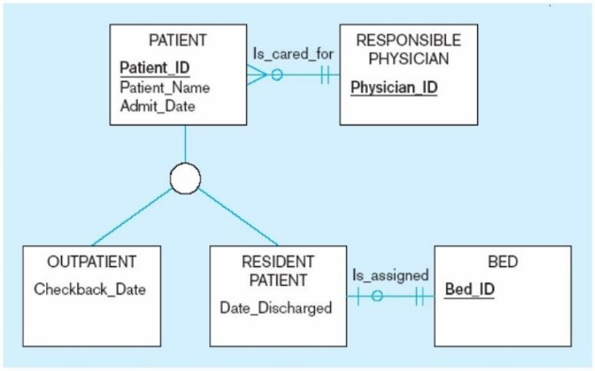

A) Outpatient

B) Physician

C) Bed

D) Date_Hired

1. The process of defining one or more subtypes of a supertype and forming relationships is called:

A) generalization.

B) creating discord.

C) selecting classes.

D) specialization.

1. The following figure is an example of:

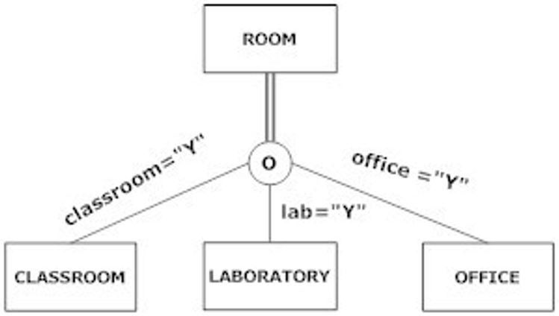

A) partial specialization.

B) completeness.

C) disjointness.

D) total specialization.

1. The ________ rule specifies that an entity instance of a supertype is allowed not to belong to any subtype.
2. semi-specialization
3. partial specialization

C) total specialization

D) disjointedness

1. A(n) ________ constraint is a type of constraint that addresses whether an instance of a supertype must also be an instance of at least one subtype.

A) disjoint

B) overlap

C) weak

D) completeness

1. Which of the following statements is true about the figure shown below?

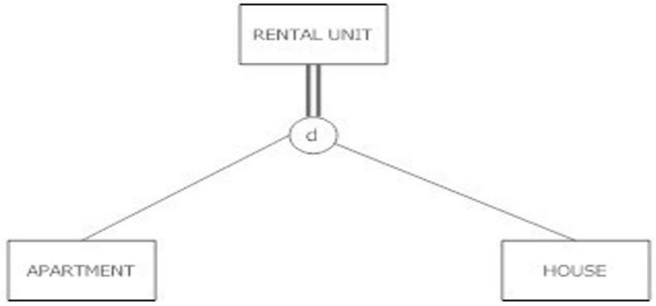

A) A rental unit can be an apartment, house or just a rental unit; it may not be more than one at the same time.

B) A rental unit must be either an apartment or a house, and could be both.

C) A rental unit can be an apartment, a house or just a rental unit. It could be both an apartment and a house at the same time.

D) A rental unit must be either an apartment or a house, and cannot be both at the same time.

1. A two-dimensional table of data sometimes is called a:

A) set.

B) group.

**C) relation**.

D) declaration.

1. An attribute in a relation of a database that serves as the primary key of another relation in the same database is called a

A) foreign attribute.

B) link key.

C) link attribute.

**D) foreign key**.

1. Which of the following are properties of relations?
2. There are multivalued attributes in a relation.
3. **No two rows in a relation are the same.**

C) Each attribute has the same name.

D) All columns are numeric.

1. A rule that states that each foreign key value must match a primary key value in the other relation is called the:

A) entity key group rule.

**B) referential integrity constraint.**

C) key match rule.

D) foreign/primary match rule.

1. An attribute (or attributes) that uniquely identifies each row in a relation is called a:
2. foreign field.
3. **Primary key.**

C) column.

D) duplicate key.

1. In the figure below, the primary key for "Order Line" is which type of key?

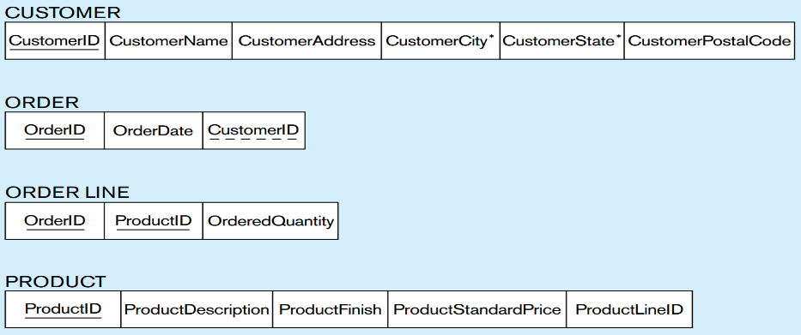

A) Foreign

**B) Composite**

C) Standard

D) Grouped

1. Which normal form is a relation that has the following properties?

(1) contains no multivalued attributes

(2) has nonkey attributes only dependent on the primary key, but

(3) contains transitive dependencies

A) First

B) Third

**C) Second**

D) Fourth

1. In the figure below, what type of relationship do the relations depict?

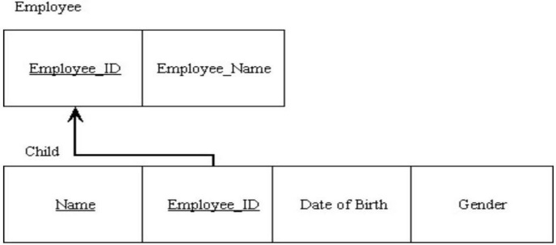

A) One-to-many

**B) Identifying strong/weak entity**

C) Multivalued

D) Composite foreign key

1. Program-data dependence is caused by:

A) file descriptions being stored in each database application.

B) data descriptions being stored on a server.

C) data descriptions being written into programming code.

D) data cohabiting with programs.

1. All of the following are primary purposes of a database management system (DBMS) EXCEPT:

A) creating data.

B) updating data.

C) storing data.

D) providing an integrated development environment.

1. Given the following entities, which of the choices below would be the most complicated?

*Automobile:* VIN, EngineSize, NumberOfDoors, NumberOfPassengers, FuelType, Transmission

*SUV:* VIN, EngineSize, NumberOfPassengers, NoWheelDrive, FuelType, Transmission

*Truck:* VIN, EngineSize, NoWheelDrive, FuelType, Transmission, Payload

A) Define one vehicle entity type to hold all entities.

B) Define a separate entity type for each entity.

C) Define a supertype called vehicle and make each of the entities subtypes.

D) Keep only the Truck entity type.

1. An attribute of the supertype that determines the target subtype(s) is called the:

A) determinant.

B) subtype decision.

C) disjoint indicator.

D) subtype discriminator.

1. In the SQL language, the ________ statement is used to make table definitions.

A) create session

B) create table

C) create index

D) select

1. All of the following are the main goals of normalization EXCEPT:

A) minimize data redundancy.

B) simplify the enforcement of referential integrity.

C) maximize storage space.

D) make it easier to maintain data.

1. ________ is a component of the relational data model included to specify business rules to maintain the integrity of data when they are manipulated.

A) Business rule constraint

B) Data integrity

C) Business integrity

D) Data structure

1. A primary key that consists of more than one attribute is called a:

A) foreign key.

B) composite key.

C) multivalued key.

D) cardinal key.

**Part B - True/False Questions.**

1. A data model is a graphical system used to capture the nature and relationships among data. True
2. A person is an example of an entity. True.
3. The allowable range of values for a given attribute is part of the domain constraint. **True**
4. If an identifier is not assigned, the default primary key for an associative relation consists of the two primary key attributes from the other two relations. True.
5. There can be multivalued attributes in a relation. **False**

(NOT PERMITTED MULTIVE ATTRIBUTES)

1. The overlap rule specifies that if an entity instance of the supertype is a member of one subtype, it can simultaneously be a member of two (or more) subtypes. True
2. When choosing an identifier, choose one that will not change its value often. True
3. Metadata are data that describe the properties of other data. True
4. When subtypes are overlapping, an additional field must be added to the supertype to act as a discriminator. False
5. A single occurrence of an entity is called an entity instance. True
6. The disjoint rule specifies that if an entity instance of the supertype is a member of one subtype, it MUST simultaneously be a member of another subtype. False
7. The columns of a relation can be interchanged without changing the meaning or use of the relation. True.
8. In the figure below, each employee has exactly one manager. **True**

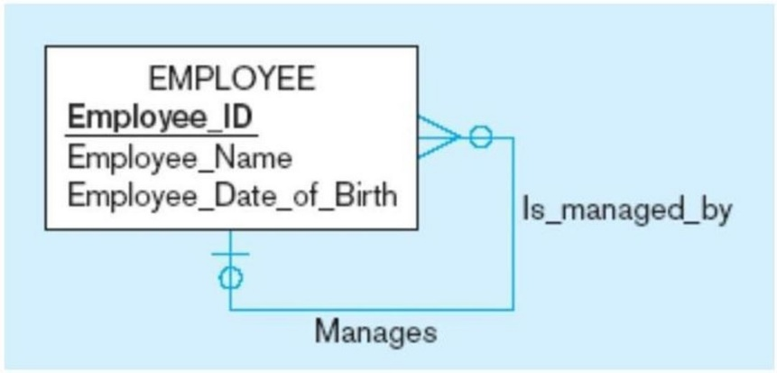

1. Redundancy increases the risk of inconsistent data. TRUE
2. A relational database establishes the relationships between entities by means of a common field. TRUE
3. Most systems developers believe that data modeling is the least important part of the systems development process. FALSE
4. A completeness constraint may specify that each entity of the supertype must be a member of some subtype in the relationship. TRUE
5. A foreign key is a primary key of a relation that also is a primary key in another relation. FALSE
6. An attribute whose value can be calculated from related attribute values is called a derived attribute. True