# Guidelines of ISOM3000 Course Project

Due date: 6 Nov.(for classes 002-003), 7 Nov.(for class 001)

The group-based database development project is the highlight of this course. You will get hands-on experiences in how to design a database system to meet business requirements. Students need to develop a **library database system** for a body*. Tasks include analyzing user requirements, developing modules with tables and relationships, and documenting the design to support user requirements and implementing the project.

You are required to*:

1. Use MS Access to design an Entity Relationship Diagram(ERD) which consists of tables/files along with all necessary relationships and integrity constraints, **see Figure – 1** below. In order to design the ERD, you need to firstly create a database consisting of those entities with attributes *at least* shown in the figure.

*Note: please refer to supplementary materials(MS Access) when necessary, which you can find under “Group projects” in Moodle.*

**Figure - 1**

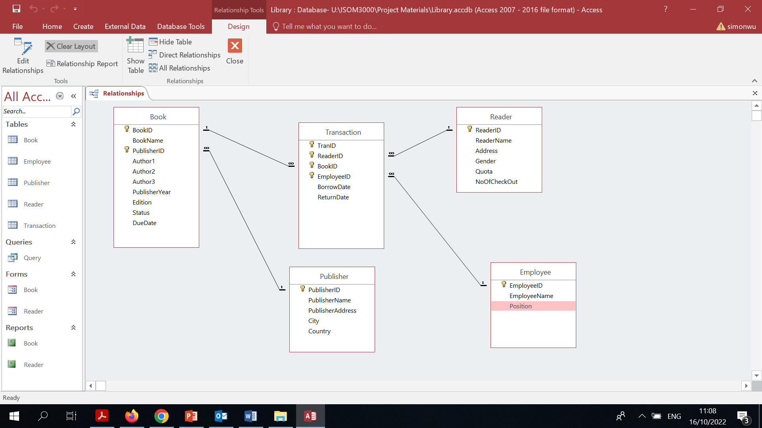

1. List and describe the business rules for all entities and relationships shown above. Please refer to **Figure – 2** and **Figure – 3** below respectively for reference. Entities must at least include the following:
2. Reader
3. Book
4. Employee
5. Publisher
6. Transaction

**Figure - 2**

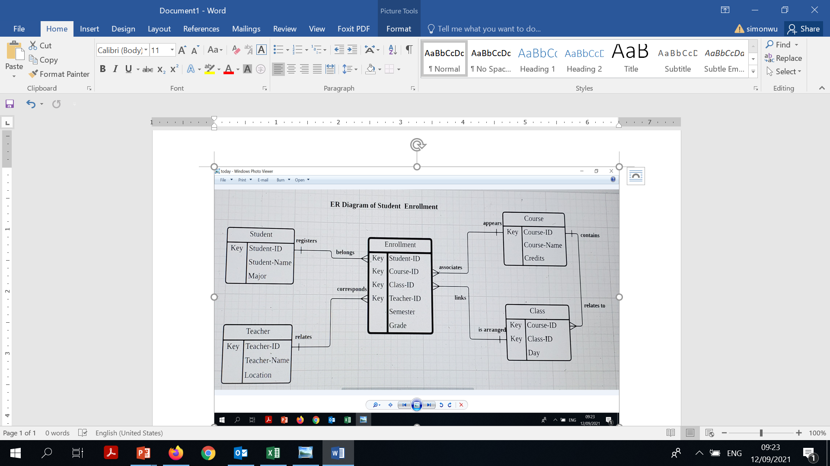

**Figure - 3**

