OATC metadata 2.0 D (DRAFT)

Recommended Practice

“TECHNICAL RECOMMENDATIONS FOR PROVISION OF CONTENT METADATA FROM CONTENT PROVIDERS TO DISTRIBUTORS AND THIRD PARTY PUBLISHERS”

# Change Log

|  |  |  |  |
| --- | --- | --- | --- |
| Doc Version | Date | Changes | Author |
| 1.0 | 4-2-2012 | Initial Release for internal comments | KC |
| 1.0a | 5-7-2012 | Changes in terminology per OATC BoD review | KC |
| 1.0b | 5-9-2012 | Release for comment | KC |
| 1.0c | 8-14-2012 | Incorporate corrections noted during public review | KC |
| 1.0d | 3-13-2013 | Incorporate final review corrections (typos, capitalization of element and attribute names); Remove overloading of the Auth attribute; Allow for default Authentication values at any level of the hierarchy of the XML document. | KC |
| 2.0a | 02/04/14 | Initial release for internal comments. See section titled “Summary of Changes from 1.x Recommended Practice” | BC |
| 2.0b | 02.08/14 | Initial review – added “Changes” section | GG |
| 2.0c | 06/10/14 | Edits for consistency and clarity. | SR, PR |
| 2.0d | 06/25/14 | Collapse of live and on-demand contexts into one schema | BC |

# notice

Copyright © Open Authentication Technology Committee 2014. All rights reserved.

This Recommended Practice (“RP”) may be copied in its entirety and displayed or distributed to others, provided that the above copyright notice and this legal notice section are preserved on all such copies. No license is granted to modify the RP.

THIS RP IS PROVIDED ON AN “AS-IS” BASIS, WITHOUT ANY EXPRESS OR IMPLIED WARRANTY OF ANY KIND, INCLUDING WITHOUT LIMITATION ANY WARRANTY OF MERCHANTABILITY, FITNESS FOR A PARTICULAR PURPOSE OR NON-INFRINGEMENT OF ANY PARTY’S INTELLECTUAL PROPERTY. OATC HEREBY DISCLAIMS ANY AND ALL LIABILITY FOR PERSONAL INJURY OR PROPERTY OR OTHER DAMAGE, OF ANY NATURE WHATSOEVER, WHETHER SPECIAL, INDIRECT, CONSEQUENTIAL OR COMPENSATORY, DIRECTLY OR INDIRECTLY RESULTING FROM THE PUBLICATION OR USE OF, OR ANY RELIANCE UPON, THIS RP.

Implementation of this RP is voluntary. No rights or licenses under any patent claims are granted hereby. OATC takes no position regarding the validity or scope of any intellectual property or other rights that might be claimed to be infringed by the implementation of this RP or to the extent to which any license under such rights might or might not be available, and OATC does not represent that it has made any effort to identify any such rights or conduct any inquiries into the validity or scope of any such rights.

# metadata feed recommended practice

## introduction

This document serves as a recommendation for content providers (“Providers”) and content distributors (“Distributors”) who have a need to exchange data to describe their content and detail how it can be used and further distributed. Adherence to these practices allows implementation of a single data package, reducing or potentially eliminating the need to code multiple interfaces for distributing or consuming content metadata. Adoption of this recommendation simplifies the content exchange and helps to ensure that metadata is of a quality consistent with the content owner’s intent.

## purpose and scope

This document recommends a method for exchange of content metadata between providers, distributors and interested third parties, applications & websites. It is not intended to provide a data source for use directly by the end consumer of the content.

## summary of changes from 1.x recommended practice

* Introduction of an XSD with inline documentation. The *Schema documentation* reference section of this document has been generated from the annotated schemas.
* The recommended practice now covers both on-demand and live channel simulcasting use cases collapsed into a single schema with attributes to differentiate usage.
* The schema has bee broken down into a set of sub-schemas that can be used in a variety of contexts.
* A general-purpose *player links* sub-schema has been added to enable the communication of content links for embedded players, sites and applications. This sub-schema can be used to transmit catalog information from Content Providers to Content Aggregators and search engines to facilitate the discoverability of TV Everywhere content.
* Restrictions can be scoped within a Flight to provide more flexibility in expressing flights with restrictions across a variety of platforms
* Element and attribute names have been refactored for consistency.

# schemas and sub-schemas

## topic area refactoring

Version 2.x of the recommended practice adds higher-level granularity in key areas, such as content substitution, playout modeling, etc. To facilitate adoption and re-use, this RP has been divided into eight (8) sub-schemas that are all imported into a primary OATC Metadata schema. The 8 sub-schemas are:

|  |  |  |
| --- | --- | --- |
| **Schema** | **Namespace** | **Domain** |
| oatc_metadatafeed_2_0.xsd | urn:oatc:feed:xsd:metadatafeed:2.0 | The refactored primary schema |
| oatc_genre_1_0.xsd | urn:oatc:feed:xsd:genre:1.0 | Standard genre information from multiple authorities |
| oatc_network_1_0.xsd | urn:oatc:feed:xsd:network:1.0 | Network (channel) definition |
| oatc_participant_1_0.xsd | urn:oatc:feed:xsd:participant:1.0 | Stars & Contributors |
| oatc_playerlinks_1_0.xsd | urn:oatc:feed:xsd:playerlinks:1.0 | Rich description of deep-linking and player URLs |
| oatc_playout_1_0.xsd | urn:oatc:feed:xsd:playout:1.0 | Rich description of live playout order |
| oatc_rating_1_0.xsd | urn:oatc:feed:xsd:rating:1.0 | Standard rating information from multiple authorities |
| oatc_restriction_1_0.xsd | urn:oatc:feed:xsd:restriction:1.0 | Restrictions and content replacement |
| oatc_title_1_0.xsd | urn:oatc:feed:xsd:title:1.0 | Title Metadata |

This modular approach allows each sub-schema to evolve independently of the primary metadata specification. Furthermore, these sub-schemas may be used in conjunction with other standards. Sub-schemas from other standards may be incorporated into future versions of this RP. For the remainder of this document, items in a sub-schema are discussed using their declared namespace prefix. The documentation provided herein is of the primary OATC Metadata schema with the other sub-schemas included. Detailed documentation of each individual sub-schema is available separately.

# metadata contexts

TV Everywhere content metadata can be delivered in two main contexts: for On-Demand viewing, and for Live Linear viewing. Structurally, metadata feeds for the two contexts are quite similar, and differ by only a few properties that are useful in each context. For the On-Demand context, the metadata feed contains more information pertaining to content discovery, whereas the Live Streaming context contains more information pertaining to viewing restrictions and in-band signaling. The live streaming metadata feed is intended be used as a companion to in-band SCTE-104 and SCTE-35 signaling, providing metadata, restriction, and content replacement rules that do not “fit” within the in-band signaling standards.

## Feed Structure

The overall metadata feed is contained within a *Feed* element, which in turn contains a *Network* element and a collection of *Item* elements. Each *Item* element includes data describing a single program asset.

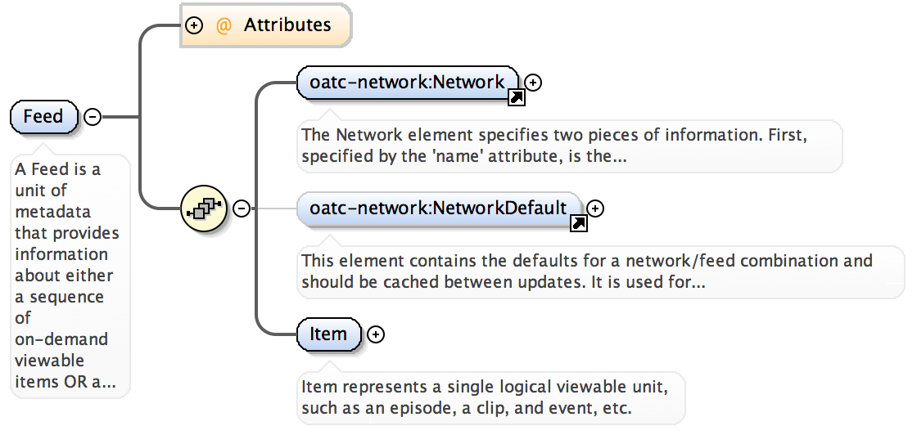

The differentiation between the on-demand and live metadata contexts is made through a single attribute of the feed, *DeliveryContext*:

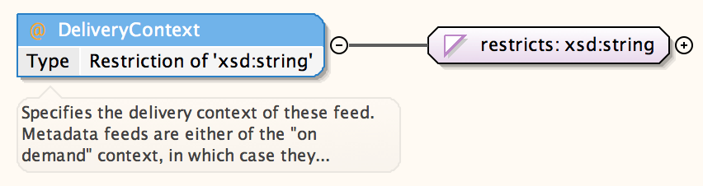

Valid values for *DeliveryContext* are “ondemand” and “live”. For each context, there are different attributes that may be appropriate. The general table of attributes is available below.

|  |  |
| --- | --- |
| *DeliveryContext* Value | Attributes Required |
| ondemand | Authenticated  Provider  DeliveryContext  TimeStamp  Status |
| live | Authenticated  Provider  DeliveryContext  TimeStamp  Start  End  Status |

For both contexts, an *oatc-network:Network* element is required. The network element identifies the provider of the context described in this feed, and it provides both human-friendly names as well as formal ID information for various authorities:

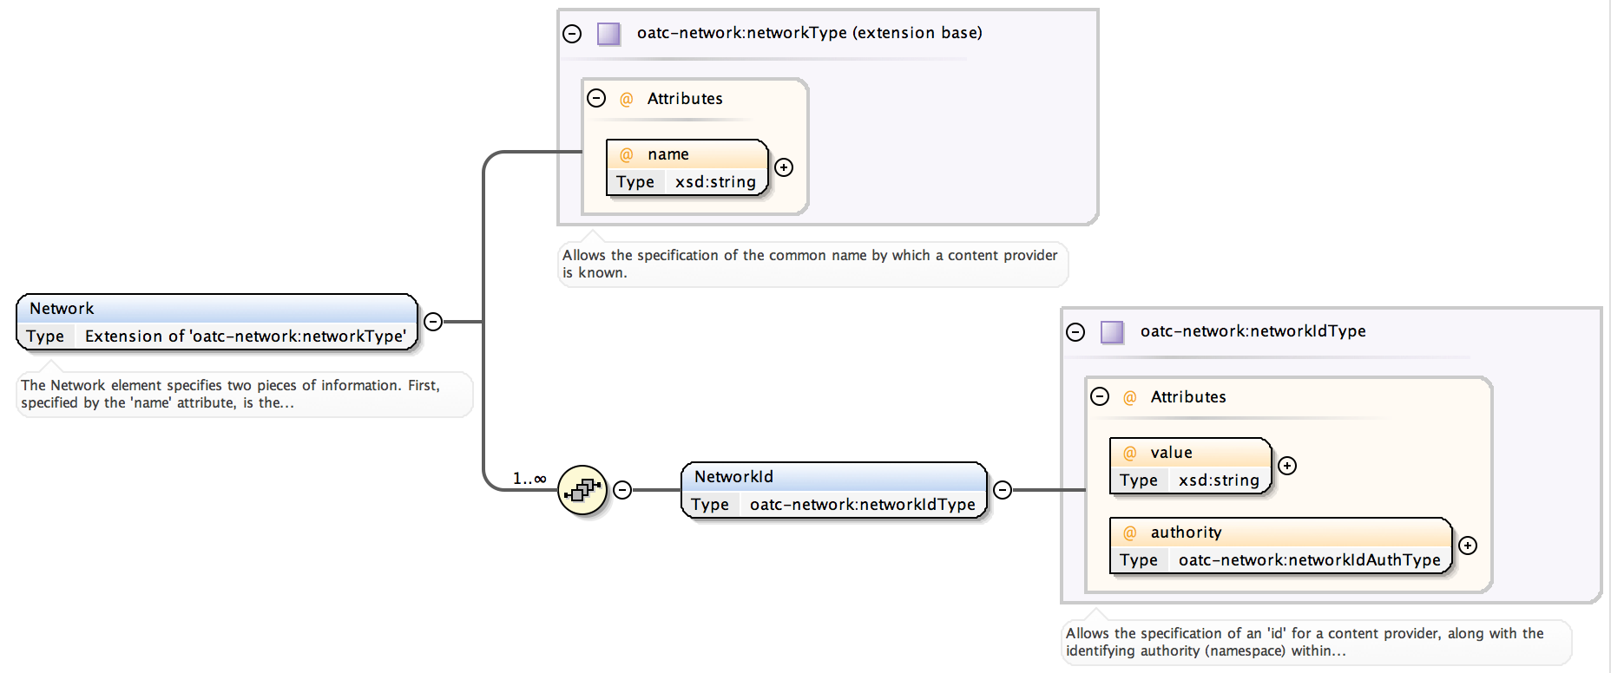

Also contained within the *Feed* element is a *NetworkDefaults* element that specifies the default behavior for certain slates and SCTE-35 device restrictions..

The *Item* represents a single viewable piece of content. The *Status*, *Title*, and *Playout* child elements are required for items in both delivery contexts. The other child items (*Restrictions*, *PlayerLinks*, *Recommended*, and *Private*) may or may not be present depending on the context and the needs of the content provider.

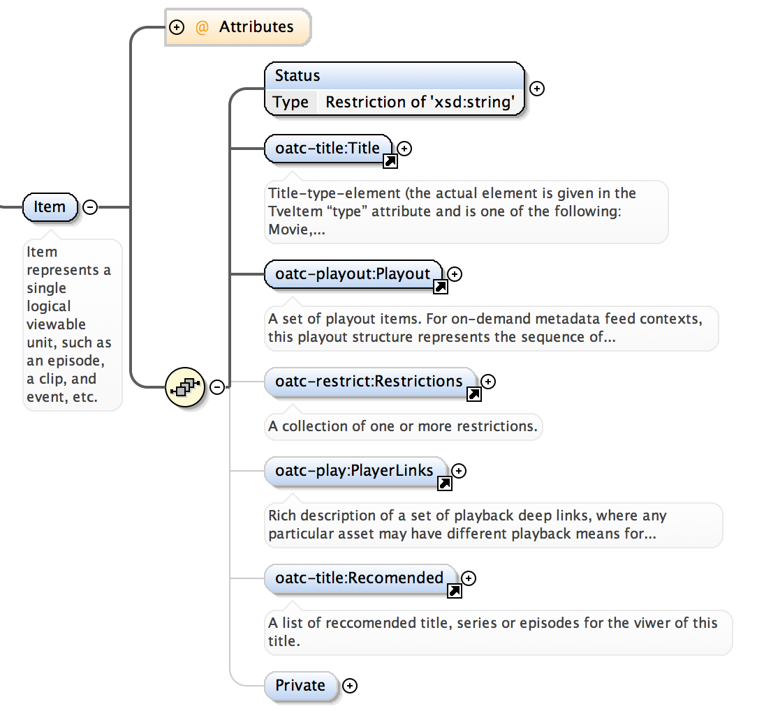

# metadata feeds

The delivery of TV Everywhere content metadata typically occurs in one of two ways: Static delivery of a metadata “side-car” file alongside audio/video content or delivery of a metadata document via web service (generally referred to as a “metadata feed”).

Under this feed concept the consumer of the metadata (e.g. a distributor/MVPD) would be expected to poll the web service periodically to learn of newly available content or changes to existing content. The polling rate is subject to agreement between the Provider and the Distributor, and is likely to differ for on-demand vs live channel simulcast use cases. For on-demand scenarios, it is encouraged that the data be refreshed, at minimum, on a two- to four-hour basis in order to facilitate quick and effective content takedowns when such a need arises. For live simulcast use cases, refresh rates may need to be quite frequent, accommodating late program schedule changes. In the live scenarios frame-accurate signaling is in-band in the video signal thus providing the key timing, with external *AiringIDs* and *PlayoutIDs* that can be referenced in the metadata feed for additional data.

For on-demand scenarios, a metadata feed describes all of the distributable content available to a given distributor at the time of the request, and/or for a pre-determined window afterwards. For example, a Provider may stipulate that the feed includes all content scheduled to become available at any time during the following eight hours. The actual time at which the content becomes visible to consumers is driven by data within the feed itself.

Data for a given Item may change from one update to the next, so Distributors are expected to parse the entire feed and apply changes to their own data stores as such changes occur. To assist with this process, each metadata feed contains a time stamp that indicates when the data was sent. This time stamp is an ever-increasing value useful for comparison.

The metadata feed is presented in all cases as an XML document.

# playout description

The *oatc-play:Playout* element describes the content of this particular item and should be interpreted relative to the delivery context. For example, in the on-demand delivery context, the *Playout* contains *PlayoutItems* that are representative of content segments (and the video assets that a segment is comprised of) and ad breaks.

One can think of an *Item* as having a “timeline”. Stacking together one or more *PlayoutItem* elements forms an end-to-end content item; the entire “stack” constitutes the complete content on that timeline. A three-segment program might consist of three *PlayoutItem*s of type “segment”, each with associated *PlayoutItem*s of type “vodAsset”. Furthermore, *PlayoutItems* can be nested, enabling representation of ad ad break (pod) and its individual elements.

A *PlayoutItem* has a start time and an end time. There should never be overlap between two or more segment descriptors. When a *PlayoutItem* of type *vodAsset* is a child of a *PlayoutItem* of type *segment*, it may, in certain cases, be necessary to ignore some leading content in the video file. This offset can be specified with the *start* attribute on the type *vodAsset* element. Thus, the timeline for a typical half-hour show might be 22 minutes long, with the first five minutes coming from one file, the next 11 minutes from another, and the final 8 minutes from yet another. Or, the same show could be specified as coming from a single file that contains all three segments with, perhaps, black video between them. When the timeline is constructed the program is fully described from start to end.

*PlayoutItem*s of type *pod* may be inserted in a similar fashion. Each *pod* element has a defined start time that references the overall program timeline. Thus, a break can be scheduled to begin at 5 minutes and end just a second later. Note that there can be any length of content dynamically inserted into the space defined by the *PlayoutItem*-- the duration is NOT defined by the content segments themselves. The break defines the “hole” that is cut into the program to be filled with some other video upon playback.

<oatc-playout:Playout>  
 <oatc-playout:PlayoutItem seq="0"   
 AiringID="AiringID1"   
 ScheduleStartTime="2014-05-04T18:13:51.0"   
 ItemType="segment">  
 <oatc-playout:Thumbs PreferredSet="TitleThumbnails">  
 <oatc-playout:ThumbSet Name="TitleThumbnails">  
 <oatc-playout:AltText Value="Main Title Thumbnail Art"/>  
 <oatc-playout:Thumb Name="Main"   
 Height="1024" ImageURL="http://www.imdb.com/title/tt1663676/"/>  
 </oatc-playout:ThumbSet>  
 </oatc-playout:Thumbs>  
 <oatc-playout:PlayoutItem seq="0"   
 AiringID="AiringID1.1"   
 ScheduleEndTime="2014-05-04T18:13:51.0"  
 ScheduleStartTime="2014-05-04T18:13:51.0"  
 ItemType="vodAsset"  
 Filename="somefile.mp4">  
   
 </oatc-playout:PlayoutItem>  
 </oatc-playout:PlayoutItem>  
 <oatc-playout:PlayoutItem seq="1"   
 AiringID="AiringID2"   
 ScheduleStartTime="2014-05-04T18:13:51.0"   
 ItemType="pod" Duration=”30”>  
 </oatc-playout:PlayoutItem>  
</oatc-playout:Playout>

For the live metadata context, the notion of *Playout* and *Playoutitem* is similar, but should be interpreted as a description of events occurring in a live linear feed rather than as the structure of a static VOD asset. Granularity of the description of playout elements is at the programmer’s discretion. As an example, an ad break can be specified with no internal details, or can be specified with details for each ad element via recursive inclusion of child *PlayoutItems*.

<oatc-playout:Playout>  
 <oatc-playout:PlayoutItem seq="0"   
 AiringID="AiringID1"   
 ScheduleStartTime="2014-05-04T18:13:51.0"   
 ItemType="segment">  
 </oatc-playout:PlayoutItem>  
 <oatc-playout:PlayoutItem seq="1"   
 AiringID="AiringID2"   
 ScheduleStartTime="2014-05-04T18:13:51.0"   
 ItemType="pod">  
 </oatc-playout:PlayoutItem>  
 <oatc-playout:PlayoutItem seq="2"   
 AiringID="AiringID3"   
 ScheduleStartTime="2014-05-04T18:13:51.0"   
 ItemType="segment">  
 </oatc-playout:PlayoutItem>  
 </oatc-playout:Playout>

# playerlinks description

The *PlayerLinks* schema provides rich description of URLs that should be used for content play out. An individual *PlayerLink* represents a specific type of deep link (a page link, OS-specific app link, streaming links, etc.) and the metadata that describes how and when that link should be used.

The types of player links are:

* **page** – Simple link to a web page containing the video.
* **embed** – Specification for a video player to be included in a web page, either as an iframe or an embed.
* **streaming** – Specification for a streaming url that can be used with a distributor’s video player.
* **applink** – Specification for a deep link to a video title within an application.
* **preview** – Link to a preview of the title.
* **Custom** – Private types can be added for custom use cases using a “private:” notation that is valid within the schema.

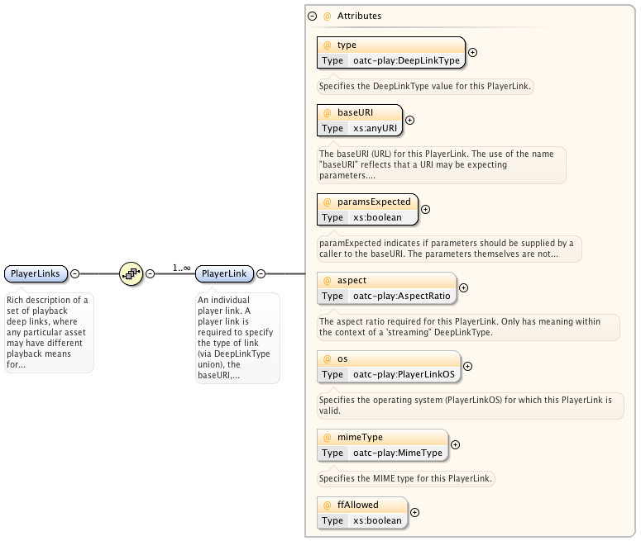

# usage restriction

Some content items are subject to restrictions from the content owner as to what types of devices, software can be used to play the content in various temporal windows. Additionally, device features and geography might impact usage rights. The *oatc-restrictions* schema describes these restrictions and actions that should be taken when a restriction is triggered.

There are three types of restrictions that can be contained within a *Restrictions* element: *Flights*, *RecordRules*, and *AllowDeny.* A *Flight* restriction is a viewing restriction that applies to a particular amount of time. *Flight* data is generally only meaningful for on-demand delivery contexts. *RecordRules* specify the required behavior of network PVR capture for future playback. *RecordRules* is only meaningful for the live delivery context. Both of these restriction types make further use of the third type, *AllowDeny*.

*AllowDeny* rules specify whether a particular platform, OS, venue, etc., is allowed to view this content subject to this and other rules. *AllowDeny* has a single attribute called *Order* that specifies the initial state before any contained rules are processed. NOTE: Care should be taken on the part of the feed creator to ensure that *AllowDeny* rules are sensible and can be interpreted by feed recipients.

If appropriate rights can’t be determined, an *Action* specifies what a Distributor of Client should do. A typical *Action* may be to display a blackout, slate, or play alternate content that may have its own set of restrictions. A Provider should be very careful to ensure that appropriate *Action*s are specified.

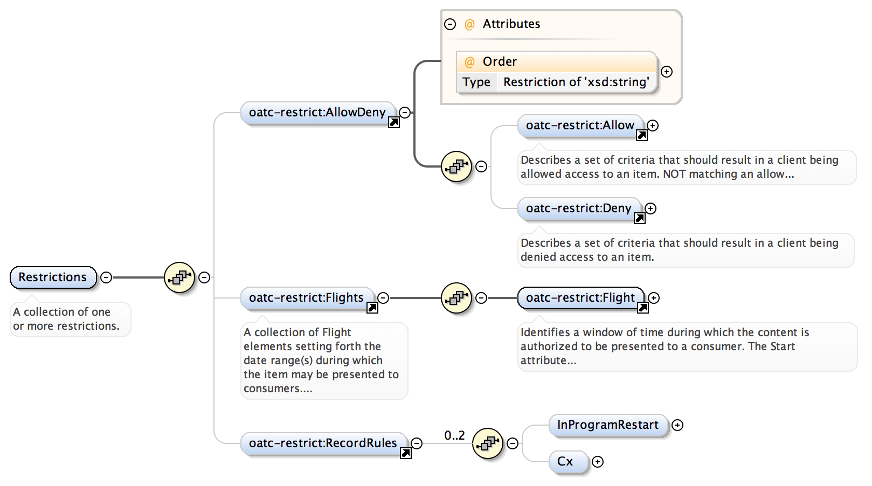

# appendix a – full schema documentation