1 - shutil. copy() will copy a single file, while shutil. copytree() will copy an entire folder and every folder and file contained in it.

2 - os. rename() method in Python is used to rename a file or directory

3- The send2trash functions will move a file or folder to the recycle bin, while shutil functions will permanently delete files and folders.

4 - OpenRead(String) Method.

5-

import os

import shutil

def **get_files**(directory, filter_extension = None):

for root,_, files in os.walk(directory):

for file in files:

if filter_extension is None or file.lower().endswith(filter_extension):

yield os.path.join(root ,file)

def **select_copy**(source , target, file_extension =None):

for file in get_files(source, file_extension):

print(file)

shutil.copy(file,target)

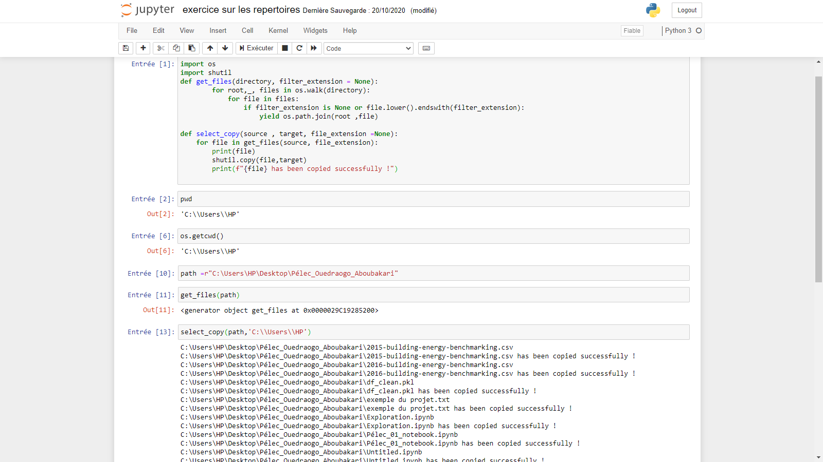 print(f"{file} has been copied successfully !")