**Advanced Programming**

**Assignment 1**

|  |
| --- |
| Osama Mohammed Afzal |
| 237529 |
| CS – 7B |

Technical Details:

* OSS: opencart
* Server used: WAMP
* Environment: Windows



**Exploring as a User**

* The user interface provided by the e-commerce framework is pretty simple to use.
* The mainstream categories are listed on a top bar which allows the user to instantly get to the required product category
* A search bar is also provided on the top right of the website with an ample amount of space hence text will not be hidden
* Right next to the search bar is the cart which lists the number of items in the cart and the total amount payable
* On selecting a category all the products are listed in a card like menu with options to ADD TO CART | ADD TO WISHLIST | COMPARE WITH OTHER STORES
* The card also lists price excluding the taxes
* The model the description and the picture makes the decision quite helpful
* On adding to cart this green bar is visible and the user is auto scrolled up to it to notify them about it
* On the top left of this bar the currency options are given a form of customization a user like me would love
* Next comes up the Helpline you can reach to if you need assistance
* Right next to it is the My Account drop down menu which allows you to:
  + Customize your account
  + Look at your order history
  + See all your Transactions
  + Logout
* Following is the wish list shopping cart and checkout shortcut buttons

**Reviewing as a user**

Overall the system which is provided on applying the opencart framework is quite helpful. It gives me as a user all the functionalities I would expect from an e-commerce website. It allows me to select as many products as I want and then buy them. In addition it also provide loyalty points on buying stuff so that is quite an incentive. The User-Interface is very user friendly and everything is placed in a way keeping the user in mind.

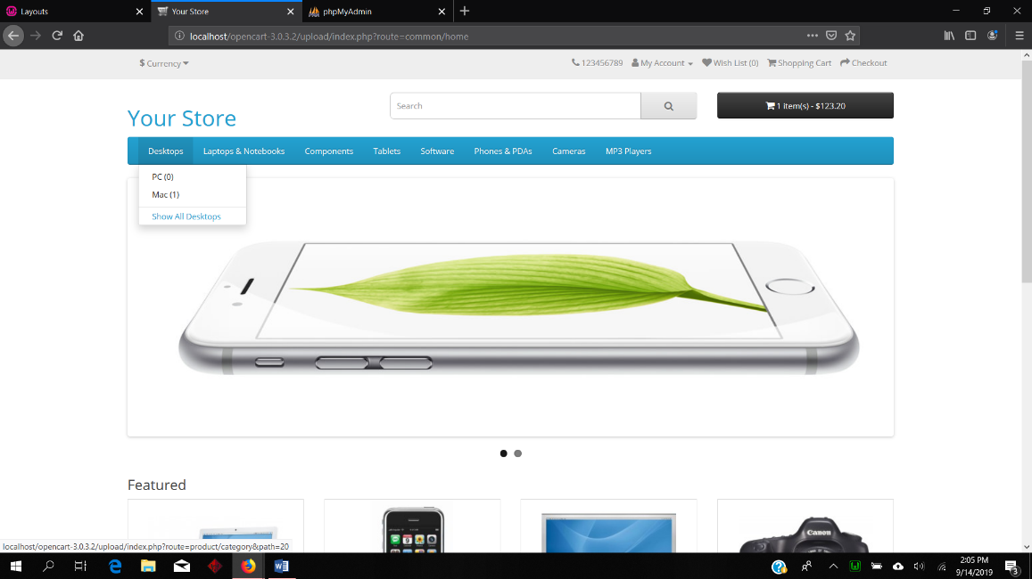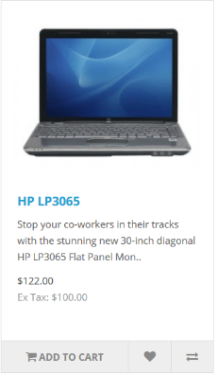

**Exploring as a Developer**

1. **Architecture Details**
   * Opencart is based on a MVC architecture
   * MVC stands for Model, View and Controller
   * **Model**: The code for data storing, editing and retrieval or in short any database related work is done using this part of MVC architecture
   * **View**: This is where everything related to view is stored. For instance all the themes may be stored here
   * **Controller**: This is where the magic happens. The controller chooses data using the model and then pushes it into the correct view.

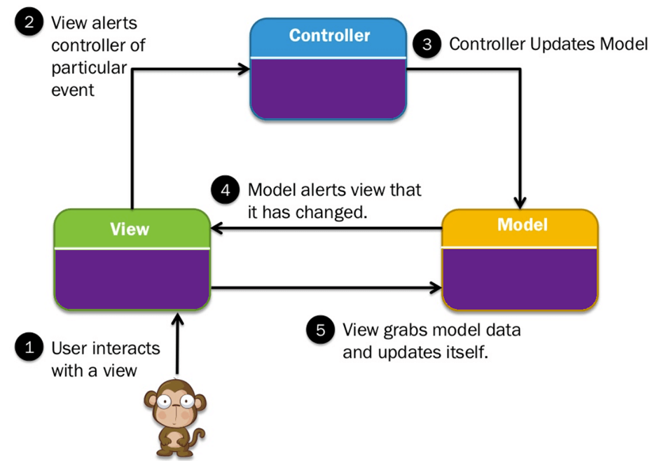

https://www.guru99.com/mvc-tutorial.html

1. **File Directory**
   * The front-end and the back-end (admin) are split into two separate folders and the shared library folder:
     1. admin : Admin Panel
     2. catalog : Store Front
     3. 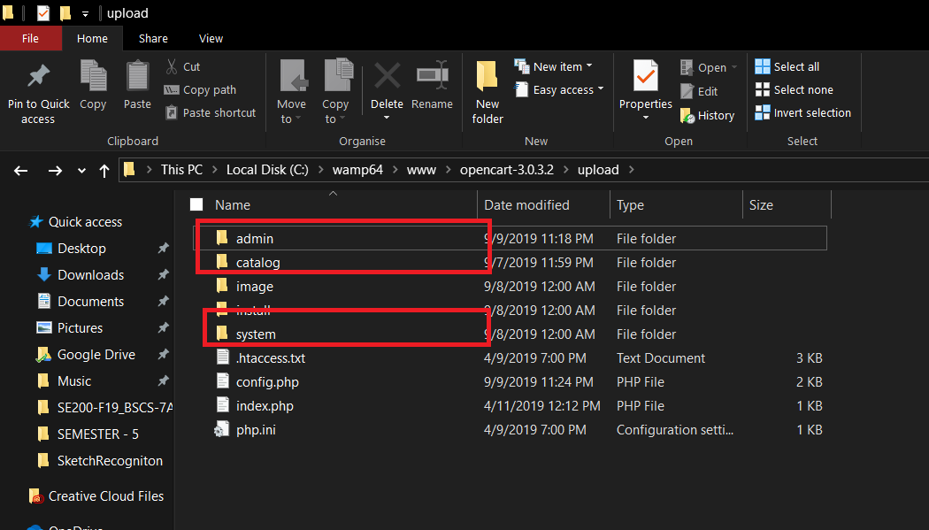system : Shared System Files

* Going inside **>admin** further leads us to:

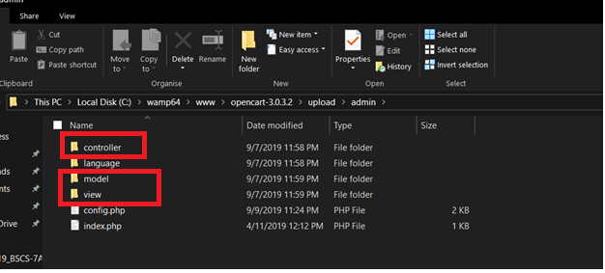

* It can be seen from the picture above that the directory above is structured into three folders which is **Model, View and Controller**

Further exploring into **>Model**

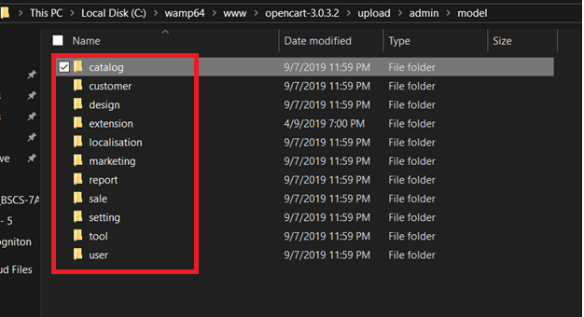

The above picture shows a few folders

On exploring the admin panel we find:

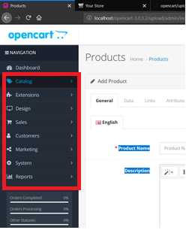

* It can be seen that the same folders which were listed above appeared here on the admin panel.

From this we can conclude that the directories are structured in a way which resembles the admin panel and this also proofs that the MVC architecture is being followed.

1. **Delving into the Code**
   * **Exploring Model**

Exploring attributes.php file in Admin/Model/

* + 1. An SQL query which is used for inserting an attribute looks like this:
    2. **"INSERT INTO ".DB_PREFIX ."attribute SET attribute_group_id = '" . (int)$data['attribute_group_id'] . "', sort_order = '" . (int)$data['sort_order'] . "'"**
    3. The above is a traditional insert query in which the data is obtained from the fields which were filled in the admin panel by the admin

On exploring the code throughout the model folder one can easily conclude that all files related to the model category are using traditional queries which they receive through the controller module of MVC.

* + **Exploring Controller**

For every controller file there is an index method which is run whenever the file starts

Exploring attributes.php file in Admin/Controller/

* + 1. The Add function in this file firstly loads the language either Admin or Catalog depending on which model we are working on
    2. It then sets the title of the document
    3. Attaches the corresponding model
    4. Passes the data which the user entered to Model/attribute.php which interacts with the database

On exploring the code throughout the Controller folder one can easily conclude that all files related to the controller category are doing two main tasks which is firstly the **routing process** and secondly **rendering the UI.**

1. **Installing an external plugin**
   * Two open source plugin were installed
   * The installing procedure was pretty simple
   * The package had to be downloaded and after unzipping copy the required folder into the root directory of opencart
   * Next upload the installation file onto the admin panel which installs it for you
   * Then activate the plugin and you could also edit some functionality if required to adjust it as per your requirement.
   * The two plugins that were installed were:
     1. **Opencart google translator**
     2. **Auto AdSense Ads for opencart 3.x.x**

**Review as a Developer**

Being a developer I was pretty impressed with how the MVC architecture structured the opencart application. If I wanted to change something which is related to the database all I have to do is go to the model directory and work there this ensures that the other categories which is Controller and Views aren’t affected due to the changes made.

Secondly opencart provided a very well balanced admin panel which allows customization which mostly removes the need for a developer if something small needs to be changed. From something as design intensive as Customizing the look and appeal to something as developer savvy as Installing a plugin and editing it all has been provided at one panel.

It is quite fascinating on how easy it has become to start an ecommerce site which is fully equipped to handle the competition of the current market