|  |  |  |
| --- | --- | --- |
| **OSAMA MOHAMMED AFZAL** | **CS-7B** | **237529** |

|  |
| --- |
| **TASK 01 (Server.py)** |
| import socket, threading  HOST = '127.0.0.1'  PORT = 8080  clients = []  clientNum = 1  def send_to_all(msg):      for client in clients :          client.sendall(bytes(msg,'UTF-8'))  class ClientThread(threading.Thread):      def __init__(self, CAddr, CSock,num):          super().__init__()  *self*.cnum = num  *self*.csocket = CSock  *self*.CAddr = CAddr          print("\nNew Connection Added: ",CAddr)      def run(self):          print("Connection from : ",*self*.CAddr,"\n")  *self*.csocket.send(bytes("You are connected as Client "+str(*self*.cnum) + "\n",'UTF-8'))          send_to_all("client "+str(*self*.cnum) + " has entered the chat")          while True:              data = *self*.csocket.recv(1024)              msg = data.decode()              if not msg:                  break              print("Client "+str(*self*.cnum),": ",msg)              send_to_all("Client "+str(*self*.cnum) + ": " + msg)              # self.csocket.send(bytes(msg,'UTF-8'))          print("client ",*self*.CAddr," disconnected\n")    with socket.socket(socket.AF_INET,socket.SOCK_STREAM) as s:      # s.setsockopt(socket.SOL_SOCKET, socket.SO_REUSEADDR,1)      s.bind((HOST,PORT))      while True:          s.listen(1)          conn, addr = s.accept()          clients.append(conn)          newthread = ClientThread(addr,conn,clientNum)          clientNum+=1          newthread.start() |

|  |
| --- |
| **TASK 01 (Client.py)** |
| import socket  import threading  from tkinter import *  def Enter_pressed(event):      input_get = input_field.get()      s.sendall(bytes(input_get,'UTF-8'))      input_user.set('')      return input_get  def toBoard(msg):        messages.config(state="normal")      messages.insert(INSERT, '%s\n' % msg)      messages.config(state="disabled")  def Get_Message():      while True:          data = s.recv(1024).decode()          toBoard(data)    HOST = '127.0.0.1'  PORT = 8080  window = Tk()  messages = Text(window,state="disabled")  messages.pack()  input_user = StringVar()  input_field = Entry(window, text=input_user,bd=5,font=("Calibri 12"))  input_field.pack(side=BOTTOM, fill=X,padx=5,pady=10)  frame = Frame(window)  input_field.bind("<Return>", Enter_pressed)  frame.pack()  with socket.socket(socket.AF_INET,socket.SOCK_STREAM) as s:      s.connect((HOST,PORT))      toBoard("Connected to Server")      t2 = threading.Thread(target=Get_Message,args=[])      t2.start()      window.mainloop() |

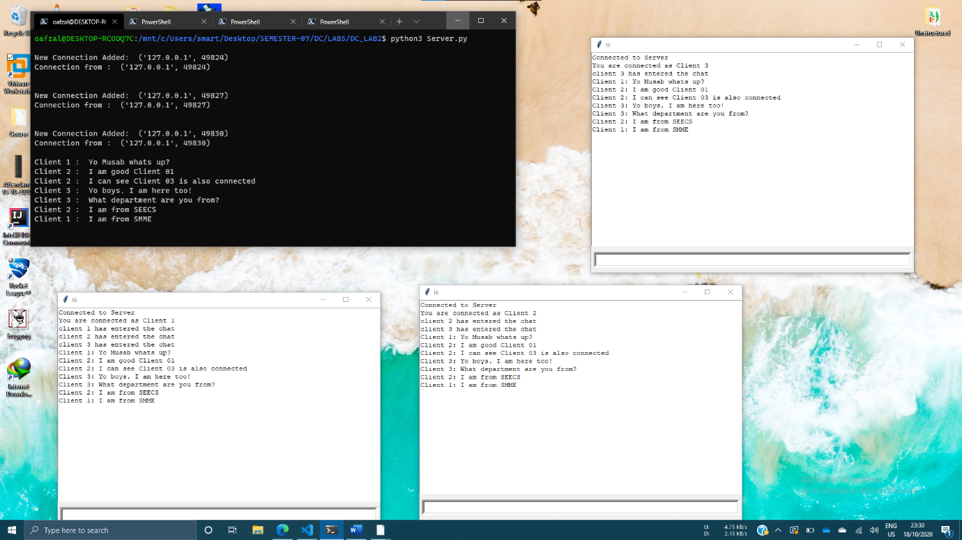

|  |
| --- |
| **TASK 02 (Server.py)** |
| import socket, threading  import re  HOST = '127.0.0.1'  PORT = 8080  clients = []  clientNum = 1  def send_to_all(msg):      for client in clients :          client[0].sendall(bytes(msg,'UTF-8'))  def send_to_unique(msg,toID,fromID):      if toID > len(clients):          clients[fromID][0].send(bytes("User Does not exist",'UTF-8'))      else:          print("Client"+str(fromID)+": "+msg)          clients[fromID][0].send(bytes("Client"+str(fromID)+": "+msg,'UTF-8'))          clients[toID][0].send(bytes("Client"+str(fromID)+": "+msg,'UTF-8'))  class ClientThread(threading.Thread):      def __init__(self, CAddr, CSock,num):          super().__init__()  *self*.cnum = num  *self*.csocket = CSock  *self*.CAddr = CAddr          print("\nNew Connection Added: ",CAddr)      def run(self):          print("Connection from : ",*self*.CAddr,"\n")  *self*.csocket.send(bytes("You are connected as Client"+str(*self*.cnum) + "\n",'UTF-8'))          send_to_all("client"+str(*self*.cnum) + " has entered the chat")          while True:              data = *self*.csocket.recv(1024)              msg = data.decode()              if not msg:                  break              tokens = msg.split()              if tokens[0][0] == "@":                  user = int(re.search(r'\d+', tokens[0]).group())                  print(*self*.cnum," ",user)                  send_to_unique(msg,user-1,*self*.cnum-1)              else:                  print("Client"+str(*self*.cnum),": ",msg)                  send_to_all("Client"+str(*self*.cnum) + ": " + msg)          print("client",*self*.CAddr," disconnected\n")    with socket.socket(socket.AF_INET,socket.SOCK_STREAM) as s:      s.bind((HOST,PORT))      while True:          s.listen(1)          conn, addr = s.accept()          clients.append([conn,addr])          newthread = ClientThread(addr,conn,clientNum)          clientNum+=1          newthread.start() |

|  |
| --- |
| **TASK 02 (Client.py)** |
| import socket  import threading  from tkinter import *  def Enter_pressed(event):      input_get = input_field.get()      s.sendall(bytes(input_get,'UTF-8'))      input_user.set('')      return input_get  def toBoard(msg):        messages.config(state="normal")      messages.insert(INSERT, '%s\n' % msg)      messages.config(state="disabled")  def Get_Message():      while True:          data = s.recv(1024).decode()          toBoard(data)    HOST = '127.0.0.1'  PORT = 8080  window = Tk()  messages = Text(window,state="disabled")  messages.pack()  input_user = StringVar()  input_field = Entry(window, text=input_user,bd=5,font=("Calibri 12"))  input_field.pack(side=BOTTOM, fill=X,padx=5,pady=10)  frame = Frame(window)  input_field.bind("<Return>", Enter_pressed)  frame.pack()  with socket.socket(socket.AF_INET,socket.SOCK_STREAM) as s:      s.connect((HOST,PORT))      toBoard("Connected to Server")      t2 = threading.Thread(target=Get_Message,args=[])      t2.start()      window.mainloop() |

