

DAND Wrangle and Analyses Data

Omar Abdulaziz Alashikh

## Introduction:

In this project we will gather data from various sources and various formats to assess its quality and tidiness, after that we will start cleaning the data

## Gathering:

1. From (CSV) file that contains archive tweets for WeRateDog account, which was given by Udacity.
2. From (TSV) file that contains detailed data about the images in each tweet.
3. From (JSON) file that contains detailed data about the count of the favorite and retweets.

## Assessing Data:

I searched through the datasets to find any

quality or tidiness issues, either visually or through programming

## Quality Issus:

1. Missing Values
2. Incorrect dog names 3-Dupliated tweets

## Tidiness Issues:

1. Convert the nominator rating and denominator rating to actual rating.
2. Create single column that express the type of dog instead of four columns for each type.
3. Merge the data frames together

## Cleaning Data:

I tidied up the Twitter archive data frame, then the image prediction and the Twitter API data frame.

**Analyses**

# Q1: What are the most Dog stages

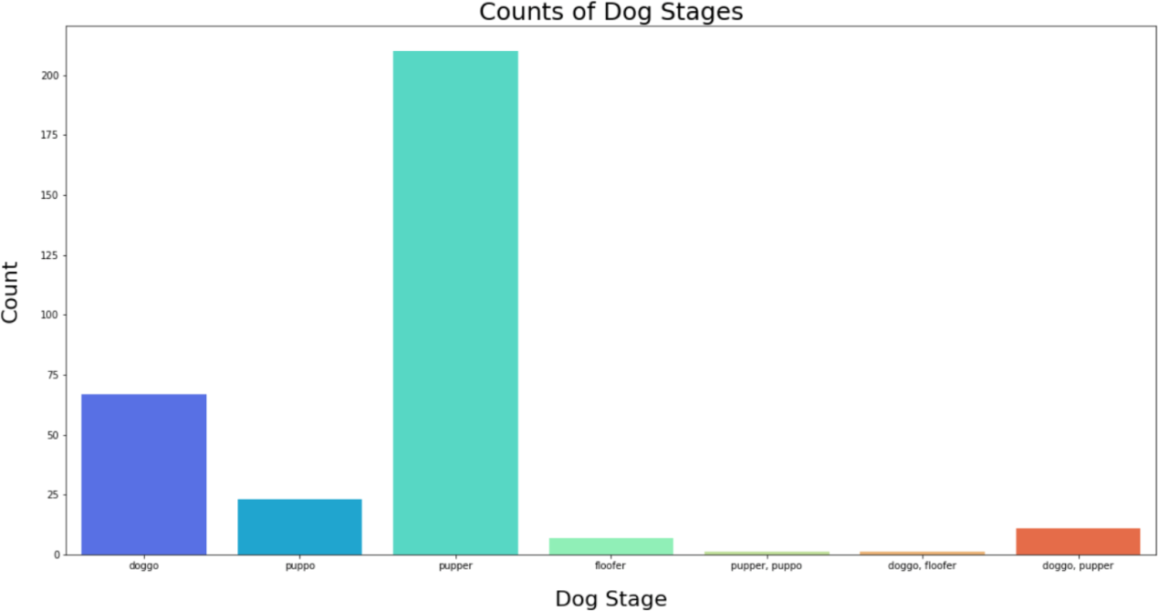

It’s the pupper breed

# Q2: The Statics of source tweets

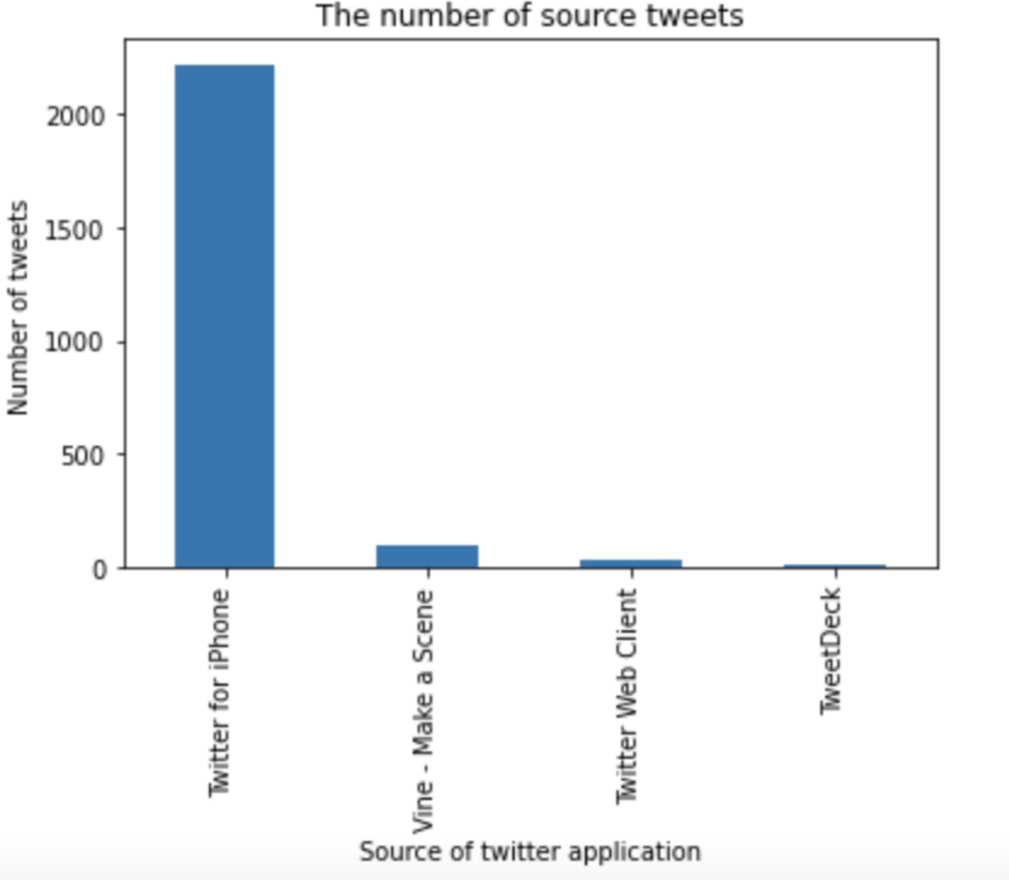

Twitter for iPhone users generates the most tweets.

# Q3: What is the Top 30 doggo names

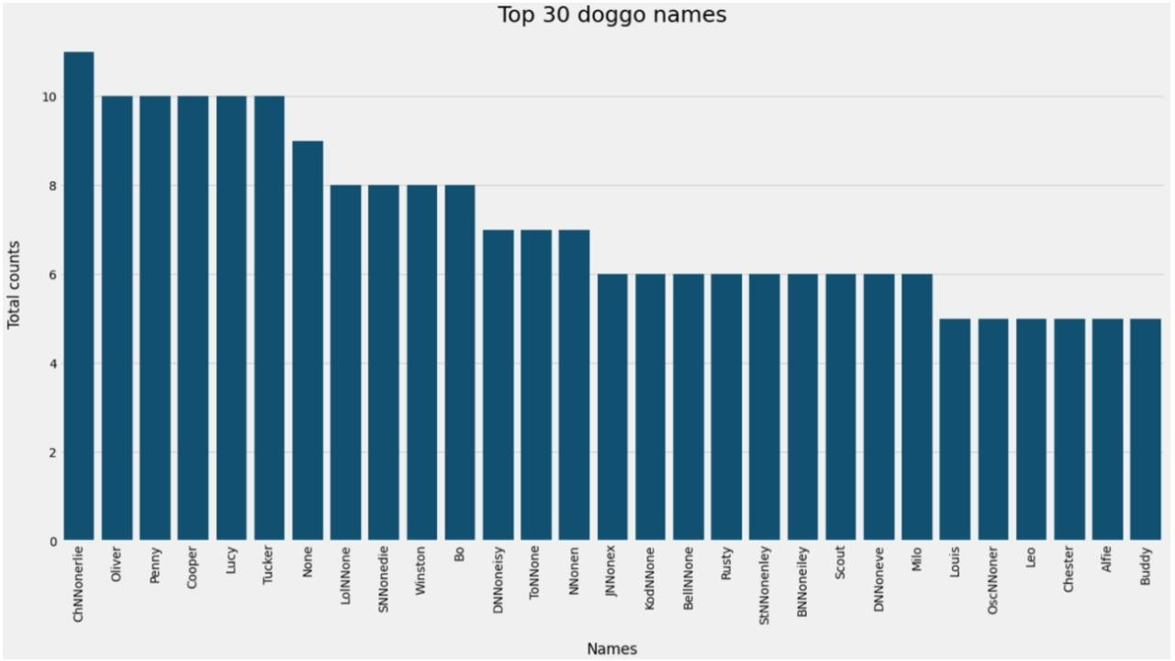

It’s not a static thing you can name your dog whatever you want

# Q4: What are the most popular dog breeds

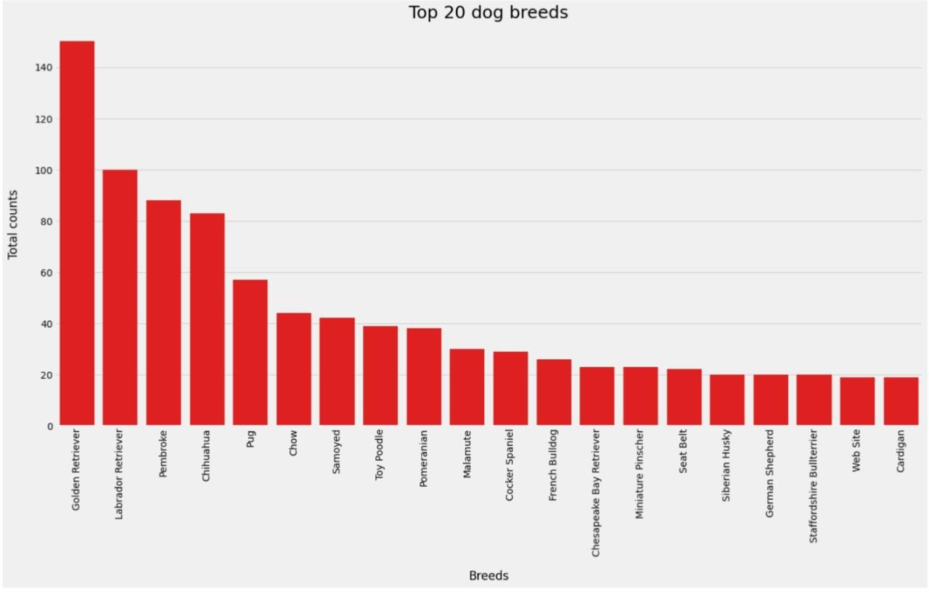

the most popular breed is the Golden Retriever