Vaja 02

Protein Folding Optimization - Threads

Andrija Obradović

15.11.2024. Maribor, Slovenija

# Results

## One thread:

The program was tested with following arguments:

ABBBBBBABBBAB -seed 1 -target -5.6104 -nfesLmt 1000000 -runtimeLmt 60.0 -Np 300 *-expRuns 50 -expThreads 1*

|  |  |  |  |  |  |
| --- | --- | --- | --- | --- | --- |
| run | seed | E | runtime | nfes | speed |
| 1 | 1 | -3.58275 | 2.14367 | 1000000 | 466490 |
| 2 | 2 | -4.25095 | 2.1101 | 1000000 | 473912 |
| 3 | 3 | -4.35414 | 2.17902 | 1000000 | 458922 |
| 4 | 4 | -3.965 | 2.09052 | 1000000 | 478350 |
| 5 | 5 | -3.86917 | 2.11427 | 1000000 | 472976 |
| 6 | 6 | -4.17073 | 2.09509 | 1000000 | 477306 |
| 7 | 7 | -4.25013 | 2.08778 | 1000000 | 478978 |
| 8 | 8 | -3.77517 | 2.15078 | 1000000 | 464947 |
| 9 | 9 | -3.74665 | 2.13111 | 1000000 | 469239 |
| 10 | 10 | -4.26663 | 2.13094 | 1000000 | 469276 |
| 11 | 11 | -4.58259 | 2.0302 | 1000000 | 492562 |
| 12 | 12 | -4.36008 | 2.08509 | 1000000 | 479595 |
| 13 | 13 | -4.40044 | 2.08639 | 1000000 | 479296 |
| 14 | 14 | -4.43146 | 2.09796 | 1000000 | 476655 |
| 15 | 15 | -3.57715 | 2.12606 | 1000000 | 470353 |
| 16 | 16 | -3.83576 | 2.11117 | 1000000 | 473671 |
| 17 | 17 | -4.56462 | 2.0951 | 1000000 | 477305 |
| 18 | 18 | -3.99316 | 2.07937 | 1000000 | 480916 |
| 19 | 19 | -3.86894 | 2.15347 | 1000000 | 464366 |
| 20 | 20 | -4.29416 | 2.14865 | 1000000 | 465407 |
| 21 | 21 | -4.23005 | 2.12632 | 1000000 | 470295 |
| 22 | 22 | -4.37482 | 2.12724 | 1000000 | 470093 |
| 23 | 23 | -3.67579 | 2.11916 | 1000000 | 471885 |
| 24 | 24 | -3.98831 | 2.13147 | 1000000 | 469160 |
| 25 | 25 | -4.58159 | 2.07539 | 1000000 | 481837 |
| 26 | 26 | -3.80741 | 2.11441 | 1000000 | 472945 |
| 27 | 27 | -4.35589 | 2.1227 | 1000000 | 471098 |
| 28 | 28 | -3.79814 | 2.07755 | 1000000 | 481336 |
| 29 | 29 | -4.07789 | 2.09003 | 1000000 | 478461 |
| 30 | 30 | -4.58049 | 2.03786 | 1000000 | 490711 |
| 31 | 31 | -4.26585 | 2.09091 | 1000000 | 478260 |
| 32 | 32 | -3.60702 | 2.11641 | 1000000 | 472499 |
| 33 | 33 | -3.87411 | 2.10141 | 1000000 | 475871 |
| 34 | 34 | -3.72828 | 2.12552 | 1000000 | 470473 |
| 35 | 35 | -3.78266 | 2.12518 | 1000000 | 470549 |
| 36 | 36 | -4.38449 | 2.15138 | 1000000 | 464818 |
| 37 | 37 | -3.72136 | 2.10667 | 1000000 | 474683 |
| 38 | 38 | -3.5042 | 2.14356 | 1000000 | 466513 |
| 39 | 39 | -3.92345 | 2.13998 | 1000000 | 467293 |
| 40 | 40 | -3.76266 | 2.18602 | 1000000 | 457453 |
| 41 | 41 | -4.06914 | 2.11661 | 1000000 | 472454 |
| 42 | 42 | -4.24262 | 2.14754 | 1000000 | 465650 |
| 43 | 43 | -4.43245 | 2.05095 | 1000000 | 487578 |
| 44 | 44 | -3.48438 | 2.0689 | 1000000 | 483349 |
| 45 | 45 | -4.07506 | 2.06039 | 1000000 | 485345 |
| 46 | 46 | -3.76437 | 2.0441 | 1000000 | 489213 |
| 47 | 47 | -3.98156 | 2.03209 | 1000000 | 492104 |
| 48 | 48 | -3.73919 | 2.11173 | 1000000 | 473545 |
| 49 | 49 | -3.88226 | 2.0827 | 1000000 | 480146 |
| 50 | 50 | -3.42214 | 2.09896 | 1000000 | 476426 |

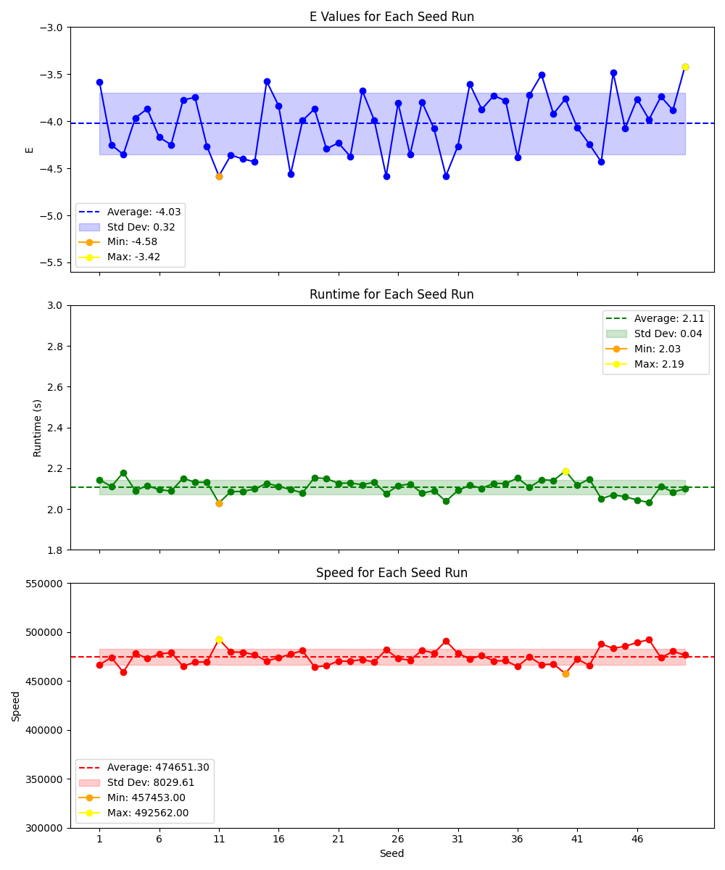

## Two threads:

The program was tested with following arguments:

ABBBBBBABBBAB -seed 1 -target -5.6104 -nfesLmt 1000000 -runtimeLmt 60.0 -Np 300 *-expRuns 50 -expThreads 2*

|  |  |  |  |  |  |
| --- | --- | --- | --- | --- | --- |
| run | seed | E | runtime | nfes | speed |
| 1 | 1 | -3.58275 | 2.23609 | 1000000 | 447209 |
| 2 | 2 | -4.25095 | 2.22869 | 1000000 | 448694 |
| 3 | 3 | -4.35414 | 2.14187 | 1000000 | 466881 |
| 4 | 4 | -3.965 | 2.15197 | 1000000 | 464690 |
| 5 | 5 | -3.86917 | 2.30609 | 1000000 | 433635 |
| 6 | 6 | -4.17073 | 2.29423 | 1000000 | 435877 |
| 7 | 7 | -4.25013 | 2.19312 | 1000000 | 455971 |
| 8 | 8 | -3.77517 | 2.20915 | 1000000 | 452663 |
| 9 | 9 | -3.74665 | 2.20773 | 1000000 | 452953 |
| 10 | 10 | -4.26663 | 2.18917 | 1000000 | 456794 |
| 11 | 11 | -4.58259 | 2.19635 | 1000000 | 455301 |
| 12 | 12 | -4.36008 | 2.25571 | 1000000 | 443320 |
| 13 | 13 | -4.40044 | 2.2073 | 1000000 | 453042 |
| 14 | 14 | -4.43146 | 2.18952 | 1000000 | 456722 |
| 15 | 15 | -3.57715 | 2.24027 | 1000000 | 446375 |
| 16 | 16 | -3.83576 | 2.23195 | 1000000 | 448039 |
| 17 | 17 | -4.56462 | 2.14321 | 1000000 | 466589 |
| 18 | 18 | -3.99316 | 2.13278 | 1000000 | 468872 |
| 19 | 19 | -3.86894 | 2.15773 | 1000000 | 463450 |
| 20 | 20 | -4.29416 | 2.11438 | 1000000 | 472953 |
| 21 | 21 | -4.23005 | 2.15547 | 1000000 | 463935 |
| 22 | 22 | -4.37482 | 2.155 | 1000000 | 464037 |
| 23 | 23 | -3.67579 | 2.161 | 1000000 | 462748 |
| 24 | 24 | -3.98831 | 2.17352 | 1000000 | 460083 |
| 25 | 25 | -4.58159 | 2.16068 | 1000000 | 462818 |
| 26 | 26 | -3.80741 | 2.21512 | 1000000 | 451443 |
| 27 | 27 | -4.35589 | 2.25674 | 1000000 | 443117 |
| 28 | 28 | -3.79814 | 2.23563 | 1000000 | 447302 |
| 29 | 29 | -4.07789 | 2.17699 | 1000000 | 459349 |
| 30 | 30 | -4.58049 | 2.1403 | 1000000 | 467223 |
| 31 | 31 | -4.26585 | 2.20115 | 1000000 | 454308 |
| 32 | 32 | -3.60702 | 2.19814 | 1000000 | 454930 |
| 33 | 33 | -3.87411 | 2.17511 | 1000000 | 459746 |
| 34 | 34 | -3.72828 | 2.1997 | 1000000 | 454608 |
| 35 | 35 | -3.78266 | 2.12142 | 1000000 | 471382 |
| 36 | 36 | -4.38449 | 2.15517 | 1000000 | 464000 |
| 37 | 37 | -3.72136 | 2.17076 | 1000000 | 460668 |
| 38 | 38 | -3.5042 | 2.1638 | 1000000 | 462149 |
| 39 | 39 | -3.92345 | 2.18549 | 1000000 | 457563 |
| 40 | 40 | -3.76266 | 2.17924 | 1000000 | 458875 |
| 41 | 41 | -4.06914 | 2.11401 | 1000000 | 473034 |
| 42 | 42 | -4.24262 | 2.13866 | 1000000 | 467583 |
| 43 | 43 | -4.43245 | 2.16776 | 1000000 | 461305 |
| 44 | 44 | -3.48438 | 2.23007 | 1000000 | 448416 |
| 45 | 45 | -4.07506 | 2.15938 | 1000000 | 463095 |
| 46 | 46 | -3.76437 | 2.16107 | 1000000 | 462735 |
| 47 | 47 | -3.98156 | 2.15539 | 1000000 | 463952 |
| 48 | 48 | -3.73919 | 2.17948 | 1000000 | 458825 |
| 49 | 49 | -3.88226 | 2.18508 | 1000000 | 457650 |
| 50 | 50 | -3.42214 | 2.21841 | 1000000 | 450774 |

# 

## Four threads:

The program was tested with following arguments:

ABBBBBBABBBAB -seed 1 -target -5.6104 -nfesLmt 1000000 -runtimeLmt 60.0 -Np 300 *-expRuns 50 -expThreads 4*

|  |  |  |  |  |  |
| --- | --- | --- | --- | --- | --- |
| run | seed | E | runtime | nfes | speed |
| 1 | 1 | -3.58275 | 2.38804 | 1000000 | 418754 |
| 2 | 2 | -4.25095 | 2.41256 | 1000000 | 414497 |
| 3 | 3 | -4.35414 | 2.35111 | 1000000 | 425331 |
| 4 | 4 | -3.965 | 2.31389 | 1000000 | 432172 |
| 5 | 5 | -3.86917 | 2.38181 | 1000000 | 419848 |
| 6 | 6 | -4.17073 | 2.36918 | 1000000 | 422086 |
| 7 | 7 | -4.25013 | 2.46307 | 1000000 | 405997 |
| 8 | 8 | -3.77517 | 2.41073 | 1000000 | 414812 |
| 9 | 9 | -3.74665 | 2.45939 | 1000000 | 406604 |
| 10 | 10 | -4.26663 | 2.46368 | 1000000 | 405897 |
| 11 | 11 | -4.58259 | 2.34039 | 1000000 | 427279 |
| 12 | 12 | -4.36008 | 2.364 | 1000000 | 423011 |
| 13 | 13 | -4.40044 | 2.35121 | 1000000 | 425313 |
| 14 | 14 | -4.43146 | 2.3257 | 1000000 | 429977 |
| 15 | 15 | -3.57715 | 2.35469 | 1000000 | 424685 |
| 16 | 16 | -3.83576 | 2.30608 | 1000000 | 433637 |
| 17 | 17 | -4.56462 | 2.39685 | 1000000 | 417214 |
| 18 | 18 | -3.99316 | 2.33998 | 1000000 | 427354 |
| 19 | 19 | -3.86894 | 2.35211 | 1000000 | 425150 |
| 20 | 20 | -4.29416 | 2.30725 | 1000000 | 433417 |
| 21 | 21 | -4.23005 | 2.39792 | 1000000 | 417028 |
| 22 | 22 | -4.37482 | 2.36784 | 1000000 | 422325 |
| 23 | 23 | -3.67579 | 2.38179 | 1000000 | 419853 |
| 24 | 24 | -3.98831 | 2.37894 | 1000000 | 420356 |
| 25 | 25 | -4.58159 | 2.40102 | 1000000 | 416490 |
| 26 | 26 | -3.80741 | 2.42322 | 1000000 | 412674 |
| 27 | 27 | -4.35589 | 2.48949 | 1000000 | 401689 |
| 28 | 28 | -3.79814 | 2.36414 | 1000000 | 422987 |
| 29 | 29 | -4.07789 | 2.34625 | 1000000 | 426212 |
| 30 | 30 | -4.58049 | 2.29883 | 1000000 | 435003 |
| 31 | 31 | -4.26585 | 2.35683 | 1000000 | 424298 |
| 32 | 32 | -3.60702 | 2.37002 | 1000000 | 421937 |
| 33 | 33 | -3.87411 | 2.25847 | 1000000 | 442778 |
| 34 | 34 | -3.72828 | 2.32788 | 1000000 | 429576 |
| 35 | 35 | -3.78266 | 2.36104 | 1000000 | 423542 |
| 36 | 36 | -4.38449 | 2.29334 | 1000000 | 436045 |
| 37 | 37 | -3.72136 | 2.34197 | 1000000 | 426992 |
| 38 | 38 | -3.5042 | 2.37138 | 1000000 | 421695 |
| 39 | 39 | -3.92345 | 2.37085 | 1000000 | 421789 |
| 40 | 40 | -3.76266 | 2.37169 | 1000000 | 421639 |
| 41 | 41 | -4.06914 | 2.36012 | 1000000 | 423708 |
| 42 | 42 | -4.24262 | 2.42417 | 1000000 | 412513 |
| 43 | 43 | -4.43245 | 2.37894 | 1000000 | 420356 |
| 44 | 44 | -3.48438 | 2.35209 | 1000000 | 425155 |
| 45 | 45 | -4.07506 | 2.36497 | 1000000 | 422839 |
| 46 | 46 | -3.76437 | 2.44947 | 1000000 | 408252 |
| 47 | 47 | -3.98156 | 2.30834 | 1000000 | 433212 |
| 48 | 48 | -3.73919 | 2.41136 | 1000000 | 414704 |
| 49 | 49 | -3.88226 | 2.15143 | 1000000 | 464806 |
| 50 | 50 | -3.42214 | 2.18021 | 1000000 | 458671 |

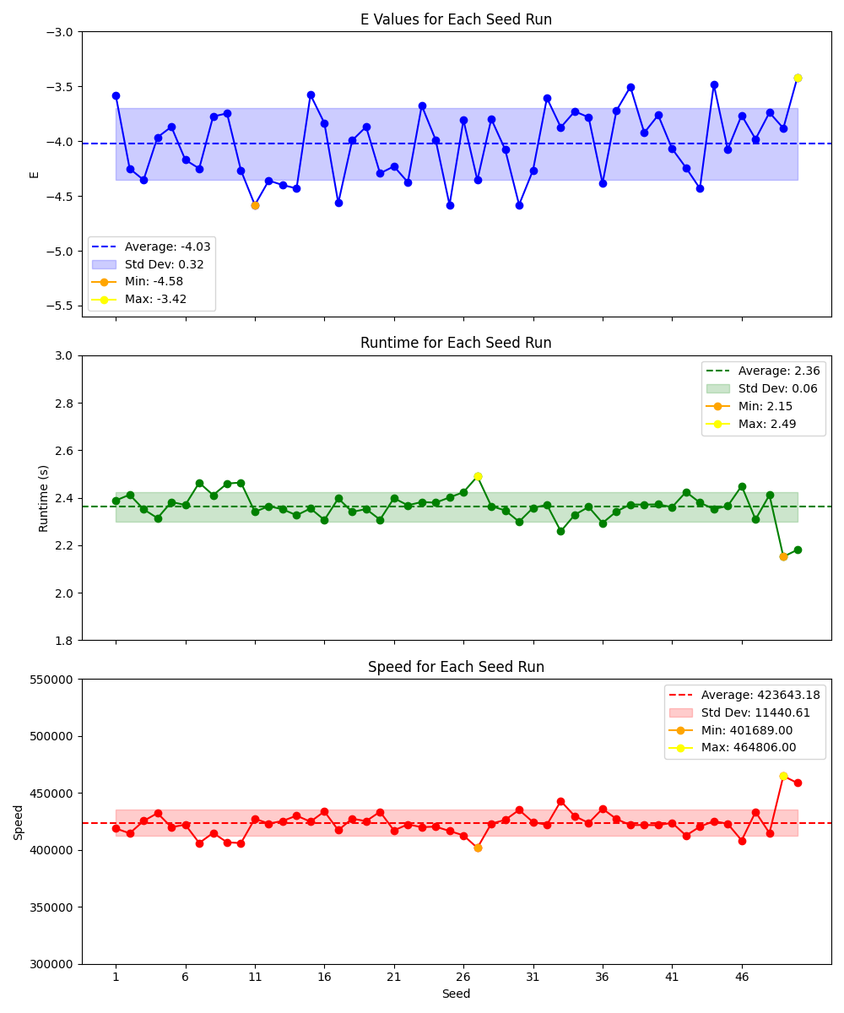

## Eight threads:

The program was tested with following arguments:

ABBBBBBABBBAB -seed 1 -target -5.6104 -nfesLmt 1000000 -runtimeLmt 60.0 -Np 300 *-expRuns 50 -expThreads 8*

|  |  |  |  |  |  |
| --- | --- | --- | --- | --- | --- |
| run | seed | E | runtime | nfes | speed |
| 1 | 1 | -3.58275 | 3.37711 | 1000000 | 296111 |
| 2 | 2 | -4.25095 | 3.26469 | 1000000 | 306307 |
| 3 | 3 | -4.35414 | 3.27368 | 1000000 | 305467 |
| 4 | 4 | -3.965 | 3.35848 | 1000000 | 297753 |
| 5 | 5 | -3.86917 | 3.36973 | 1000000 | 296760 |
| 6 | 6 | -4.17073 | 3.27254 | 1000000 | 305573 |
| 7 | 7 | -4.25013 | 3.4055 | 1000000 | 293643 |
| 8 | 8 | -3.77517 | 3.29891 | 1000000 | 303130 |
| 9 | 9 | -3.74665 | 3.07976 | 1000000 | 324701 |
| 10 | 10 | -4.26663 | 3.20118 | 1000000 | 312385 |
| 11 | 11 | -4.58259 | 3.11604 | 1000000 | 320920 |
| 12 | 12 | -4.36008 | 3.1024 | 1000000 | 322331 |
| 13 | 13 | -4.40044 | 3.04337 | 1000000 | 328583 |
| 14 | 14 | -4.43146 | 3.03767 | 1000000 | 329200 |
| 15 | 15 | -3.57715 | 3.21919 | 1000000 | 310637 |
| 16 | 16 | -3.83576 | 3.15104 | 1000000 | 317356 |
| 17 | 17 | -4.56462 | 3.00212 | 1000000 | 333098 |
| 18 | 18 | -3.99316 | 3.07081 | 1000000 | 325647 |
| 19 | 19 | -3.86894 | 3.13052 | 1000000 | 319436 |
| 20 | 20 | -4.29416 | 3.07299 | 1000000 | 325416 |
| 21 | 21 | -4.23005 | 3.2049 | 1000000 | 312022 |
| 22 | 22 | -4.37482 | 3.11812 | 1000000 | 320706 |
| 23 | 23 | -3.67579 | 3.04319 | 1000000 | 328603 |
| 24 | 24 | -3.98831 | 3.04124 | 1000000 | 328813 |
| 25 | 25 | -4.58159 | 3.03876 | 1000000 | 329081 |
| 26 | 26 | -3.80741 | 3.04168 | 1000000 | 328766 |
| 27 | 27 | -4.35589 | 2.97844 | 1000000 | 335746 |
| 28 | 28 | -3.79814 | 3.03496 | 1000000 | 329494 |
| 29 | 29 | -4.07789 | 2.97094 | 1000000 | 336594 |
| 30 | 30 | -4.58049 | 3.02796 | 1000000 | 330255 |
| 31 | 31 | -4.26585 | 2.9934 | 1000000 | 334068 |
| 32 | 32 | -3.60702 | 3.00523 | 1000000 | 332753 |
| 33 | 33 | -3.87411 | 2.98061 | 1000000 | 335501 |
| 34 | 34 | -3.72828 | 3.11689 | 1000000 | 320833 |
| 35 | 35 | -3.78266 | 2.9389 | 1000000 | 340263 |
| 36 | 36 | -4.38449 | 3.06144 | 1000000 | 326643 |
| 37 | 37 | -3.72136 | 3.06145 | 1000000 | 326642 |
| 38 | 38 | -3.5042 | 2.98327 | 1000000 | 335202 |
| 39 | 39 | -3.92345 | 3.06693 | 1000000 | 326059 |
| 40 | 40 | -3.76266 | 3.02682 | 1000000 | 330380 |
| 41 | 41 | -4.06914 | 2.821 | 1000000 | 354484 |
| 42 | 42 | -4.24262 | 2.94166 | 1000000 | 339944 |
| 43 | 43 | -4.43245 | 2.94405 | 1000000 | 339668 |
| 44 | 44 | -3.48438 | 3.01473 | 1000000 | 331705 |
| 45 | 45 | -4.07506 | 3.03141 | 1000000 | 329879 |
| 46 | 46 | -3.76437 | 2.89869 | 1000000 | 344984 |
| 47 | 47 | -3.98156 | 2.75589 | 1000000 | 362859 |
| 48 | 48 | -3.73919 | 2.94768 | 1000000 | 339250 |
| 49 | 49 | -3.88226 | 2.31916 | 1000000 | 431190 |
| 50 | 50 | -3.42214 | 2.28269 | 1000000 | 438079 |

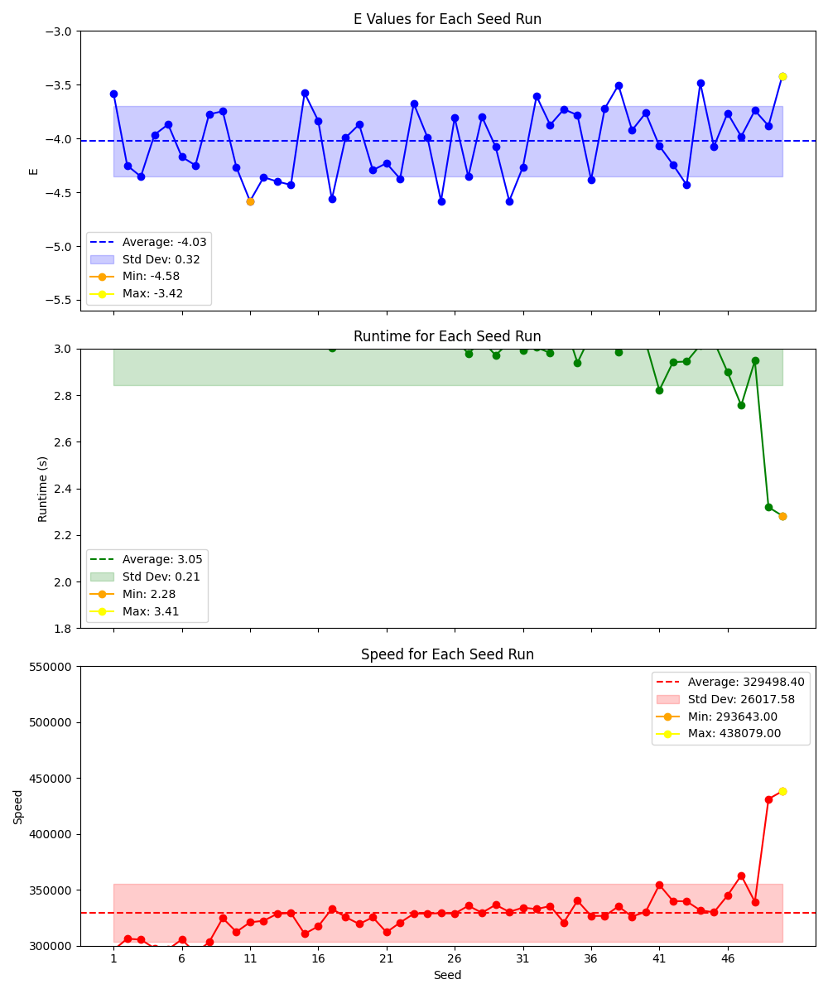

## Sixteen threads:

The program was tested with following arguments:

ABBBBBBABBBAB -seed 1 -target -5.6104 -nfesLmt 1000000 -runtimeLmt 60.0 -Np 300 *-expRuns 50 -expThreads 16*

|  |  |  |  |  |  |
| --- | --- | --- | --- | --- | --- |
| run | seed | E | runtime | nfes | speed |
| 1 | 1 | -3.58275 | 6.46807 | 1000000 | 154606 |
| 2 | 2 | -4.25095 | 3.63487 | 1000000 | 275113 |
| 3 | 3 | -4.35414 | 4.20532 | 1000000 | 237794 |
| 4 | 4 | -3.965 | 4.61139 | 1000000 | 216855 |
| 5 | 5 | -3.86917 | 6.44559 | 1000000 | 155145 |
| 6 | 6 | -4.17073 | 4.52931 | 1000000 | 220784 |
| 7 | 7 | -4.25013 | 3.63535 | 1000000 | 275077 |
| 8 | 8 | -3.77517 | 3.65752 | 1000000 | 273409 |
| 9 | 9 | -3.74665 | 6.53893 | 1000000 | 152930 |
| 10 | 10 | -4.26663 | 6.3868 | 1000000 | 156573 |
| 11 | 11 | -4.58259 | 4.48722 | 1000000 | 222855 |
| 12 | 12 | -4.36008 | 4.96123 | 1000000 | 201563 |
| 13 | 13 | -4.40044 | 4.39317 | 1000000 | 227626 |
| 14 | 14 | -4.43146 | 4.49731 | 1000000 | 222355 |
| 15 | 15 | -3.57715 | 6.38981 | 1000000 | 156499 |
| 16 | 16 | -3.83576 | 6.45685 | 1000000 | 154874 |
| 17 | 17 | -4.56462 | 3.94538 | 1000000 | 253461 |
| 18 | 18 | -3.99316 | 4.08781 | 1000000 | 244630 |
| 19 | 19 | -3.86894 | 4.01611 | 1000000 | 248997 |
| 20 | 20 | -4.29416 | 5.73986 | 1000000 | 174220 |
| 21 | 21 | -4.23005 | 4.72172 | 1000000 | 211787 |
| 22 | 22 | -4.37482 | 4.60341 | 1000000 | 217230 |
| 23 | 23 | -3.67579 | 4.56272 | 1000000 | 219168 |
| 24 | 24 | -3.98831 | 4.65855 | 1000000 | 214659 |
| 25 | 25 | -4.58159 | 4.62596 | 1000000 | 216171 |
| 26 | 26 | -3.80741 | 4.35463 | 1000000 | 229641 |
| 27 | 27 | -4.35589 | 5.57711 | 1000000 | 179304 |
| 28 | 28 | -3.79814 | 4.35194 | 1000000 | 229782 |
| 29 | 29 | -4.07789 | 5.51367 | 1000000 | 181367 |
| 30 | 30 | -4.58049 | 5.67306 | 1000000 | 176272 |
| 31 | 31 | -4.26585 | 5.46423 | 1000000 | 183008 |
| 32 | 32 | -3.60702 | 5.64842 | 1000000 | 177041 |
| 33 | 33 | -3.87411 | 4.49038 | 1000000 | 222698 |
| 34 | 34 | -3.72828 | 4.6193 | 1000000 | 216483 |
| 35 | 35 | -3.78266 | 4.58546 | 1000000 | 218081 |
| 36 | 36 | -4.38449 | 4.35891 | 1000000 | 229415 |
| 37 | 37 | -3.72136 | 4.38158 | 1000000 | 228228 |
| 38 | 38 | -3.5042 | 4.5479 | 1000000 | 219882 |
| 39 | 39 | -3.92345 | 4.43252 | 1000000 | 225605 |
| 40 | 40 | -3.76266 | 4.5376 | 1000000 | 220381 |
| 41 | 41 | -4.06914 | 4.50401 | 1000000 | 222025 |
| 42 | 42 | -4.24262 | 4.80359 | 1000000 | 208178 |
| 43 | 43 | -4.43245 | 3.82067 | 1000000 | 261734 |
| 44 | 44 | -3.48438 | 3.6843 | 1000000 | 271422 |
| 45 | 45 | -4.07506 | 3.6819 | 1000000 | 271599 |
| 46 | 46 | -3.76437 | 3.64652 | 1000000 | 274234 |
| 47 | 47 | -3.98156 | 3.26712 | 1000000 | 306080 |
| 48 | 48 | -3.73919 | 3.58238 | 1000000 | 279144 |
| 49 | 49 | -3.88226 | 3.51827 | 1000000 | 284231 |
| 50 | 50 | -3.42214 | 3.25533 | 1000000 | 307189 |

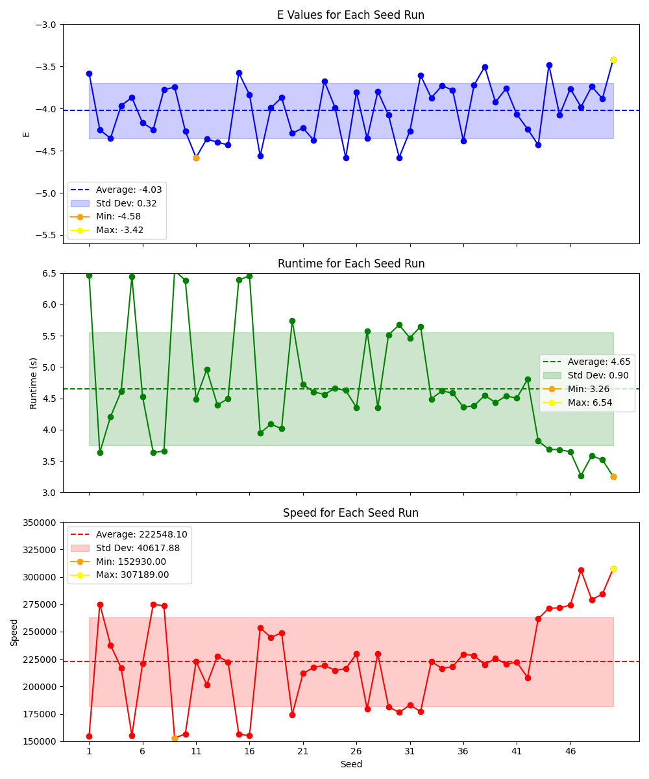

# Runtime comparison

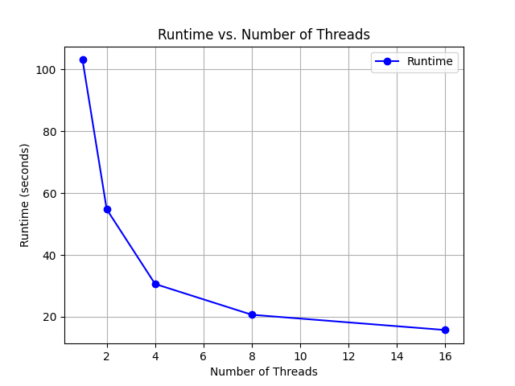

# Computer Hardware

CPU: AMD Ryzen 5 5600G (6-core 3.9ghz)

RAM: 32 GB (2133mhz)