REPUBLIC OF RWANDA

KIGALI INDEPENDENT UNIVERSITY ULK

P.O Box 2280 Kigali

Website://www.ulk.ac.rw

E-mail: [infos@ulk.ac.rw](mailto:infos@ulk.ac.rw)



**CAT 2 ASSIGNMENT OF**

**SOFTWARE ENGENEERING**

**Year III COMPUTER SCIENCE**

Done By:

* **201720 379**
* **201720 502**

Lecture: **KAGARAMA J. Baptist**

Academic Year: 2019-2020

1. **Mention the topic of your project and its case study**

**Answer:**

ANALYSIS, DESIGN AND IMPLEMENTATION OF A BANK CUSTOMERS MANAGEMENT SYSTEM.

1. **Give a brief introduction to your project**

**Answer:**

**Introduction**

As we know the technology is defined as the application of scientific knowledge for practical purposes, and is all about the use and knowledge of techniques and processes for producing goods and services especially in companies and industries.

The bank does not need to take for a long-standing dealing with the manual techniques to save information of customer which can lead to a very serious waste of time, so budding technologies have altered the banking industry from paper and conventional approach to digital approach.

Today, banks are looking beyond the transactions to the full opportunity on how to manage their customers. Accordingly, they are moving beyond managing clients as simple contacts to a whole new level of client relationship management, crafting a superior commercial client experience that gives the bank a competitive advantage and a more loyal, profitable and committed customers. The main intention behind the commencement of electronic banking services is to provide the customers with an alternative that is more responsive and with less expensive options.

The bank does not need to take for a long-standing dealing with the manual techniques to save information of customer which can lead to a very serious west of time, so budding technologies have altered the banking industry from paper and conventional approach to digital approach.

1. **Describe the problem statement**

**Answer:**

Problem Statement

Look at the current system we are facing some problems such as:

* The lack of the customer’s private data in the company.
* The rapid problem of the transaction processes.
* Issues suck fraud operating within a conventional environment.
* Lack of adequate security measure is making it really challenging to successfully transform the bank customers.
* The lack communication between the bank and their customers

1. **Describe project objective(Both general and specific objectives)**

**Answer:**

**Objectives:**

General Objective

The main objective of this project is to develop, to improve and to implement the good performance of managing customers in a bank and to have a big interaction between a bank and customers effectively and efficiency.

Specific Objective

There are many specific objectives but according to our project we have been concentrated on only some of them such as:

* Providing a printed deposit and withdrawal slips;
* Record automatically customers private data;
* To create a database which will store all customers informations and all transactions datas;
* To have a efficiency communication with customers;
* To describe and print the customers list;

1. **Describe a scenario showing the way the system will be working**

**Answer:**

* **The Bank Customers Management System** allow only administrator to login and after login the Admin can register customers informations, can create account and only the registered customers can be able to make transactions like deposits, withdrawal and to have credit and the administrator can manage customers data by editing, deleting some private data.

After doing any transaction the system sends messages automatically to the customers.

The customer can also verify his account balance by sending a message to the system.

Also after all processes the system will be able to print the customers list, All Transactions (Deposit, Withdrawal, Credits) Reports and Slips, Communications Report.

All data such as Customer Informations, Transactions (Deposit, Withdrawal and Credits), all communication and Slips should be store in the database.

1. **Describe all functional requirements for your system**

**Answer:**

All functional requirements are:

* Administrator login
* Register customers/Account creation
* Deposit processes
* Withdrawal processes
* Credit processes
* Edit Customer’s private data
* Delete Customer’s private data
* Sending messages
* Print customers list
* Print all transactions(Deposit, Withdrawal and Credit) slips
* Print all communications

1. **Briefly describe the system analysis and design method you prefer to use**

**Answer:**

Structured Systems Analysis & Design methodology

1. **On the basis of the method you selected in (vii) above, draw the following diagrams**

* **Level 0/context, Level 1 Data Flow Diagram and Entity Relationship Diagram for your system.**

**OR**

* **Use cases, Class diagram and Sequence diagram for your system.**

**Answer:**

* **Level 0/context, Level 1 Data Flow Diagram and Entity Relationship Diagram for your system**

1. **LEVEL 0/CONTEXT**

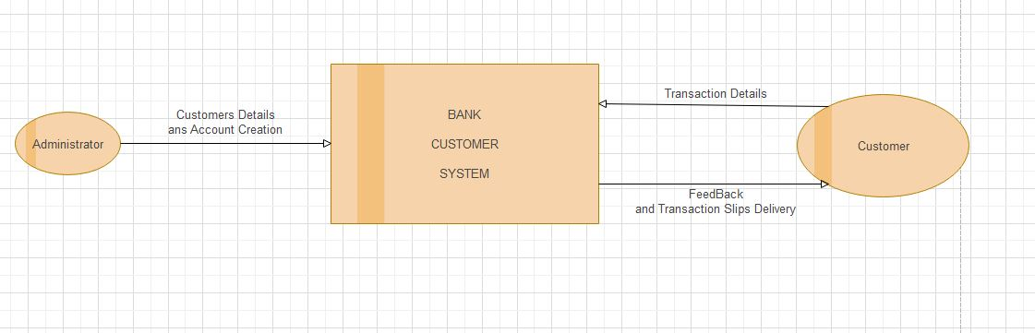

1. **LEVEL 1 DFD/CONTEXT**

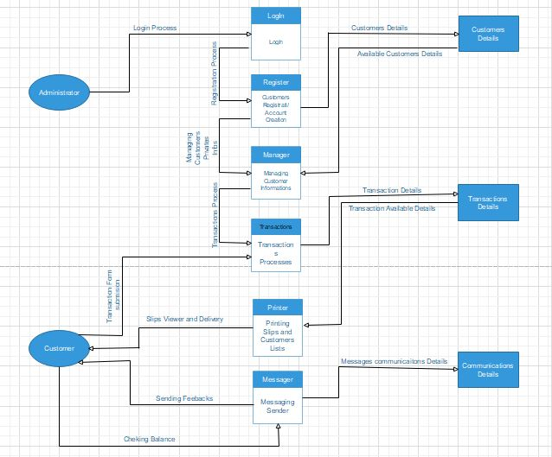

1. **ERD**

