|  |  |
| --- | --- |
|  | akado-logo-medium.pngAKaDo User Guide 2.0 |
|  |  |
| 23/07/2015 | DATA QUALITY ANALYSIS FOR AVDTH |
|  |  |

AKaDo User Guide 2.0

Data quality analysis for AVDTH

Summary

Introduction 2

InSTAllation 3

USAGE Erreur ! Signet non défini.

Set of controls 12

Acknowledgements 17

# Introduction

## Context

The AKADO tool automatically performs a series of tests on the data and produces summary tables that provide more or less detailed balance anomalies. The new version of AKADO, called “AKaDo 2”, is a fusion of different software developed by the *Tropical Tuna Observatory* team, *i.e.* “BaBys”, “AKADO 4.x and many SQL queries. The purpose of this new version is to prepare the transition with the electronic logbook based on the ERS.

AKaDo runs with compatible databases with the latest evolution of AVDTH model data (version 3.5). All predicates evaluated since the 3.3 version of the AKADO are included in this version. We also introduced many new controls. Like the previous version, the importation in T3+ shall not include major errors; it is a guarantee that engages the AVDTH technology.

The major point of the previous version was a translation in English and inclusion of comments in report analysis. We kept these evolutions and improved report analysis. We have codified each error encountered to perform detailed statistics if needed.

This version of AKaDo produces a spreadsheet document easy to read on screen. The spreadsheet must improve the treatment results with more effective than a web browser interface.

## Prerequisites

To be an user of the AVDTH database, “*Acquisition et Validation des Données Thonières”*, created by the *Tropical Tuna Observatory*, *Institute of research for development*.

France, Ghana, Mauritius, Senegal, Seychelles and Spain AVDTH database (October 1, 2013).

## Miscellaneous

This version of AKaDo is developed by Julien Lebranchu. Contact: [OT support team](mailto:support.obs.thonier@listes.ird.fr?subject=[AKADO]%20).

This guide was created the 8 July 2014.

The date of the last modification is 24 September 2015 by .

Revision number: .

# Installation

## Preamble

To use AKaDo software, you must have already JAVA installed. You can download JAVA at <https://www.java.com/en/>, and follows the instructions to install it.

## Procedure

Run the AKaDo installer by double clicking the “**AKado4AVDTH-XX.jar**” file where XX is the version number; and follow instructions to install or update AKaDo.

1. Press Next to continue.
2. Read the README, and press Next to continue.
3. Accept the AKaDo’s licence, and press Next to continue.
4. Select the packages you want to install (only the documentation, the Licence and Readme files are not mandatory).
5. Select the installation path, you can choose your directory by browsing your computer.
6. This panel presents information about the installation. Press Next to continue and begin the installation.
7. The installation is progressing.
8. The installation is done.

To uninstall AKaDo, you could click on the Uninstaller shortcut if exists in the start menu or you could run the uninstaller which is in the application directory. If you have not changed this directory, the uninstaller file should be in **C:\Program Files (x86)\AKaDo4AVDTH\Uninstaller** on Windows and in user home **$HOME/AKaDo4AVDTH/Uninstaller** on UNIX.

# Usage

**To launch AKaDo, you could run the script which is in the application directory[1].**

When you run AKaDo, the interface is showed (see Figure 1). There are four menus: File, Option, VMS and Help.

* In the File menu, you can load an AVDTH database or quit the application.
* In the Option menu, you can choose your language (need a restart), you can also turn on/off all inspectors.
* In the VMS menu, you can handle the ANAPO functionalities (for more information see the section “Anapo (OT team only)”, p. 16).
* In the Help menu, you can see the information about AKaDo.

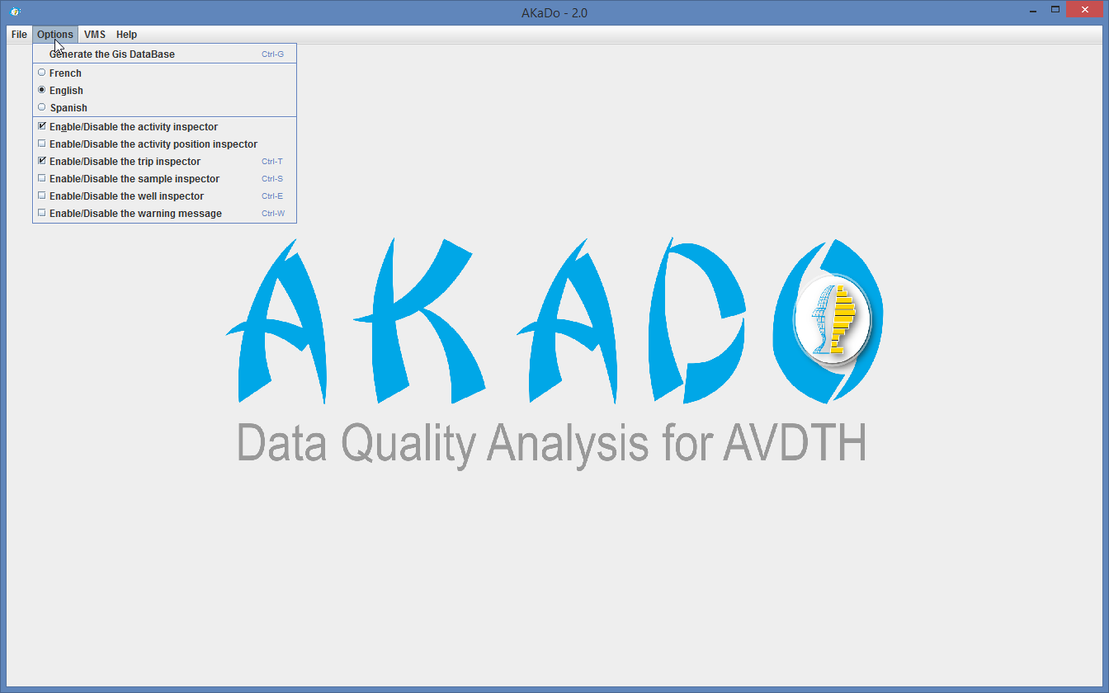

Figure 1

For loading a database, you must browse yours directories and choose a database file (see Figure 2). You can use the shortcut keyboard Ctrl+O or File>Open....



Figure 2

Once you have loaded the database, you must press the start button to run the process (see Figure 3). During the processing, the application prints for each invalid control a message[2]. At the end, a result file is generated and the program prints the path on your system. This file is a spreadsheet and it can be opened with different software like Microsoft Excel or LibreOffice Calc[3].

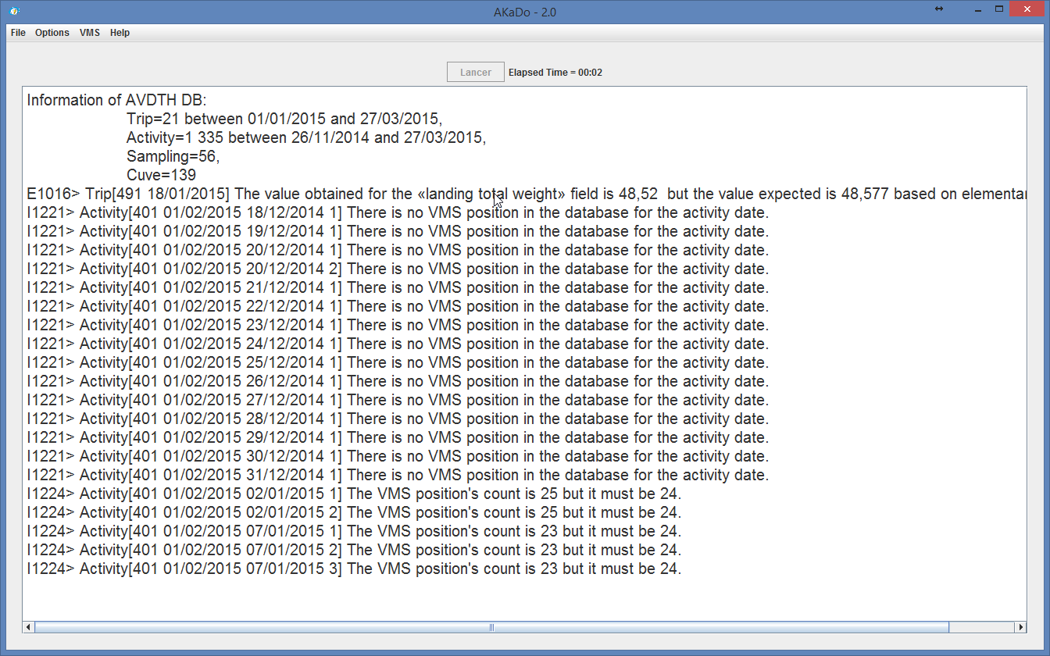

Figure 3

## Results in the spreadsheet

For each group of controls, there is a dedicated sheet: Trip, Activity... By default, we have realised some conditional formatting. For example, if the catch weight in activity is different to the elementary catches weight then the cell is coloured red (see Figure 4). You could add conditional formatting directly in the template which is in the configuration directory: **$HOME/appconfig/akado/akado_avdth_result_model.xlsx** on UNIX and **C:\Users\USERNAME\appconfig\akado\akado_avdth_result_model.xlsx**. You must send the file to the development team in order to add formatting in the next version.

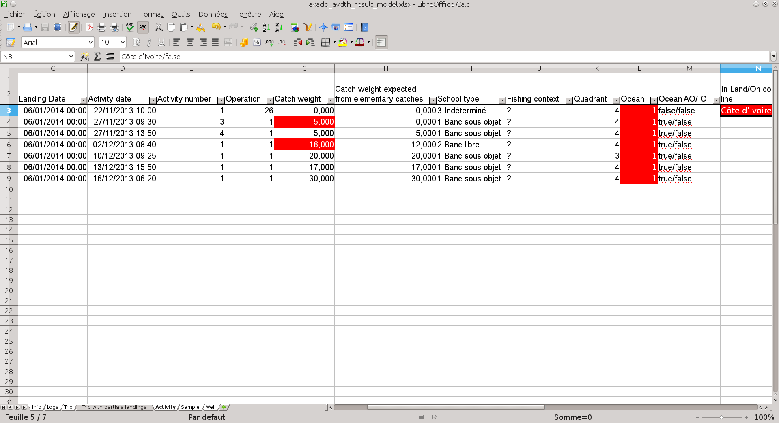

Figure 4

# Set of controls

**Trip**

### Activity (Warning)

* In this case, we check if the trip has at least one activity and the flag “F_ENQ” equals 1.
* Is flag F_ENQ consistent with the official declaration? We check database with application AVDTH -> Landings -> Trip file update -> Logbook?

### Fishing Time

* In this case, we check if the fishing time in trip equals the sum of fishing time in all activities.
* If the values are not equal, you must report the sum value in the “fishing time” in the trip.

### Time At Sea

* In this case, we check if the time at sea in equals the sum of time at sea all activities.
* If the values are not equal, you must report the sum value in the “time at sea” in the trip.

### Landing (Warning)

* We calculate the capacity in tons from the vessel, we check if the capacity is superior of the landing total weight.
* If the landing total weight is superior of the capacity, you must check if the “landing weight” in the trip is correct.

### Landing Total Weight

* We check if the landing total weight is consistent with the elementary landing weight.
* If the values are not equal, you must report the sum value in the “landing weight” in the trip.

### Loch (Warning)

* We check if the value is between 0 and the maximum distance which is calculated from the maximum speed and the number of activities.

### Recovery Time

* We check if the activities are continuous during a trip.
* You must examine if a day is missing in logbook.

### Temporal Limit

* We check if the temporal limits, the first and last day, of the trip are consistent with activities.
* You must check Departure and Arrival date between logbook and landing documents.

### Total Catch Weight

* We check if the total catch weight from activities and elementary catches are equals.
* If the values are not equal, you must check the catch weight in the “Activity” sheet of the result file.

### Raising Factor (Info)

* We calculate the raising factor, with and without the local market, for all trips (included trip with partial landings).
* If the ratio is not between 0.9 < R < 1.1 (Landing/Catches), you must inspect the flag partial landing.

**Activity**

### Fishing Context

* We check if the school type and the fishing context are consistent.
* If the school type is an artificial school (code 1), then it must at least one fishing context;
* If the school type is an artificial school (code 1), then the fishing context code must be equal to 10, 60, 81 or between 20 and 28;
* If the school type is a free school (code 2), then the fishing context code must ***not*** be equal to 10, 60, 81 or between 20 and 28.

### Operation

* We check if the operation associated with activity is consistent with other information.
* If the operation code is 0, then the value of the total catch weight must be equal to 0;
* If the operation code is 1 or 2, then the value of the total catch weight must not be equal to 0;
* If the value of the total catch weight isn’t equal to 0, then the operation code is 1 or 2;
* If the operation code is 12, 13 or 14, then the value of the total catch weight must be equal to 0;

### Position

* We check if the position activity is in ocean or inland, and if the position activity and ocean are consistent.
* If the position is in land, you must inspect the latitude, longitude and quadrant fields.
* If the position activity and the ocean field are not equal, you must examine these fields and correct it.

### Quadrant

* We check if the quadrant and the position activity are consistency, i.e.
* If the quadrant value is 3 or 4, the ocean value must be “Atlantic Ocean”.
* If the quadrant value is 3 or 4, the position must be located in “Atlantic Ocean”.
* You must verify the ocean field, the quadrant field and the position field.

### Weight

* We check if the total catch weight is consistent with elementary catches.
* If the values are not equal, you must report the sum value of elementary catches weight in the activity.

**Sample**

### Activity

* We check if the activity information for each sample well is consistent.
* You must examine the following information: the date, the activity number, the quadrant, the latitude, the longitude and the school type

### Length class

* We check if the length class is consistent with each length class of species (L=80cm for YFT and BET and L=42cm for ALB).

### Species

* We check if the specie sampled is authorised.

### Measure

* We check if the sample species number is consistent with the measure number.

### Position

* We check if the position activity for each sample well is consistent.

### Sample without Measure

* We check if the sample has at least one measure.

### Sample without Species

* We check if the sample has at least one specie.

### Sample without Trip

* We check if the sample is linked at one trip.

### Super Sample

* We check if the sub-sample number is consistent.

### Well

* We check if the sample is linked at one trip.

### Ratio of little and big fish

* We check if the percentage of little and big fish sampled is consistent.

### Weighting

* We examine the weighting information for each sample well is consistent.
* If the vessel engine is a purse seine, the sample weight must be inferior to 100kg.
* If the vessel engine is a purse seine, the weighted weight must be inferior to the weight and the ration between weighted weight and the weight must be superior or equal to 0,85.
* If the vessel engine is a bait boat,

**Well**

### Activity

* We check if the activity information for each well plan is consistent. We examine the date and the number.
* You must examine in the well plan the date and the number of the activity.
* You must check if the logbook is in AVDTH.

### Well without Trip

* We check if the well is associated at one trip existing.
* You must enter the logbook in AVDTH.

### Well without Well Plan

* We check if the well is associated at least one well plan existing.

# Anapo (OT team only)

See the French version of this guide.

# Acknowledgements

Jean-Jacques Lechauve and Laurent Floc’h for the development of the previous version.

Pascal Cauquil, Jean-Jacques Lechauve for the development of the AVDTH database.

Pierre Chavance, Emmanuel Chassot, Patrice Dewals and Alain Damiano for their scientific and fisheries information.

Pierre Lopez for the design of the logo on the front page.

1. If you have not changed this directory, the file should be in **C:\Program Files (x86)\AKaDo4AVDTH\bin\akado.bat** on Windows and in user home **$HOME/AKaDo4AVDTH/bin/akado.sh** on UNIX/LINUX.
2. The message can be of three types: INFO, WARNING and ERROR. We will see thereafter actions to be taken depending on the type of messages.
3. **LibreOffice** is free and open source software; you can download it at <https://www.libreoffice.org/> .