|  |  |
| --- | --- |
|  | **17th Annual Bioinformatics Open Source Conference**  **BOSC 2016**    **Orlando, Florida, USA**  **July 8-9, 2016**  *open-bio.org/wiki/BOSC_2016* |

Welcome to BOSC 2016! The Bioinformatics Open Source Conference, established in 2000, is held every year as a Special Interest Group (SIG) meeting in conjunction with the Intelligent Systems for Molecular Biology (ISMB) Conference. BOSC is organized by the Open Bioinformatics Foundation (OBF), a non-profit group dedicated to promoting the practice and philosophy of Open Source software development and Open Science within the biological research community.

**Sponsors**

We thank Curoverse (the team behind the open source platform Arvados) as returning sponsors of BOSC 2016 and the OBF Codefest, and we welcome PLOS as new sponsors of Codefest 2016.

|  |  |  |  |  |
| --- | --- | --- | --- | --- |
|  | Pixel:Users:nomi:Dropbox:BOSCFILES:sponsor logos:arvados-curoverse-1.png |  |  |  |

**Organizing Committee**

**Nomi Harris** and **Peter Cock** (Co-Chairs)

Brad Chapman, Chris Fields, Karsten Hokamp, Hilmar Lapp, Mónica Muñoz-Torres, Heather Wiencko

**Program Committee:** Nomi Harris, Michael Heuer, Karen Cranston, Gianluca Della Vedova*, George Githinji, Christopher Fields, Hilmar Lapp*, Scott Markel, Frank Nothaft, Lorena Pantano, Michael Reich, Morgan Taschuk, Heather Wiencko*, Kai Blin*, Spencer Bliven*, Brad Chapman*, Michael Crusoe, Bastian Greshake*, Hans-Rudolf Hotz*, Herve Menager, Fiona Nielsen, Konstantin Okonechnikov, João Rodrigues*, Eric Talevich, Jason Williams, Melissa Wilson Sayres, Peter Cock*, Björn Grüning, Karsten Hokamp*, Amye Kenall, John Chilton, Konrad Förstner*, Jens Lichtenberg, Monica C Munoz-Torres

∗ Also reviewed Late-Breaking Lightning Talk abstracts



BOSC is a community effort—we thank all who made it possible, including the organizing committee, the program committee, the session chairs, our sponsors, and the ISMB SIG chair, Steven Leard.

If you are interested in helping to organize BOSC 2016, please email [bosc@open-bio.org](mailto:bosc@open-bio.org).

**Talks and Posters**

BOSC includes two full days of talks, posters, and [Birds of a Feather interest groups (BOFs)](https://docs.google.com/document/d/1zKSzP4_6_ezVw1g4Igy8ZRdFDBJ268uMy_5LKA98Mc0/edit). [Session topics](https://www.open-bio.org/wiki/BOSC_2016_Schedule) this year include Standards and Interoperability, Data Science, Open Science and Reproducibility, and two new sessions this year: Developer Tools and Libraries, and Workflows. Like last year, we will end with a session of late-breaking lightning talks. The longer talks this year are 15 minutes (plus 3 minutes for questions); lightning talks are 5 minutes, with a short time allocated for questions at the end of the session.

This year's keynote speakers will be Jennifer Gardy and Steven Salzberg. Our panel topic this year is “Growing and sustaining open source communities”, with panelists Abigail Cabunoc Mayes, Bastian Greshake, Jamie Whitacre, John Chilton, and Natasha Wood, and moderator Mónica Muñoz-Torres.

Poster sessions will be held on both days during the lunch hour. Authors should put up their posters in their assigned spot before the first poster session (which starts at 1pm).

We have space for several walk-in posters, in addition to those listed in the program. Please contact us at [bosc@open-bio.org](mailto:bosc@open-bio.org) if you’d like to present a last-minute poster.

**Optional BOSC Dinners**

We invite you to join BOSC organizers and attendees at a pay-your-own-way dinner the first evening of BOSC (Friday, July 8 at 7pm) at Paradiso 37 at the Disney Springs shopping center, about 4 miles from the conference center and accessible via a free shuttle bus.

If you want to join us for dinner, RSVP at <http://bit.ly/BOSC2016-Friday-dinner> before Friday at 3pm. The restaurant has space for 30 BOSC guests; only those who RSVP will be admitted.

On Saturday (again at 7pm), we’re going farther offsite to [Marlow’s Tavern](http://www.marlowstavern.com/menu#/floridafoodmenu). RSVP at <http://bit.ly/BOSC2016-Saturday-dinner> before Saturday at 3pm if you want to join us!

**OBF Membership**

Professionals, scientists, students, and others active in open science or open source software or in the life sciences are invited to join BOSC’s parent organization, the [Open Bioinformatics Foundation (the OBF)](https://www.open-bio.org/wiki/Main_Page). The OBF grew out of the volunteer projects [BioPerl](http://www.open-bio.org/wiki/BioPerl), [BioJava](http://www.open-bio.org/wiki/BioJava) and [Biopython](http://www.open-bio.org/wiki/Biopython) and was formally incorporated in 2001 in order to handle modest requirements of hardware ownership, domain name management and funding for conferences and workshops. In 2005, we enacted [bylaws](http://www.open-bio.org/wiki/File:OBF-Bylaws.pdf) for the first time, and along with it created a formal membership.

In 2012, after overwhelming approval in a membership vote, we changed from being independently incorporated to joining Software In The Public Interest, Inc., a fiscal sponsorship organization that aligns well with our own values and culture. We continue to maintain our own membership so that our community has a role in shaping our direction and vision. You can find information on how to join OBF on the OBF wiki at <http://www.open-bio.org/wiki/Membership>. There is no membership fee. If you are interested in meeting and talking to some of the OBF Directors and members, please join us at one of the BOSC dinners (see above).

**BOSC 2016 Schedule**

**Day 1 (Friday, July 8, 2016)**

| **Time** | **Title** | **Speaker / Chair** |
| --- | --- | --- |
| 7:30-9:00 | **Registration** |  |
| 9:00-9:15 | **Introduction and Welcome** | Nomi Harris and Peter Cock (Co-Chairs) |
| 9:15-10:15 | **Keynote: *The open-source outbreak: can data prevent the next pandemic?*** | Jennifer Gardy |
| 10:15-10:45 | ***Coffee Break*** |  |
| 10:45-12:30 | **Session: Workflows** | Chair: Brad Chapman |
| 10:45-11:03 | GenomeSpace: Open source interoperability platform with crowd-sourced analysis recipes | Ted Liefeld [P1] |
| 11:03-11:21 | This is Why We Can Have Nice Things: Getting to 1.0 of the Common Workflow Language | Michael R. Crusoe [P2] |
| 11:21-11:39 | CWL in Practice: Experiences, challenges, and results from adopting Common Workflow Language | Dan Leehr [P3] |
| 11:39-11:57 | Using the Common Workflow Language (CWL) to run portable workflows with Arvados and Toil | Peter Amstutz |
| 11:57-12:02 | Planemo – A Scientific Workflow SDK | John Chilton |
| 12:03-12:08 | Sample Size Does Matter: Scaling Up Analysis in Galaxy with Metagenomics | Daniel Blankenberg |
| 12:09-12:14 | NextflowWorkbench: Reproducible and Reusable Workflows for Beginners and Experts | Fabien Campagne [P4] |
| 12:15-12:20 | Promoting platform interoperability with portable bcbio workflows | Brad Chapman |
| 12:20-12:25 | Questions for lightning talk speakers in this session |  |
| 12:30-13:30 | ***Lunch*** |  |
| 13:00-14:00 | **Poster Session and** [**Birds of a Feather**](https://docs.google.com/document/d/1zKSzP4_6_ezVw1g4Igy8ZRdFDBJ268uMy_5LKA98Mc0/edit)(overlapping with lunch) |  |
| 14:00-15:30 | **Session: Standards and Interoperability** | Chair: Hilmar Lapp |
| 14:00-14:18 | Enhancements to MISO: An open-source community-driven LIMS | Andre Masella |
| 14:18-14:36 | Biothings APIs: high-performance bioentity-centric web services | Chunlei Wu [P5] |
| 14:36-14:54 | The Noctua Modeling Tool | Seth Carbon [P6] |
| 14:54-15:12 | Processing phenotype data using Phenopackets-API and PXFTools | Chris Mungall |
| 15:12-15:17 | The EDAM Ontology | Jon Ison [P7] |
| 15:18-15:23 | Towards traceable, scriptable, and efficient data distribution for next-generation genomics | John Bradley [P8] |
| 15:23-15:28 | Questions for lightning talk speakers in this session |  |
| 15:30-16:00 | ***Coffee Break*** |  |
| 16:00-17:00 | **Panel: *Growing and sustaining open source communities*** | ***Moderator***: Mónica Muñoz-Torres  ***Panelists***: Abigail Cabunoc Mayes, Bastian Greshake,  Jamie Whitacre, John Chilton, Natasha Wood |
| 17:00-17:10 | Open Bioinformatics Foundation (OBF) Update | Hilmar Lapp (President, OBF) |
| 17:10-17:15 | **Announcements** | Nomi Harris |
| 17:15-18:30 | [**BOFs**](https://docs.google.com/document/d/1zKSzP4_6_ezVw1g4Igy8ZRdFDBJ268uMy_5LKA98Mc0/edit) |  |
| 19:00- | Pay-your-own-way BOSC dinner, Paradiso 37 | RSVP at [bit.ly/BOSC2016-Friday-dinner](http://bit.ly/BOSC2016-Friday-dinner) (limited space--you must RSVP to attend) |

*Any last-minute schedule updates will be posted at*

[*http://www.open-bio.org/wiki/BOSC_2016_Schedule*](http://www.open-bio.org/wiki/BOSC_2016_Schedule)

**Day 2 (Saturday, July 9, 2016)**

| **Time** | **Title** | **Speaker or**  **Session Chair** |
| --- | --- | --- |
| 9:00-9:05 | **Announcements** | Peter Cock and Nomi Harris |
| 9:05-9:15 | Codefest 2016 Report | Brad Chapman (Codefest 2016 Organizer) |
| 9:15-10:15 | **Keynote:** ***Open source, open access, and open data: why science moves faster in an open world*** | Steven Salzberg |
| 10:15-10:45 | ***Coffee Break*** |  |
| 10:45-12:30 | **Session: Data Science** | Chair: Heather Wiencko |
| 10:45-11:03 | Mango: Data Exploration on Large Genomic Datasets | Alyssa Morrow [P9] |
| 11:03-11:21 | ADAM Enables Distributed Analyses Across Large Scale Genomic Datasets | Frank Nothaft |
| 11:21-11:39 | SUPERSMART - A Self-Updating platform for Estimating Rates of Speciation and Migration, Ages, and Relationships of Taxa | Hannes Hettling |
| 11:39-11:57 | Characterization of the small RNA transcriptome using the bcbio-nextgen python framework | Lorena Pantano Rubino |
| 11:57-12:15 | MetaR: simple, high-level languages for data analysis with the R ecosystem | Fabien Campagne [P10] |
| 12:15-12:20 | Development of NGSEP as an open-source comprehensive solution for analysis of high throughput sequencing data | Jorge Duitama [P11] |
| 12:21-12:26 | GRNmap and GRNsight: open source software for dynamical systems modeling and visualization of medium-scale gene regulatory networks | Kam D. Dahlquist [P12] |
| 12:26-12:30 | Questions for lightning talk speakers in this session |  |
| 12:30-13:30 | ***Lunch*** |  |
| 13:00-14:00 | **Poster Session and** [**BOFs**](https://docs.google.com/document/d/1zKSzP4_6_ezVw1g4Igy8ZRdFDBJ268uMy_5LKA98Mc0/edit)(overlapping with lunch) |  |
| 14:00-14:40 | **Session: Developer tools and libraries** | Chair: Chris Fields |
| 14:00-14:18 | Biopython Project Update 2016 | Christian Brueffer |
| 14:18-14:23 | Sequenceserver: a modern graphical user interface for custom BLAST databases | Anurag Priyam [P13] |
| 14:24-14:29 | Linuxbrew and Homebrew-Science to Navigate the Software Dependency Labyrinth | Shaun Jackman [P14] |
| 14:30-14:35 | SnoVault and encodeD: A novel object-based storage system and applications to ENCODE metadata | Benjamin Hitz [P15] |
| 14:35-14:40 | Questions for lightning talk speakers in this session |  |
| 14:40-15:30 | **Session: Open Science and Reproducibility** | Chair: Karsten Hokamp |
| 14:40-14:58 | State of the openSNP.org Union: Dockerizing, Crowdfunding & Opening for Contributors | Bastian Greshake [P16] |
| 14:58-15:16 | The GenePattern Notebook Environment | Michael Reich [P17] |
| 15:16-15:21 | Reproducibility in computationally intensive workflows with continuous analysis | Brett K Beaulieu-Jones |
| 15:22-15:27 | Reproducible Research in the Cloud with the Refinery Platform | Nils Gehlenborg [P18] |
| 15:28-15:33 | ReportMD: Writing complex scientific reports in R | Peter Humburg [P19] |
| 15:33-15:38 | Questions for lightning talk speakers in this session |  |
| 15:30-16:00 | ***Coffee Break*** |  |
| 16:00-16:40 | **Session: Late-Breaking Lightning Talks** | Chair: Karsten Hokamp |
| 6:00-16:05 | Apollo Genome Annotation Editor: Latest Updates, Including Galaxy Integration | Mónica C. Muñoz-Torres [P20] |
| 16:06-16:11 | An invitation to the bioinformatics community to participate in the HUBzero® open source release | Michael Zentner [P21] |
| 16:12-16:17 | PDB on steroids – compressive structural bioinformatics | Peter Rose [P22] |
| 16:18-16:23 | Puzzle: VCF/GEMINI interface for genetic disease analysis | Robin Andeer [P23] |
| 16:24-16:29 | Modernization of the Cytoscape ecosystem | Keiichiro Ono [P24] |
| 16:30-16:35 | Collaborative Software Development: Lessons from Open Source | Abigail Cabunoc Mayes |
| 16:35-16:40 | Questions for lightning talk presenters |  |
| 16:40-16:50 | **Concluding remarks** | Nomi Harris and Peter Cock |
| 17:00-18:30 | [**BOFs**](https://docs.google.com/document/d/1zKSzP4_6_ezVw1g4Igy8ZRdFDBJ268uMy_5LKA98Mc0/edit) |  |
| 19:00 | Pay-your-own-way dinner, Marlow’s Tavern | [RSVP](http://bit.ly/BOSC2016-Saturday-dinner) |

*Any last-minute schedule updates will be posted at*

[*http://www.open-bio.org/wiki/BOSC_2016_Schedule*](http://www.open-bio.org/wiki/BOSC_2016_Schedule)

**Keynote Speakers**

**Jennifer Gardy**

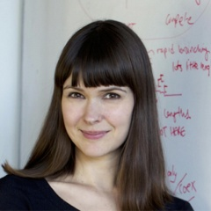Dr. Jennifer Gardy is both a scientist and science communicator. She holds a PhD in Bioinformatics, and is an Assistant Professor of Population and Public Health at the University of British Columbia and a Senior Scientist at the British Columbia Centre for Disease Control (BCCDC). At the BCCDC, she pioneered a new way of investigating outbreaks of infectious diseases – “genomic epidemiology,” which uses a pathogen's genome sequence as a tool for understanding how an infectious disease spreads. Her group was the first to use genome sequencing to reconstruct a large outbreak of tuberculosis, and she is continuing to apply this novel technique to other outbreak scenarios. She is also involved in other genomics-related research, including replacing traditional laboratory microbiology protocols with single genomic analyses. In 2014, she was appointed the Canada Research Chair in Public Health Genomics, and is Senior Editor at the new open data, open access journal Microbial Genomics.

In addition to her career as a research scientist, Dr. Gardy is known for her work in science communication and education, both in print and on TV. She has made regular appearances on CBC's documentary series The Nature of Things, has hosted CBC's eight-part science series Project X, and is a regular guest host on Discovery Channel’s Daily Planet science show. She has written and blogged for the Globe and Mail, has written a children’s book – It’s Catching! The Infectious World of Germs and Microbes – and runs a series of workshops on how to communicate science effectively.

Dr. Gardy’s keynote topic is “The open-source outbreak: can data prevent the next pandemic?”

*Every century, something comes along that shakes up public health – vaccines, sanitation, antibiotics – and data promises to be the great disrupter of 21st century infectious disease epidemiology. In the last 5-6 years, genomics has dramatically changed how public health agencies diagnose and investigate diseases from food poisoning to tuberculosis, giving us a new tool to understand and control infections. The change is also apparent at a cultural level – genomics and bioinformatics researchers have largely come from an open data, collaborative space and have brought new ways of thinking to public health laboratories, previously secret, closed organizations. In this talk, we’ll explore some of the dramatic changes in public health microbiology that genomics and bioinformatics has facilitated, and look at how future data sharing efforts in areas such as digital disease detection might be the key to preventing future pandemics.*

### Steven Salzberg

Dr. Steven Salzberg is the Bloomberg Distinguished Professor of Biomedical Engineering, Computer Science, and Biostatistics and the Director of the Center for Computational Biology in the McKusick-Nathans Institute of Genetic Medicine at Johns Hopkins University. From 2005-2011, he was the Director of the Center for Bioinformatics and Computational Biology and the Horvitz Professor of Computer Science at the University of Maryland, College Park. From 1997-2005 he was Senior Director of Bioinformatics at The Institute for Genomic Research (TIGR) in Rockville, Maryland, one of the world's leading DNA sequencing centers at the time.

Salzberg's lab currently focuses on next-generation sequence alignment, genome assembly, and microbiome analysis. They have produced several popular systems for alignment of next-generation sequencing reads, including the Bowtie, Tophat, and Cufflinks systems. All of the group's software is free and open source, and their systems have been downloaded hundreds of thousands of times.

Dr. Salzberg is a Fellow of the American Association for the Advancement of Science (AAAS) and a Fellow of the International Society for Computational Biology (ISCB). He was the 2013 winner of the Benjamin Franklin Award for Open Access in the Life Sciences, in recognition of his many contributions to open access bioinformatics software and his strong advocacy for open access to data, software and publications.

Dr. Salzberg will speak about "Open source, open access, and open data: why science moves faster in an open world."

*The Human Genome Project established a practice of sharing data rapidly, prior to publication, that has since become a model for many projects in genomics. Data sharing has been slow to penetrate other fields because of many factors, some of which I will discuss in this talk. Nevertheless, sharing of methods, data, and results helps science move ahead faster, and openness is essential for the continual process of checking and self-correction that good science requires. I will discuss some of the successes as well as some noteworthy mistakes that have been discovered thanks to open science.*

**Panel: *Growing and sustaining open source communities***

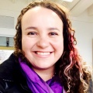Panel chair **Mónica Muñoz-Torres** ([@monimunozto](https://twitter.com/monimunozto)) is the biocuration lead for Berkeley Bioinformatics Open-Source Projects (BBOP) at Lawrence Berkeley National Laboratory. She is part of the development teams for Apollo (a web-based annotation editor designed to support community-based curation of genomes) and the tools of the Gene Ontology (GO) Consortium. She leads the Community Curation group within the global initiative to sequence and annotate the genomes of 5,000 arthropods (i5K Initiative), and is a member of the Executive Committee of the International Society for Biocuration (ISB). As a graduate student, Monica founded the first Southeastern Chapter of the Society for Advancement of Hispanics/Chicanos and Native Americans in Science (SACNAS) at Clemson University; the chapter has since been actively involved in outreach activities to local high schools in an attempt to inspire students to pursue careers in STEM.

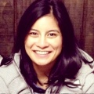**Abigail Cabunoc Mayes** ([@abbycabs](https://twitter.com/abbycabs)) is the Lead Developer of the [Mozilla Science Lab](https://mozillascience.org/), an initiative of the Mozilla Foundation working to make research collaborative, accessible and usable. She has led development on various open source science projects such as [Contributorship Badges for Science](https://badges.mozillascience.org/) and WormBase. Before joining Mozilla, Abby worked as a bioinformatics software developer at the Ontario Institute for Cancer Research and at Michigan State University. With a background in bioinformatics and computer science, she builds tools that use the web to move science forward.

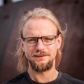**Bastian Greshake** ([@gedankenstuecke](https://twitter.com/gedankenstuecke)) **is a biologist-turned-bioinformatician, currently working on his PhD in the Group for Applied Bioinformatics at the University of Frankfurt. When not doing research in fungal genomics he's also an open* advocate. In 2011 he co-founded openSNP, a crowdsourced/citizen science open data project that puts personal genetics data into the public domain. Over the course of running openSNP he experienced the different sides of sustaining and growing a scientific open source project which is independent of traditional academic institutions.**

**Jamie Whitacre is the technical project manager for Project Jupyter, which was born out of the IPython Notebook in 2014. Jupyter is a web application that allows users to perform exploratory data analysis and create and share documents that contain live code, equations, visualizations and explanatory text. Before joining Project Jupyter, Jamie worked with the Smithsonian’s National Museum of Natural History building out scientific workflows and databases for several genetics and genomics initiatives. Jamie works from the Berkeley Institute for Data Science and is an affiliate of the Lawrence Berkeley National Laboratory.**

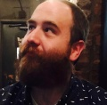**John Chilton**([@jmchilton](https://twitter.com/jmchilton)) is a software developer on the [Galaxy project](https://galaxyproject.org/) working at Penn State in the lab of Anton Nekrutenko. He has loudly pushed the Galaxy community toward increased openness by spearheading efforts such as the adoption of an [open governance model](https://github.com/galaxyproject/galaxy/pull/314) and a project [code of conduct](https://github.com/galaxyproject/galaxy/blob/dev/CODE_OF_CONDUCT.md). He is also one of the co-founders of the [Common Workflow Language](http://www.commonwl.org/).

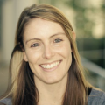**Natasha Wood** ([@natasha_wood](https://twitter.com/natasha_wood)) is an NRF Research Career Award Fellow and lecturer in the Department of Integrative Biomedical Sciences at the University of Cape Town, South Africa. Her research includes molecular dynamics and evolutionary modelling of HIV structural and sequence data to better understand the interplay between the virus and host immune system. She promotes the development of the bioinformatics community through training initiatives, hackathons and more social platforms (as co-founder of the Cape Unseminars in Bioinformatics).

**Talk and Poster Abstracts**

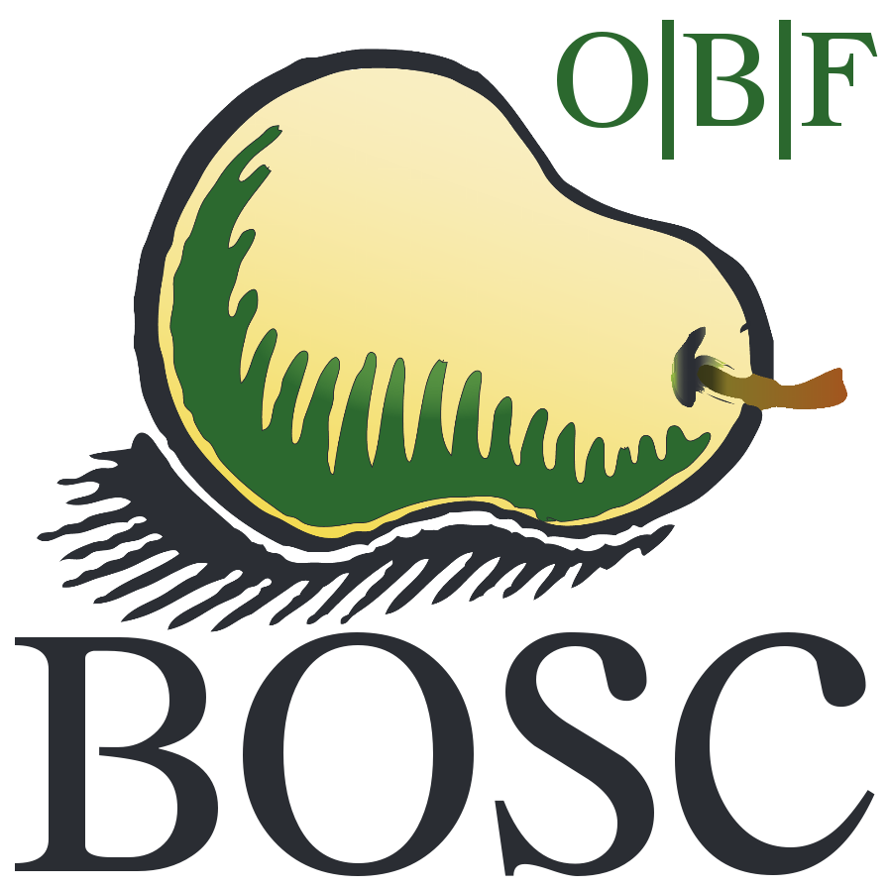

In the pages that follow, talk abstracts appear in the order in which the talks will be presented. Some authors will also present their work as posters. Those abstracts have a poster number on the abstract. Poster-only abstracts appear after the talk abstracts.

There are also a few spaces available for walk-in posters. If you would like to present one, please email your abstract (which must meet the BOSC criteria of freely available source and recognized open source license) to [bosc@open-bio.org](mailto:bosc@open-bio.org).

|  |  |  |
| --- | --- | --- |
| **Poster #** | **Title** | **Presenter** |
| 1 | GenomeSpace: Open source interoperability platform with crowd-sourced analysis recipes | Ted Liefeld |
| 2 | Why We Can Have Nice Things: Getting to 1.0 of the Common Workflow Language | Michael R. Crusoe |
| 3 | CWL in Practice: Experiences, challenges, and results from adopting Common Workflow Language | Dan Leehr |
| 4 | NextflowWorkbench: Reproducible and Reusable Workflows for Beginners and Experts | Fabien Campagne |
| 5 | Biothings APIs: high-performance bioentity-centric web services | Chunlei Wu |
| 6 | The Noctua Modeling Tool | Seth Carbon |
| 7 | The EDAM Ontology | Jon Ison |
| 8 | Towards traceable, scriptable, and efficient data distribution for next-generation genomics | John Bradley |
| 9 | Mango: Data Exploration on Large Genomic Datasets | Alyssa Morrow |
| 10 | MetaR: simple, high-level languages for data analysis with the R ecosystem | Fabien Campagne |
| 11 | Development of NGSEP as an open-source comprehensive solution for analysis of high throughput sequencing data | Jorge Duitama |
| 12 | GRNmap and GRNsight: open source software for dynamical systems modeling and visualization of medium-scale gene regulatory networks | Kam D. Dahlquist |
| 13 | Sequenceserver: a modern graphical user interface for custom BLAST databases | Anurag Priyam |
| 14 | Linuxbrew and Homebrew-Science to Navigate the Software Dependency Labyrinth | Shaun Jackman |
| 15 | SnoVault and encodeD: A novel object-based storage system and applications to ENCODE metadata | Ben Hitz |
| 16 | State of the [openSNP.org](http://opensnp.org/) Union: Dockerizing, Crowdfunding & Opening for Contributors | Bastian Greshake |
| 17 | The GenePattern Notebook Environment | Michael Reich |
| 18 | Reproducible Research in the Cloud with the Refinery Platform | Nils Gehlenborg |
| 19 | ReportMD: Writing complex scientific reports in R | Peter Humburg |
| 20 | Apollo Genome Annotation Editor: Latest Updates, Including Galaxy Integration | Monica Munoz-Torres |
| 21 | An invitation to the bioinformatics community to participate in the HUBzero® open source release | Michael Zentner |
| 22 | PDB on steroids – compressive structural bioinformatics | Peter Rose |
| 23 | Puzzle: VCF/GEMINI interface for genetic disease analysis | Robin Andeer |
| 24 | Modernization of the Cytoscape ecosystem | Keiichiro ONO |
| **Poster only:** | | |
| **Poster #** | **Title** | **Presenter** |
| 25 | Lightweight sample labeling, barcoding and tracking systems for the academic laboratory | Dimitra Sarantopoulou |
| 26 | Kronos: a workflow assembler for genome analytics and informatics | Jafar Taghiyar |
| 27 | PhyPipe: an automated pipeline for phylogenetic reconstruction from multilocus sequences | Javier Correa Alvarez |
| 28 | Skip the line and balance your work with vQ | Gregory Zynda |
| 29 | Using the Nextflow framework for reproducible in-silico omics analyses across clouds and clusters | Paolo Di Tommaso |
| 29-32 | *Walk-in posters (email* [*bosc@open-bio.org*](mailto:bosc@open-bio.org) *to apply!)* |  |