**Consumers affordability to** buy **house**

USA Housing market

**Table of Contents**

* Overview
* Data Question
* Gathering the Data
* Analyzing the Data
* Visualizing the Data
* Technologies
* Data Sources
* Conclusion

**Overview**

* The primary objective of this project is to analyze the rising housing prices and the ability of consumers to afford homeownership. It will explore the relationship between house prices, income levels, mortgage rates, and other economic factors. To understand how consumers' purchasing power is affected in different market conditions and US states, I have considered analysis including 2014 to 2023.Key variables include Price-to-Income ratio, Mortgage payment-to-income ratio, household Debt-to-Income ratio and housing affordability Index.

**Data Question**

* How do higher prices impact consumers affordability to buy house?

**Gathering the Data**

* Using Python, I scrapped data for house prices from websites and converted it into a data frame. For the map, I downloaded a Json file which had the polygon geometry for states, and I created a centroid to facilitate popups at the centroid. Collected historical data on housing prices, income levels, mortgage rates, and other relevant economic indicators by importing from government sources, real estate platforms, and financial institutions.

**Analyzing the Data**

* I did Exploratory Data Analysis around median income, KPI (Key performance indicator) in each state and compared with influencing factors affecting savings for down payment and mortgage payments.

**Visualizing the Data**

I utilized seaborn and matplotlib to create visualizations and then moved them to Power point. I used Power Bi to create visualizations to do interactive analysis and visuals. I imported the data into Power Bi and framed median income column to check the affordability of oneself.

**Technologies**

Python - pandas, NumPy, seaborn, matplotlib, Power Bi

Power Bi – visualizations, Data cleaning

MS Excel -Data cleaning

**Data Sources**

Web scraping and imported from

* www.stlouisfed.org

* www.bls.gov

* www.worldpopulationreview.com

* www.bankrate.com

* www.usinflationcalculator.com

* www.businessinsider.com

* www.usnews.com

* www.edweek.org

**Conclusion:**

The chances for buying houses are increasing currently. With the in Federal Rate, the tendency towards buying houses is increasing. Based on the chart below, with the analysis over the period of 2014 -2023, this is evident.

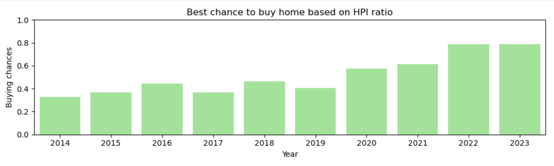

**Capstone for Nashville Software School Data Analytics Program**

Completion date: December 2024