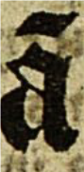 | (a1) | ã | 00E3  &#227; | latin small letter A with tilde
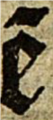 | (e1) | ẽ | 1EBD  &#7869; | latin small letter E with tilde
 | (i1) |  |  | latin small letter I with tilde
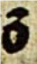 | (o1) | õ | 00F5  &#245; | latin small letter O with tilde
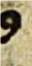 | (us) | 9 | A770  &#42864; | modifier letter us
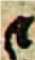 | (et) | et | A75B  &#42843; | latin small letter r rotunda
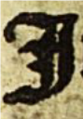 | I | I |  | Latin capital lettre I
