Assignment 5b, Code-a-mon:

Design pattern 1: Decorator -

For this design pattern, I decided to have it based around Codeamon stats and evolution. The decorator allows for codeamon stats to be altered during an evolution. The requirements met in this package are:

- The simulation should run on cycles. A cycle is considered to be of 2 parts - 1 daytime and 1 night time.
- Each cycle should have it’s own weather event.
- During the night, evolutions of code-a-mons can occur.
- Code-a-mons should have at minimum: Attack, Defense, Health.

Design pattern 2: Factory -

For this design pattern, I decided to have it based around the creation of trainers and codeamons, and allows use of a factory class to easily create and store trainer/codeamon values. The requirements met in this package are:

- A new world must start with a number of trainers, at least 2, each of them starts with at least one code-a-mon
- The trainer can acquire more code-a-mons (max of 6) throughout their adventure. How they acquire them is up to you.
- Code-a-mons should have at minimum: Attack, Defense, Health, Attack Type.

Design pattern 3: Mediator -

For this design pattern, I decided to have it based around the the battle and shop operations. I used a mediator class with multi threading to simulate a tick-based world. Only one operation runs at a time. The requirements met in this package are:

- A new world must start with a number of trainers, at least 2, each of them starts with at least one code-a-mon
- Code-a-mons will compete 1v1 with another trainers code-a-mons
- Weather events should benefit certain types of code-a-mon’s stats while being a dis-advantage to others
- Only one battle can take place at a time. A battle is always between two trainers and each using one code-a-mon
- Attacks should be performed in a turn-based manner, one code-a-mon attackes while the other defends, then vice-versa until one faints. When a code-a-mon’s health reaches 0 or less, they faint, and this particular fight is over. Experience points can be handled in two ways: when a code-a-mon defeats another or when the battle is over, it can be given either to the entire team orto just the code-a-mon that won.

Checkstyle report:
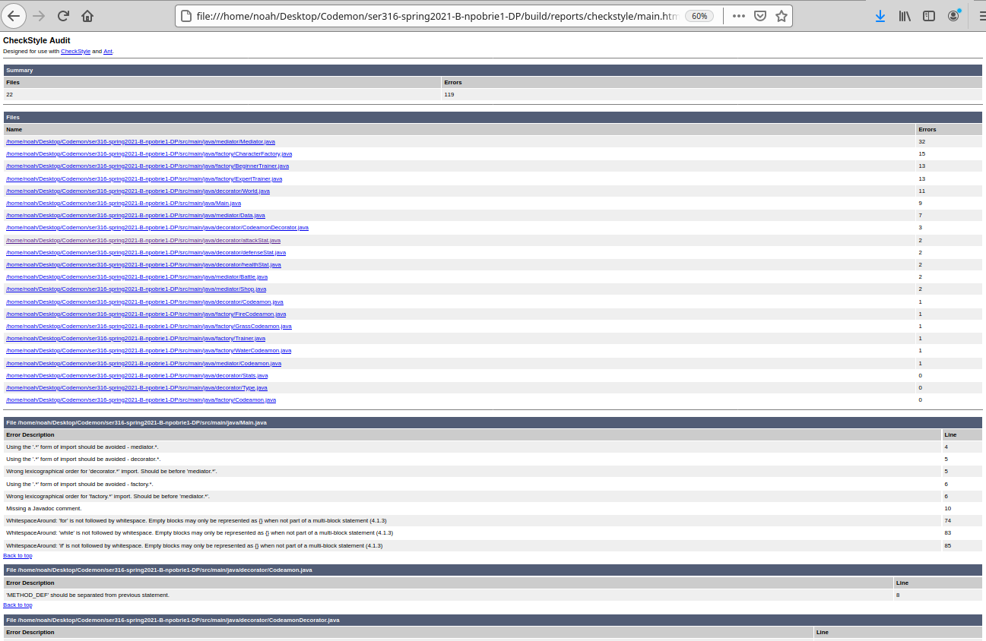
Spotbugs report:
