Linear regression model
Week 2

Aniket Vaishnav
2017BTEIT00062

Introduction
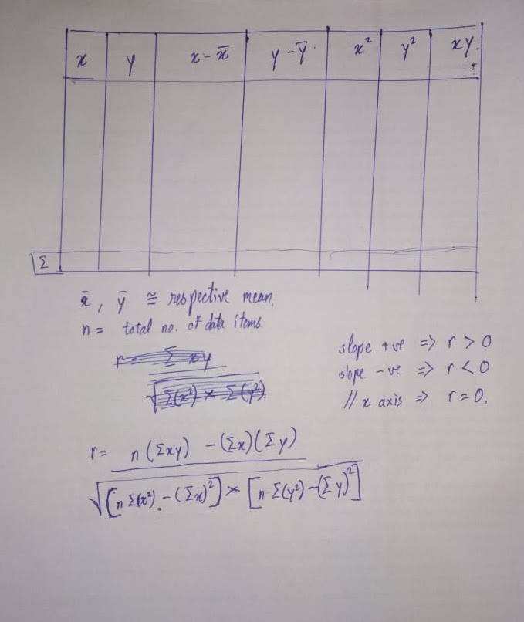
A Linear regression is a way of finding a linear relation between two variables. It may be extended to more than two variables in this it is known as multiple regression. It depends upon correlation coefficient.

Data Set chosen here is Graduate Admission

Code
Written in python can be found at GitHub

import math
import pandas

def selectattribute(csv_file):
index = 0 # default value of index
for row in csv_file.keys():
print(index, ': ', row)
index += 1
index = int(input('input : '))
return csv_file.keys()[index]

if __name__ == '__main__':
target_csv_file_name = 'dataset/Admission_Predict.csv'
csv_file = pandas.read_csv(target_csv_file_name)

print('select one of the Y attribute')
y_attr = selectattribute(csv_file)
print(' Y attribute set to : ', y_attr)

print('select one of the X attribute')
x_attr = selectattribute(csv_file)
print(' X attribute set to : ', x_attr)

# print('table creation')
y = list(csv_file[y_attr])
x = list(csv_file[x_attr])

y_sum = csv_file[y_attr].sum()
x_sum = csv_file[x_attr].sum()

y_mean = csv_file[y_attr].mean()
x_mean = csv_file[x_attr].mean()

y_minus_y_mean = []
for ele in y:
y_minus_y_mean.append(ele-y_mean)
x_minus_x_mean = []
for ele in x:
x_minus_x_mean.append(ele-x_mean)

y_sq = []
for ele in y:
y_sq.append(ele**2)
x_sq = []
for ele in x:
x_sq.append(ele**2)

xy = []
for p, q in zip(x, y):
xy.append(p*q)

n = csv_file[x_attr].count()

r = ( n*(sum(xy)) - sum(x)*sum(y) ) / math.sqrt( (n*sum(x_sq)-sum(x)**2) * (n*sum(y_sq)-sum(y)**2) )
print('r = ',r)

Dependencies
Python 3+
Pandas

Run via python3 main.py

References
https://scikit-learn.org/stable/modules/generated/sklearn.linear_model.LinearRegression.html

