**Template of write-up for LA4**

**Name:**

**Rolll/PRN No**

**Group of LA123::- A/B/C/D**

**(All write-up in times new roman)**

**Assignment No: 1 (size 14, Bold)**

**Title: (size 12 bold) Demonstration of Linux Distributions OS’s and their purpose with comparisons.**

**Subtitle (12 Bold):** This fedora OS. (12 normal) text (12 normal)

Steps of works ( step by step)

Feature of work performing(List)

1. Various versions of that distros with code name :fedora [1]
2. Default desktop GUI :kde
3. Main purpose of that : user friendly os development
4. Package management of that distros : rpm
5. List of Default Packages : NA
6. Important Screenshots of that distros:
7. Compare '/etc' hierarchy:
8. Compare package managers: [2]
9. Pros/cons of both distros:

Eg.



Eg.

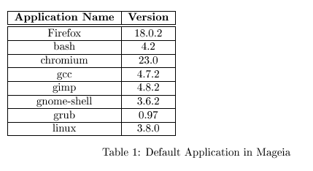

Eg.

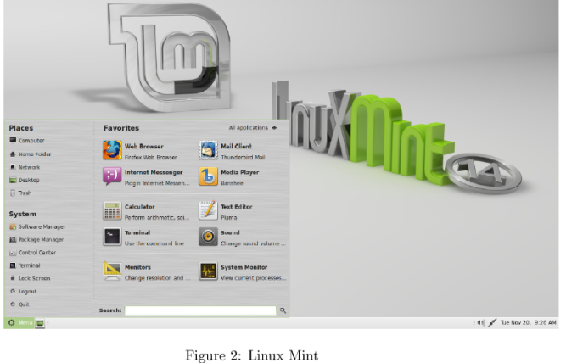

(Note: add imp figures/image and tables with title to figure and table, if table, figure /image copied, mention reference [xx])

**Information of tool with Characteristic /feature/applications of tool etc:**

**Steps of configuration if any:**

1. **aaa**
2. **bbb**
3. **ccc**
4. **ddd**

**Flowcharts or steps of configuration**: (12 normal) server / client separately if exist

add smart draw figures/image with title to figure.

Eg.

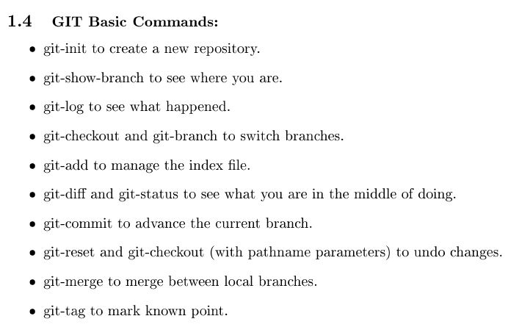

**Important 5 snaps of demo.**

**Conclusions:** (12 normal)

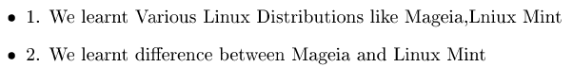

1. Learn to use fedora distro

2. Learn the os and network interaction

3. Learn top ten cmds

**References:**

[1] <https://www.docker.com/> date of access of wesite: 29.7.17

[2] <https://opensource.com/resources/what-docker> date of access of wesite: 29.7.17

[3] <https://mobyproject.org/> date of access of wesite: 29.7.17