Base Module Quality

Name of module: base_module_quality (available on trunk-extra-addons)
The module check the quality of Openerp module available on list of modules on Administrator/Modules Management/ Modules using different tests.

Salient features of Quality module:

- Check the quality of the module using different criteria (pylint, speed efficiency, coding standard followed by openepr, etl...)

- Evaluate score in percentage (%) for whole module as well as it can provied score for individual tests also

- It can skip some tests if module is not installed in server(workflow test...) so that your score is not go down.

- Use Ponderation value to calculate score.

- It allows you to save the result of test (Save Report button)

- Module also provide generic framework to define your own quality test.
- For more information (base_module_quality/README.txt)

Menu of Quality Module:

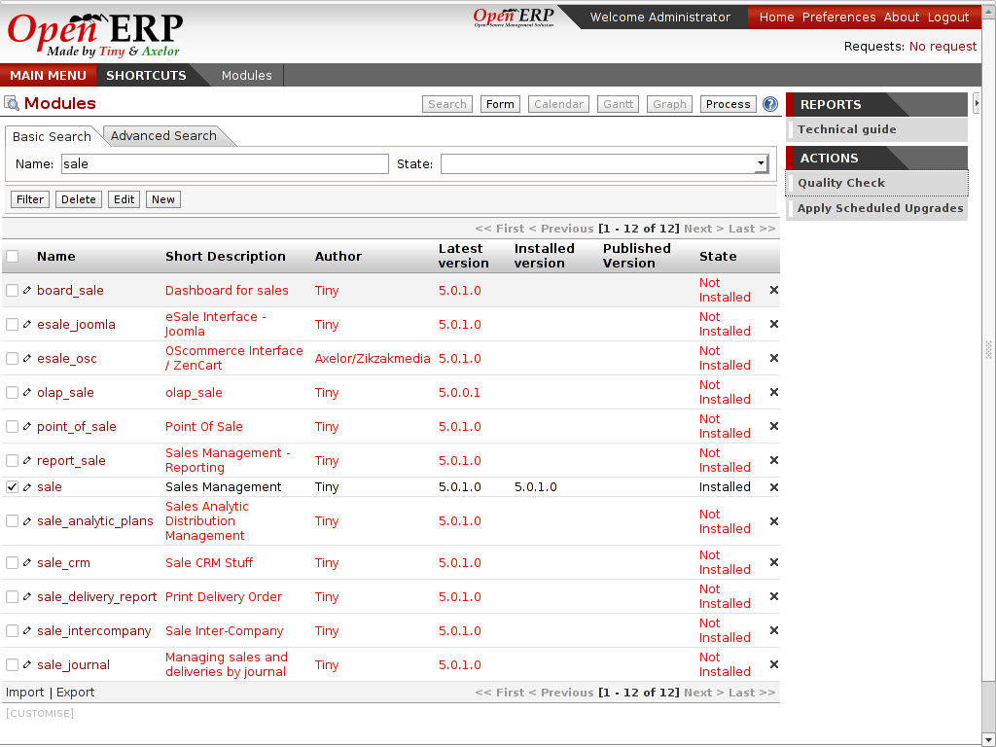
Wizard to check quality
-> You can tick on any number of modules and run the Quality check wizard

For now we will check the quality of sale module,

Result of Quality Check:
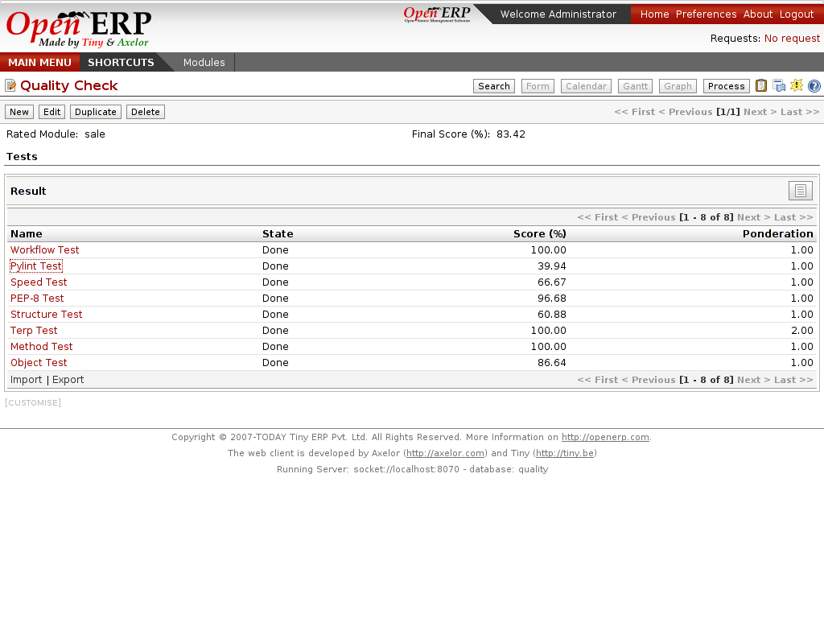
Here is the result of base_module_quality for sale module.
- You can see differnt tests on sale module to calculate its quality
- Related Module: Name of the module
- Final Score: average score from all tests
- Tests :
  - Workflow Test
  - Pylint Test
  - Speed Test
  - PEP-8 Test
  - Structure Test
  - Terp Test
  - Method Test
  - Object Test

- Now we will look all tests result in detail:
Workflow Test

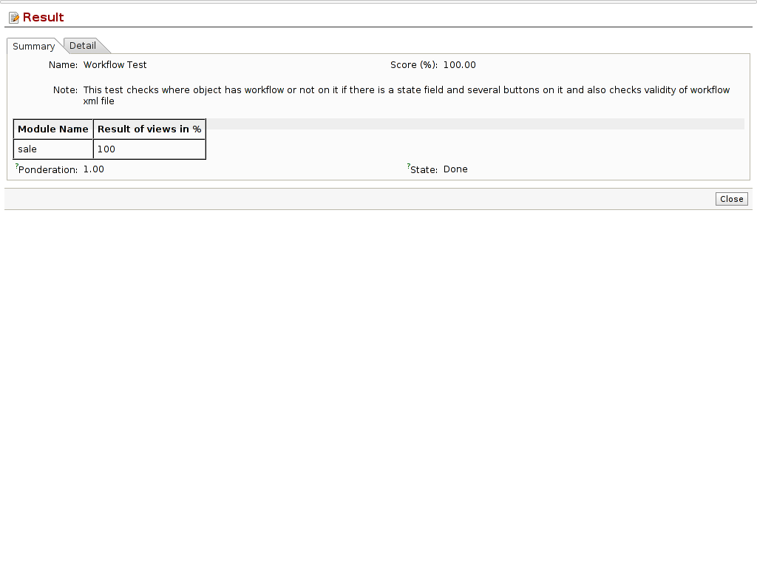
It check:
- If an object has a field state if there are several buttons to make the status change, is there a workflow defined for this object?
- If you implemented workflows in the module, create demo data that passes most branches of your workflow
- For each workflow defined, is there at least one starting node and one ending node?
- Is there any useless nodes?

Pylint Test

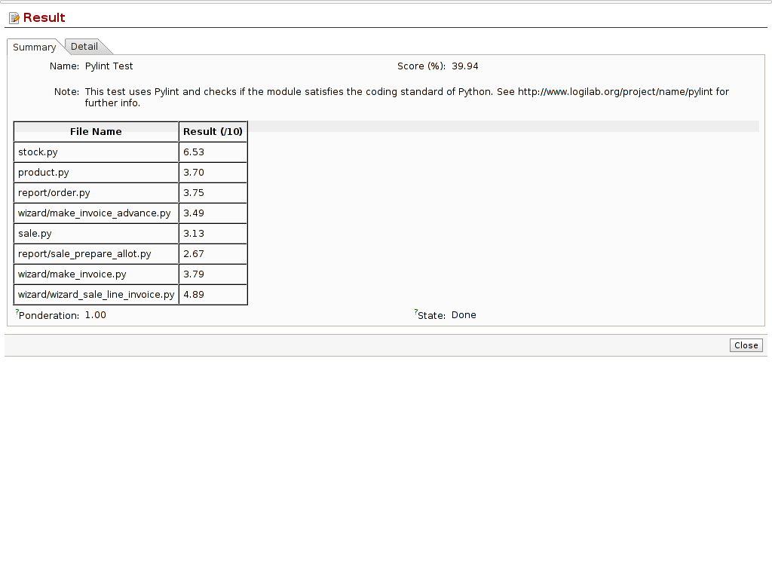
This test check the quality of all py files available on the module by pylint (python) standard see the Detail tab for detail result (you can save the result also!). You have to install pylint pacakge for it (http://pypi.python.org/pypi/pylint)

Pylint test follow pure python standart and give the result

There is config file available on pylint_test module, which allow users to change pylint test work for e.g.
# Maximum number of characters on a single line.
max-line-length=80
You can change the test to make max line lenght to 100

Speed Test
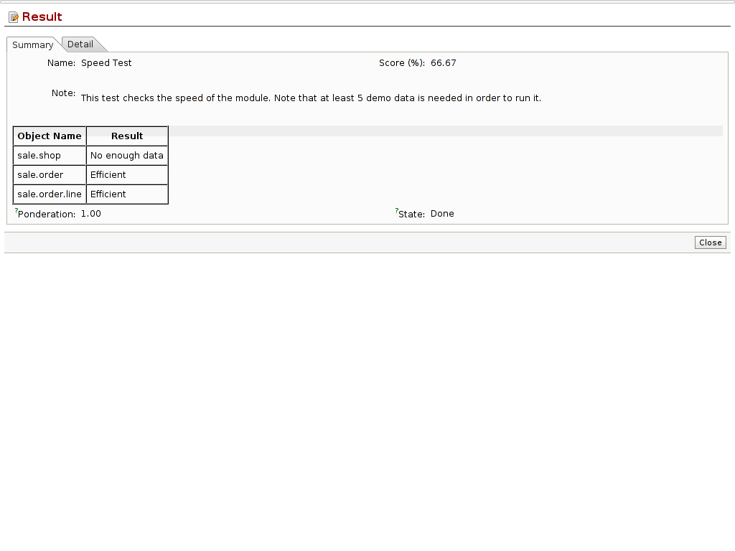
This test calculate score based on the speed of the object to read result using read method, There is atleast some demo data needed to run this test,

It also calculated reading complexity by reading records 1, N/2, N (N=number of records).

for e.g: If the time of reading of one record from database and the time of reading N record from database should be same, if no then speed the module is not good

PEP-8 Test

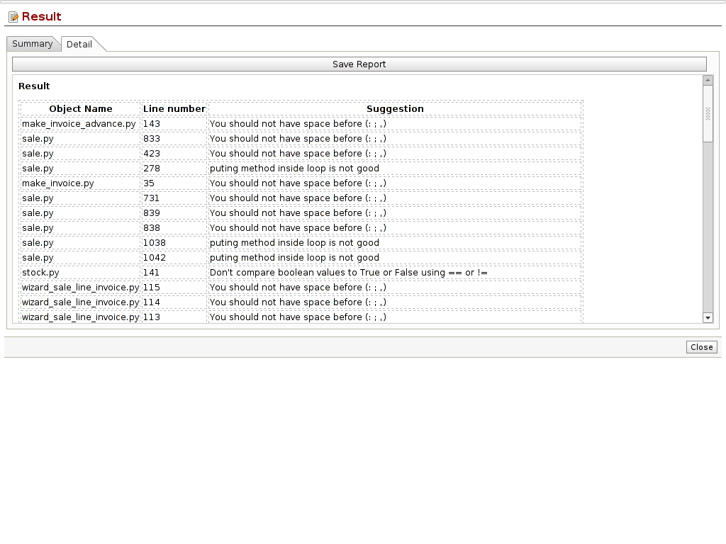
It checks following criteria on py files:
- Imports should usually be on separate lines
- Imports are always put at the top of the file, just after any module comments and docstrings, and before module globals and constants
- There should be a one space after , : ;
- Have all the .py files a copyright? (Openerp)
- Does the module avoid unecessary queries like when we put a browse into a loop?
- For sequences, (strings, lists, tuples), use the fact that empty sequences are false
- Don't compare boolean values to True or False using == and !=

Structure Test
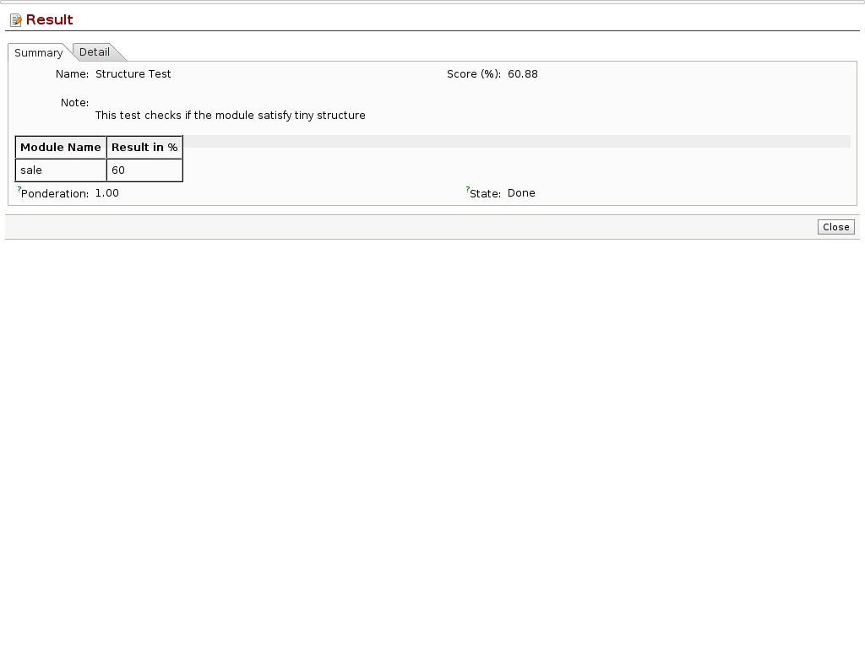
This test checks the module follow the structure of the tiny module
For e.g:
/module_name/
/module_name/__init__.py
/module_name/__terp__.py
/module_name/module.py
/module_name/module_view.xml
/module_name/module_wizard.xml
/module_name/module_report.xml
/module_name/module_data.xml
/module_name/module_demo.xml
/module_name/module_security.xml
/module_name/wizard/
/module_name/wizard/__init__.py
/module_name/wizard/wizard_name.py
/module_name/wizard/wizard_name_view.xml
/module_name/wizard/wizard_name_workflow.xml
/module_name/report/
/module_name/report/__init__.py
/module_name/report/report_name.sxw
/module_name/report/report_name.rml
/module_name/report/report_name.py
/module_name/security/
/module_name/security/ir.model.access.csv
/module_name/security/module_security.xml
.............................
.............................

Terp Test

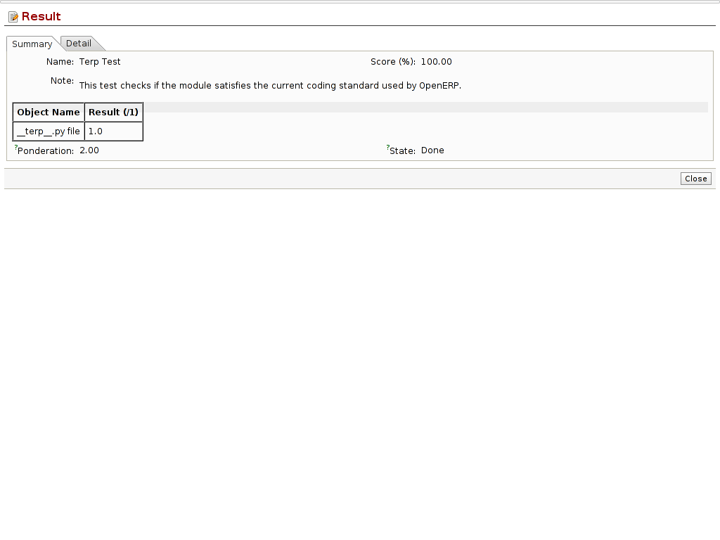
It check the __terp__.py file of the module.
- Each tag should be appear in terp file with its information
'category', 'name', 'description', 'author', 'website', 'update_xml', 'init_xml', 'depends', 'version', 'active', 'installable', 'demo_xml', 'certificate', etc....
- description tag should contain minimum 5 lines or 150 chars
- check validity of website tag.
- installable tag should be set to true
- active tag should not be set to true accept for “base” module

Method Test

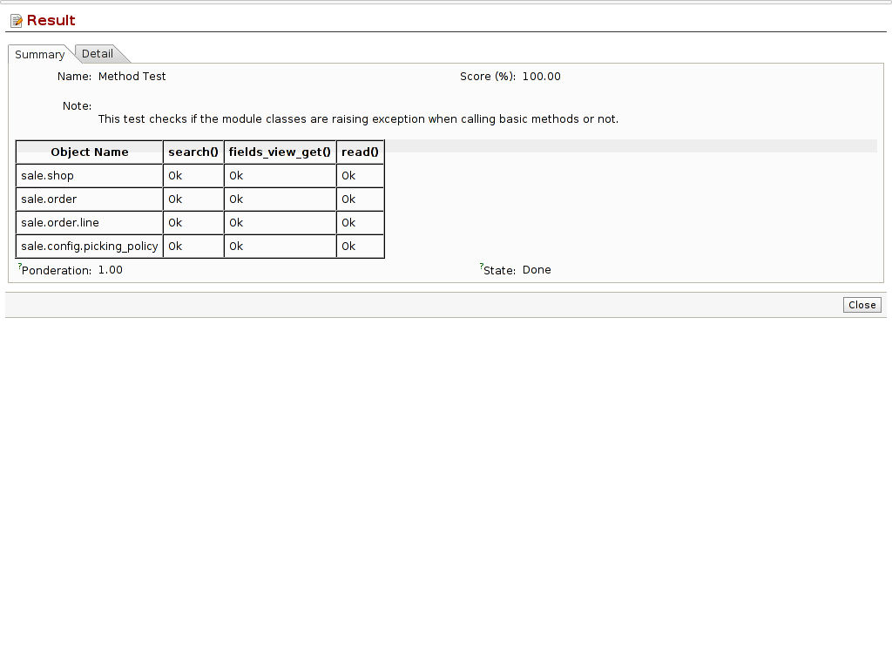
The test checks whether method on object is called or not without exception
methods : search,fields_view_get,read method

You can add your method in code so that it can work on that.

Object Test

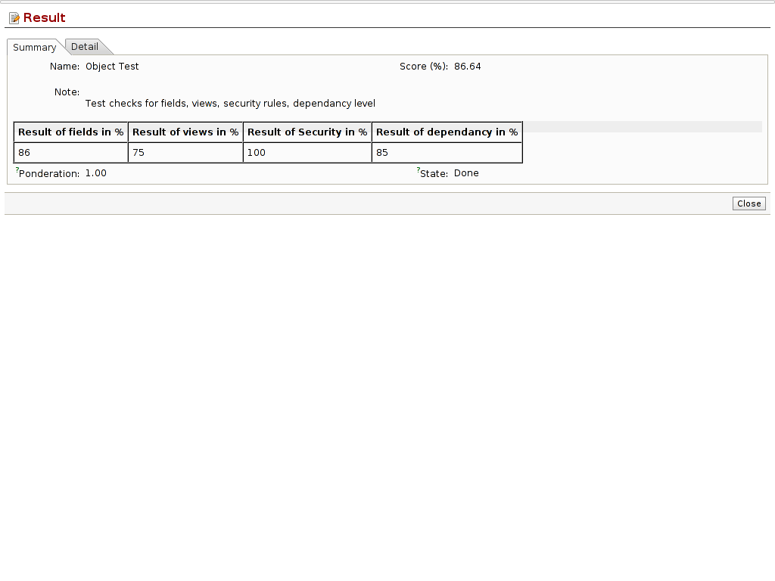
This test work on py files, view files, security rules test.
It checks:
Fields Test:
- many2one field should end with _id
- one2many, many2many fields should end with _ids
- fields name should in lower case and should follow python standards
Views Test:
-all object should have atleast one tree/form view
Security Rule Test:
- Module should have security folder to define access of its all object
- And there should be atleast one group on that access
Dependacy test of module (in __terp__.py=> depends tag)
- it check that module should have highest level of dependancy
for e.g if you have 'account' in your dependancy no need to put 'product' in.
- ['product', 'account'] = Not good
- ['account'] = Good
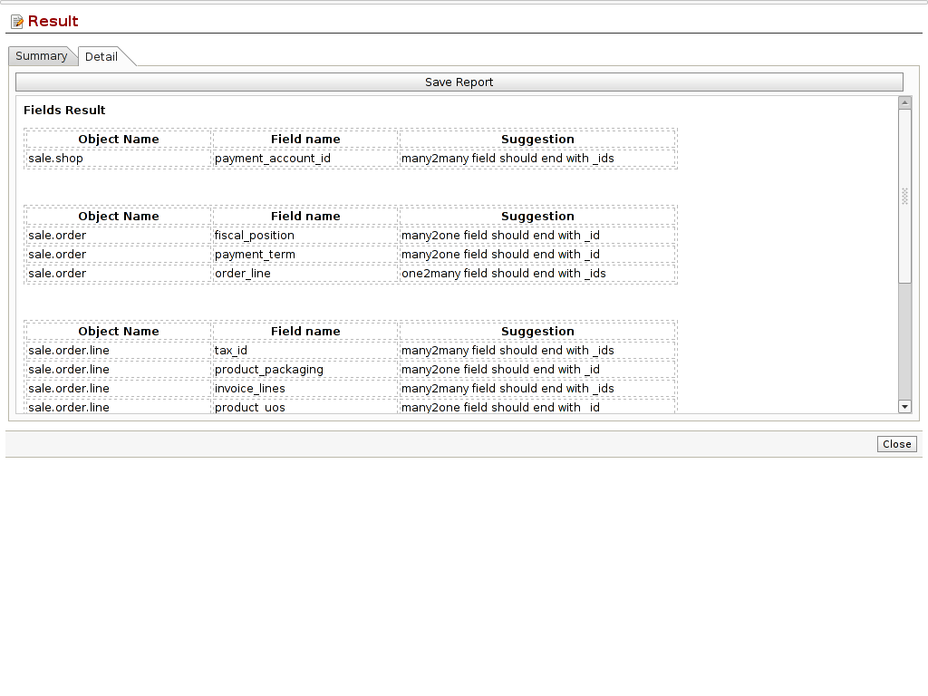
Detail result of Object Test:

